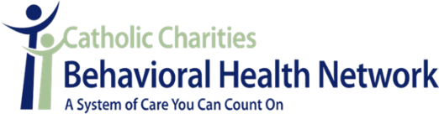
Support & Recovery Services
Referral Form

If you or someone you know would benefit from assistance with strengthening their emotional health, physical health and support network as well as increasing their access and connection to community resources, please complete the referral information below and fax it to us at 871-7457. If there is need for more immediate assistance, please walk-in to (66 State Street, Portland, 3rd Floor) or call (871-7431) and our Community Response provider can schedule a same day appointment with you. Community Office hours are Monday -Friday 8:30 a.m. to 4:30 p.m.

Referent
Date: | Date Referral Received:
Referent: | Referent Contact #:
Referent Agency: | Referent Email:

Individual Seeking Services
Name: | DOB:
Social Security #: | Contact #:
Address: | City/Zip Code:
Email: | Mainecare #:
Which program is the individual seeking support from? ____ ACT ____ BHH ___Other:
Current DSM V Diagnosis:
PCP Name: | PCP Contact #:
If the individual does not have Mainecare, we will provide assistance with completing and submitting the application at their initial appointment.
Is the individual currently enrolled in services with Catholic Charities of Maine? _____Yes _____ No
If yes, please list the services they are enrolled in:
For provider referrals, please submit a current diagnosis and signed Consent for Release of Information with this form.
What supports would be most helpful to the individual seeking services (check all that apply):
____ Housing | ____ Employment | ____ Education | ____ Financial Support
____ Counseling | ____ Substance Use | ____ Medication | ____ Nutrition
____ Mobility | ____ Food Access | ____ Dental Care | ____ Coping Skills
____ Healthy Lifestyle | ____ SSI/SSDI | ____ Support Network | ____ Childcare
____ Other: (please list) ____________________________________________________________________________________________________

