## CR-05 - Goals and Outcomes

**Progress the jurisdiction has made in carrying out its strategic plan and its action plan. 91.520(a)**

This could be an overview that includes major initiatives and highlights that were proposed and executed throughout the program year.

The City of Revere's Consolidated Plan provides the framework that identifies community development and housing priorities. This CAPER reports on the accomplishments and progress made towards the above mentioned Plan for the 2018 Program Year.

One of the City’s priority economic development goals was the continued rehabilitation and upgrading of commercial properties in the Broadway and Shirley Avenue Business Districts. The Office of Strategic Planning & Economic Development (OSPED) has met on an ongoing basis with existing businesses and property owners about the storefront and signage improvement program; in the case of Shirley Avenue, these meetings complement regular district stakeholder meetings to advance overall district improvement priorities. Staff have identified over one dozen candidates for the program across both districts, a pipeline that complements two state-funded MassWorks grant projects calling for the reconstruction of sidewalk and roadway to enhance accessibility and sustainability in these two business districts. The project will continue to leverage private funds alongside the over five million in other public funds, and aids in attracting economic development, job creation and retention in these business corridors that benefit the city and its residents.

Another goal is the continuing development and improvement of public open spaces, a priority also highlighted in the City’s Open Space and Recreation Plan completed in 2018. The ongoing commitment to park improvement initiatives facilitated the City’s ability to secure over $200000 of private funds for the Paul Revere School Park project, which had been anticipated for CDBG funding during this program year. OSPED staff subsequently began preparation for improvements to Curtis Park, an expansive and aging school-adjacent facility in need of significant upgrades to its ball field, basketball court, and playground serving one of the City’s most significantly low-moderate income neighborhoods.

Another Community Development goal was the completion of sidewalk improvements on Cambridge Street, Dedham Street, Essex Street, and Furness Street, a project that provided an estimated 5600 linear feet of new concrete sidewalks and accessible ramps for neighborhood residents. These efforts have been coordinated with the City's Engineering and Water and Sewer Departments, which have been working on replacements of the water main along these neighborhood streets. This project utilized both CDBG funding and Mass Chapter 90 funding.

The City’s Public Social Service goal is to provide/sustain a suitable living environment for L/M Revere residents. Subrecipients provided valuable workforce and adult education training to low-moderate income residents, including those pursing higher education and skills training to secure more stable employment opportunities. Some Public Service proposals were referred to other funding sources and/or provided guidance on future capacity to administer according to CDBG requirements.

During this program year, the City of Revere benefited from increased capacity for CDBG administration on staff. In addition to improving its grant management capabilities, City staff will be dedicated specifically to CDBG and HOME activities for the City of Revere.

**Comparison of the proposed versus actual outcomes for each outcome measure submitted with the consolidated plan and explain, if applicable, why progress was not made toward meeting goals and objectives. 91.520(g)**

Categories, priority levels, funding sources and amounts, outcomes/objectives, goal outcome indicators, units of measure, targets, actual outcomes/outputs, and percentage completed for each of the grantee’s program year goals.

|  |  |  |  |  |  |  |  |  |  |  |
| --- | --- | --- | --- | --- | --- | --- | --- | --- | --- | --- |
| **Goal** | **Category** | **Source / Amount** | **Indicator** | **Unit of Measure** | **Expected – Strategic Plan** | **Actual – Strategic Plan** | **Percent Complete** | **Expected – Program Year** | **Actual – Program Year** | **Percent Complete** |
| Commercial Property Improvements | Non-Housing Community Development | CDBG: $ | Facade treatment/business building rehabilitation | Business | 28 | 16 | 57.14% | 5 | 0 | 0.00% |
| Economic Development | Non-Housing Community Development | CDBG: $ | Businesses assisted | Businesses Assisted | 3 | 3 | 100.00% |  |  |  |
| Housing Development | Affordable Housing | CDBG: $ | Rental units rehabilitated | Household Housing Unit | 10 | 0 | 0.00% |  |  |  |
| Housing Development | Affordable Housing | CDBG: $ | Direct Financial Assistance to Homebuyers | Households Assisted | 5 | 0 | 0.00% |  |  |  |
| Housing Rehabilitation | Affordable Housing | CDBG: $ | Rental units rehabilitated | Household Housing Unit | 13 | 10 | 76.92% |  |  |  |
| Housing Rehabilitation | Affordable Housing | CDBG: $ | Homeowner Housing Rehabilitated | Household Housing Unit | 15 | 1 | 6.67% |  |  |  |
| Planning and Adminstration | Planning and Administration | CDBG: $ | Other | Other | 1 | 1 | 100.00% |  |  |  |
| Public Facilities, Parks, and Open Spaces | Non-Housing Community Development | CDBG: $ | Public Facility or Infrastructure Activities other than Low/Moderate Income Housing Benefit | Persons Assisted | 3084 | 3084 | 100.00% | 6145 | 0 | 0.00% |
| Public Infrastructure | Non-Housing Community Development | CDBG: $ | Public Facility or Infrastructure Activities other than Low/Moderate Income Housing Benefit | Persons Assisted | 4775 | 4775 | 100.00% | 6005 | 965 | 16.07% |
| Public Services | Homeless Non-Homeless Special Needs Non-Housing Community Development | CDBG: $ | Public service activities other than Low/Moderate Income Housing Benefit | Persons Assisted | 300 | 1136 | 378.67% |  |  |  |
| Public Services | Homeless Non-Homeless Special Needs Non-Housing Community Development | CDBG: $ | Public service activities for Low/Moderate Income Housing Benefit | Households Assisted | 0 | 0 |  | 1000 | 61 | 6.10% |
| Public Services | Homeless Non-Homeless Special Needs Non-Housing Community Development | CDBG: $ | Homeless Person Overnight Shelter | Persons Assisted | 24 | 0 | 0.00% |  |  |  |

Table 1 - Accomplishments – Program Year & Strategic Plan to Date

**Assess how the jurisdiction’s use of funds, particularly CDBG, addresses the priorities and specific objectives identified in the plan, giving special attention to the highest priority activities identified.**

<p dir="ltr"><span>As in the prior year, the City of Revere utilized its CDBG funding to complement two MassWorks grants for major infrastructure improvements (improved sidewalk and road conditions, enhanced lighting and public safety, and improved accessibility) along the Broadway Central Business District and the Shirley Avenue Business District. CDBG’s economic development and community objectives were to provide existing business owners with the opportunity to improve the appearance of their storefronts or business signs in order to encourage consumer activity, support business retention, and further complement the public infrastructure improvements. The combined upgrades aim to increase consumer activity by Revere residents in the city’s Broadway Central Business District and Shirley Avenue Business District, which continue to attract increasing interest from new businesses along with job creation opportunities for local residents.</span></p><p dir="ltr"><span>Comprehensive planning initiatives, including a citywide Open Space and Recreation Plan and citywide visioning and master planning process, are providing additional insight for community development priorities including public facilities, housing, and economic development goals for the City of Revere. The Open Space and in-process comprehensive plan will include funding strategies to encourage strategic approaches to the City of Revere's use of funds for eligible projects.</span></p><p dir="ltr"><span>Public Service activities continue to include important education and training benefits to low income residents, with increased attention to building partnerships across service providers as well as with training and employment providers. New and existing City staff are coordinating ongoing support and technical assistance to public service subrecipients that are providing services to Revere residents.</span></p>

## CR-10 - Racial and Ethnic composition of families assisted

**Describe the families assisted (including the racial and ethnic status of families assisted). 91.520(a)**

|  |  |
| --- | --- |
|  | **CDBG** |
| White | 55 |
| Black or African American | 4 |
| Asian | 6 |
| American Indian or American Native | 0 |
| Native Hawaiian or Other Pacific Islander | 3 |

|  |  |  |
| --- | --- | --- |
|  |  | |
| **Total** | **68** |

|  |  |  |
| --- | --- | --- |
|  |  | |
| Hispanic | 27 |
| Not Hispanic | 41 |

**Table 2 – Table of assistance to racial and ethnic populations by source of funds**

**Narrative**

## CR-15 - Resources and Investments 91.520(a)

**Identify the resources made available**

|  |  |  |  |
| --- | --- | --- | --- |
| **Source of Funds** | **Source** | **Resources Made Available** | **Amount Expended During Program Year** |
| CDBG | public - federal | 790,383 | 545,629 |

Table 3 - Resources Made Available

**Narrative**

Over $250000 of State Chapter 90 funds were leveraged as part of the infrastructure improvements completed during this year.

**Identify the geographic distribution and location of investments**

|  |  |  |  |
| --- | --- | --- | --- |
| **Target Area** | **Planned Percentage of Allocation** | **Actual Percentage of Allocation** | **Narrative Description** |
|  |  |  |  |

Table 4 – Identify the geographic distribution and location of investments

**Narrative**

Infrastructure improvements were completed based on a low-moderate area basis. Staff continued planning activities related to the Facade and Signage Improvement commercial property improvement program during the program year, with a sustained focus on the Broadway Central Business District and the Shirley Avenue Business District. During the program year, state funds targeting the Shirley Avenue District facilitated at least five sign improvement projects that are at various stages of design, construction, or fabrication.

**Leveraging**

**Explain how federal funds leveraged additional resources (private, state and local funds), including a description of how matching requirements were satisfied, as well as how any publicly owned land or property located within the jurisdiction that were used to address the needs identified in the plan.**

CDBG Public Facilities funds ($150000) were initially committed to reconstruction of the Paul Revere School Park during this program year; private charitable funding was secured during the AP year to cover this project in excess of the full amount - an estimated $200000 total. These funds are reflected as deobligated from the program year's available resources.

The sidewalk reconstruction project along the adjacent streets of Cambridge Street, Dedham Street, Essex Street, and Furness Street leveraged over $250000 of State Chapter 90 funding.

## CR-20 - Affordable Housing 91.520(b)

**Evaluation of the jurisdiction's progress in providing affordable housing, including the number and types of families served, the number of extremely low-income, low-income, moderate-income, and middle-income persons served.**

|  | One-Year Goal | Actual |
| --- | --- | --- |
| Number of Homeless households to be provided affordable housing units | 0 | 0 |
| Number of Non-Homeless households to be provided affordable housing units | 0 | 0 |
| Number of Special-Needs households to be provided affordable housing units | 0 | 0 |
| **Total** | **0** | **0** |

Table 11 – Number of Households

|  | One-Year Goal | Actual |
| --- | --- | --- |
| Number of households supported through Rental Assistance | 0 | 0 |
| Number of households supported through The Production of New Units | 52 | 52 |
| Number of households supported through Rehab of Existing Units | 0 | 0 |
| Number of households supported through Acquisition of Existing Units | 0 | 0 |
| **Total** | **52** | **52** |

Table 12 – Number of Households Supported

**Discuss the difference between goals and outcomes and problems encountered in meeting these goals.**

The City of Revere in conjunction with the North Suburban Consortium are continuing to offering down payment and closing cost assistance to first time homebuyers through NSC HOME funding. Chelsea Restoration Corporation and Medford Community Housing are both agencies that provide HUD certified housing counseling services. The Neighborhood Developers are in process of completing a HOME funded project at 571 Revere Street, which will create 52 units of deed-restricted affordable housing in a transit-oriented development. The city continues to work to increase its capacity to facilitate referrals for residents to local agencies.

**Discuss how these outcomes will impact future annual action plans.**

These activities in process will result in an increase in our supply of deed-restricted affordable housing units in the City of Revere. The Metropolitan Area Planning Council is currently working on the City of Revere's Master Plan and the final forum is scheduled for January of 2020. CHAPA has recently designated the City of Revere as an MEI (Municipal Engagement Initiative) community and will assist the City in program development and capacity building to support affordable housing preservation and construction. A primary goal is to encourage the passage of an inclusionary zoning ordinance requiring future developments in the City to provide affordable housing.

**Include the number of extremely low-income, low-income, and moderate-income persons served by each activity where information on income by family size is required to determine the eligibility of the activity.**

|  |  |  |  |
| --- | --- | --- | --- |
| **Number of Households Served** | **CDBG Actual** | **HOME Actual** | |
| Extremely Low-income | 0 | 0 |
| Low-income | 0 | 0 |
| Moderate-income | 0 | 0 |
| **Total** | **0** | **0** |

Table 13 – Number of Households Served

**Narrative Information**

The 52 affordable workforce units began construction in spring 2019.

## CR-25 - Homeless and Other Special Needs 91.220(d, e); 91.320(d, e); 91.520(c)

**Evaluate the jurisdiction’s progress in meeting its specific objectives for reducing and ending homelessness through:**

**Reaching out to homeless persons (especially unsheltered persons) and assessing their individual needs**

<p dir="ltr">The City of Revere is not the direct recipient of any public or private resources with which to address homeless needs and prevent homelessness. Revere is part of the “Balance of State” continuum which is overseen by the state Department of Transitional Assistance (DTA) and Department of Housing and Community Development (DHCD). Revere supports efforts of regional providers and nonprofits working in Revere to apply to the state for homelessness assistance to support a variety of housing programs for homeless families and individuals in Revere. The state applies for this funding annually, with the communities in the “Balance of State” continuum, for specific projects. </p><p dir="ltr">CAPIC, the local anti-poverty agency, has been designated by the Massachusetts Department of Housing and Community Development as the official Continuum of Care -balance of State Homeless Providers for Chelsea, Revere, and Winthrop. CAPIC completes the Point In Time count. </p>

**Addressing the emergency shelter and transitional housing needs of homeless persons**

There are no emergency shelters within Revere nor within the North Suburban Consortium, of which Revere is a member community. CAPIC will screen unsheltered homeless persons for mainstream resources and assist them with the application process, and assist unsheltered persons access emergency shelters. The City of Revere also operates an active Substance Use Disorders Initiative (SUDI) Office which works closely with the City's Veterans Affairs agency on ongoing dedicated case management and referrals for vulnerable and chronically unsheltered Revere residents.

**Helping low-income individuals and families avoid becoming homeless, especially extremely low-income individuals and families and those who are: likely to become homeless after being discharged from publicly funded institutions and systems of care (such as health care facilities, mental health facilities, foster care and other youth facilities, and corrections programs and institutions); and, receiving assistance from public or private agencies that address housing, health, social services, employment, education, or youth needs**

Non-profits within the NSC operate programs that provide essential services designed to help low income persons and families to avoid homelessness. Specifically,

* Just-A-Start Corporation provides court mediation services; it also stabilizes families through housing assistance via HomeBASE- rental assistance and security deposit to at-risk households
* Housing Families provides pro-bono legal services to housing-unstable residents
* Bread of Life: Provides free meals and food pantry to low-income families and food deliveries to at-risk elders and homeless families displaced into area motels.
* HarborCov: provides holistic services to victims of domestic violence, often in partnership and through referrals from public safety agency personnel
* Heading Home: Offers case management, supportive services, advocacy, access to job training and employment services, life-skills and housing search.
* CAPIC: provides a tremendous amount of housing support from basic needs to emergency housing services and rental assistance.

**Helping homeless persons (especially chronically homeless individuals and families, families with children, veterans and their families, and unaccompanied youth) make the transition to permanent housing and independent living, including shortening the period of time that individuals and families experience homelessness, facilitating access for homeless individuals and families to affordable housing units, and preventing individuals and families who were recently homeless from becoming homeless again**

Revere as part of the North Suburban Consortium has been successful at forging partnerships with several non-profit service providers as well as the development community.  The North Suburban Consortium, through the development of dedicated affordable housing units, has assisted homeless families to obtain and sustain affordable housing. CAPIC will assume the responsibility to coordinate homelessness prevention which includes outreach to identify unsheltered homeless individuals and foster relationships with them in an effort to encourage these individuals to accept additional resources, shelter and housing.

## CR-30 - Public Housing 91.220(h); 91.320(j)

**Actions taken to address the needs of public housing**

The Revere Housing Authority (RHA) continues to make gains in the areas of administrative management, finance & accounting, maintenance, asset management, housing management, tenant selection and the Housing Choice Voucher Program. As in past years, the RHA will continue to seek tenant input on housing quality and the improvement of authority developments by means of public meetings, posting of plans and documents, and open communication.

**Actions taken to encourage public housing residents to become more involved in management and participate in homeownership**

The RHA has a well-established Family Self-Sufficiency (FSS) Program and continues to work at moving resident families from "welfare to work". The FSS program is structured to provide an avenue to homeownership opportunities for RHA voucher holders. The RHA  initiated its FSS program within the Section 8 program.

**Actions taken to provide assistance to troubled PHAs**

N/A

## CR-35 - Other Actions 91.220(j)-(k); 91.320(i)-(j)

**Actions taken to remove or ameliorate the negative effects of public policies that serve as barriers to affordable housing such as land use controls, tax policies affecting land, zoning ordinances, building codes, fees and charges, growth limitations, and policies affecting the return on residential investment. 91.220 (j); 91.320 (i)**

<p dir="ltr"><span>The greatest barrier to increased availability of high-quality, affordable housing continued to be extremely limited public funding, and very limited private sector interest in developing affordable housing in Revere. Nevertheless, Revere has continued to explore incentives development incentives to increase the supply of housing, including actively working with, and encouraging nonprofit and for-profit development partners to collaborate and otherwise create more affordable opportunities in the community. During the Program Year, The Neighborhood Developers actively engaged with the City to explore a variety of strategies to restore and/or create affordable units, such as exploration of the disposition of municipally-owned vacant parcels for housing production. The Neighborhood Developers are also committed to a project at 571 Revere Street for the creation of 52 affordable workforce units. As has been mentioned in this report, the City is also working closely on a Master Plan that will outline an array of regulatory, financing, and programmatic strategies to further address the demand for affordable housing units.</span></p><p dir="ltr"><span>The shortage of opportunities to create new affordable housing in Revere is attributable only in part to public policies such as zoning; the lack of developable land for this purpose, and the significant costs of development in the Greater Boston region, remain the main barriers and production constraints. The City’s master planning process which began in January 2019 is facilitating the most comprehensive overview of housing needs in decades, including a review of development constraints, programmatic approaches, and incentive-based strategies that complement the City’s ongoing focus on underutilized industrial and commercial properties as opportunities for workforce and mixed-income housing development. </span></p><p dir="ltr"><span>As in prior years, the City continues to adopt and practice transit-oriented development principles, including through overlay zoning, that permits less stringent parking requirements for units within a quarter mile of rapid transit at sites near its Wonderland, Revere Beach, and Beachmont public transit stations. The City, particularly in the Shirley Avenue neighborhood, has permitted projects proposed by local developers to redevelop blighted or vacant sites such as surface parking lots to increase the supply of affordable, non deed-restricted rental housing. The City approved the expansion for the Highway Business District Zone (from single-family) in North Revere to permit Roseland Property Company to develop more multi-family units in the Overlook Ridge project; construction of new units is currently under consideration.</span></p>

**Actions taken to address obstacles to meeting underserved needs. 91.220(k); 91.320(j)**

<p dir="ltr"><span>The primary obstacle to addressing underserved needs has been limited resources and capacity to secure funding for full implementation. Through the efforts of City staff and community agencies, the City was able to secure two million dollar of funding for the Revitalization of Shirley Avenue Business District, for which design and engineering for roadway, sidewalk, lighting, and street-scaping is underway and will complement the facade improvement project.</span></p><p dir="ltr"><span>The City also recognizes the significant impact of limited local employment opportunities and transportation barriers on its community development goals. Following the prior year’s closure of the Necco candy factory, the announcement of Amazon’s expected tenancy at the former Necco site in Revere raised the prospect of hundreds of jobs. The City continues to build on existing relationships with service providers, local businesses, and regional agencies to identify opportunities to provide residents with greater access to education, training, and employment to complement many of its existing housing and community development programs.</span></p>

**Actions taken to reduce lead-based paint hazards. 91.220(k); 91.320(j)**

The City has public improvement projects that are ready to proceed. Most of our public works projects are designed in-house reducing potential delays.

Since any lead-based paint presents a serious and unacceptable threat to children, the City of Revere has carried out housing rehabilitation activities for many years, routinely testing for lead paint in any unit to be rehabilitated. Efforts to decrease the overall impact of lead paint in Revere’s older housing stock has been relatively successful, given limited availability of funds and the stringent requirements of Title X, HUD’s “Lead Based Paint Hazard Reduction Act”.  All housing rehabilitation projects are first tested for lead paint.  If the property tests positively for lead paint, it is included in the project work write–up and must be removed before any other work is started.  Some lead paint was remediated in one housing rehabilitation project and was done within the scope of that project with CDBG funds No other lead paint remediation was done in FY2018 program year using CDBG funds.  HOME and Mass Housing funded programs are also available to assist in the removal of lead paint.

**Actions taken to reduce the number of poverty-level families. 91.220(k); 91.320(j)**

<p dir="ltr"><span>Revere continues its active engagement in a network of regional and local organizations operating programs and initiatives intended to help reduce the number of persons living in poverty. This has included enhanced coordination with the regional workforce board serving the Metro Boston region, as well as close collaboration with local workforce agencies to address barriers to economic stability and mobility. As of this report, approximately 15% of Revere residents live in poverty. To reduce this number, the City will continue its focus on the following Anti-poverty initiatives:</span></p><ul><li dir="ltr" aria-level="1"><p dir="ltr" role="presentation"><span>Support for economic development initiatives that result in employment opportunities for low and moderate income residents</span></p></li><li dir="ltr" aria-level="1"><p dir="ltr" role="presentation"><span>Provision of training, technical assistance, and resources to support emerging and existing small business owners</span></p></li><li dir="ltr" aria-level="1"><p dir="ltr" role="presentation"><span>Provision of job readiness and job training programs for low-income residents</span></p></li><li dir="ltr" aria-level="1"><p dir="ltr" role="presentation"><span>Removal of Barriers to Education and Employment</span></p></li><li dir="ltr" aria-level="1"><p dir="ltr" role="presentation"><span>Provision of services that support self-sufficiency </span></p></li></ul><p dir="ltr"><span>Funding has been provided to public service agencies supporting 23 adults in English Education Classes to improve their language skills.</span></p>

**Actions taken to develop institutional structure. 91.220(k); 91.320(j)**

<p dir="ltr"><span>The Office of Strategic Planning & Economic Development continues to implement the City’s goals and our institutional structure has been realigned to better meet the needs of our residents and partners. This has included increased coordination with local health providers, community outreach agencies, and other City departments. The Office of Strategic Planning & Economic Development works with the Healthy Community Initiatives Department, Revere on the Move, Elder Affairs, other City agencies and community partners in elevating healthy living as an essential and achievable priority within the community and economic development agenda for the City of Revere, through strategic coalition-building and the creation of new programs.</span></p><p dir="ltr"><span>The City will continue to enhance its program coordination functions, largely in the areas of prioritization of projects and of performance monitoring. Through inter-departmental communication, the The Office of Strategic Planning & Economic Development will be readily available to identify those public works and facility projects which are ready to proceed. The City will evaluate its process for selection of public service projects to include a greater focus on outcome measures. </span></p>

**Actions taken to enhance coordination between public and private housing and social service agencies. 91.220(k); 91.320(j)**

<p dir="ltr"><span>The City benefits from a strong network of Revere-based providers as well as a network of regional housing and human services providers. City staff have been participating along with staff from its fellow Consortium communities of Chelsea and Winthrop in a three-year Integrated Community Health Needs Assessment process, which is expected to generate clear opportunities for improved coordination, communication, and investment to better serve the region's residents.</span></p><p dir="ltr"><span>The City will continue to participate as a member of the North Suburban HOME Consortium. Through this participation, the City is able to effectively coordinate its housing agenda with the surrounding communities.  One Beach at Broadway, a project of the Neighborhood Developers, utilized several participants including the North Suburban HOME Consortium that provided 30 units of elderly housing.</span></p><p dir="ltr"><span>Another project at 571 Revere Street, an anticipated workforce housing project by The Neighborhood Developers, will utilize several participants including the North Suburban HOME Consortium. The Neighborhood Developers has worked to develop a robust resident services model aimed at supporting financial stability and social service referrals among residents, a component of all of its projects in Revere and one that is expected to continue with the 571 Revere Street project.</span></p>

**Identify actions taken to overcome the effects of any impediments identified in the jurisdictions analysis of impediments to fair housing choice. 91.520(a)**

<p dir="ltr"><span>The Office of Strategic Planning and Economic Development has worked with the Building, Fire and Health Departments to utilize “Language Line” and to aggressively communicate local rules and procedures to all new residents buying property in Revere. The Office of Strategic Planning & Economic Development has continued to urge these departments to make existing homeowners aware of these provisions during any permitting processes. The City has targeted its Certificate of Occupancy process as a good vehicle through which to do so. </span></p><p dir="ltr"><span>The City continues to work with local real estate agents providing them with comprehensive information and education so as to ensure their clients are treated fairly in both purchasing and renting properties. Significant improvements in the City's municipal communications and constituent service center have also facilitated greater access to information, including for residents whose first language is not English.</span></p>

## CR-40 - Monitoring 91.220 and 91.230

**Describe the standards and procedures used to monitor activities carried out in furtherance of the plan and used to ensure long-term compliance with requirements of the programs involved, including minority business outreach and the comprehensive planning requirements**

The Office of Strategic Planning & Economic Development (OSP&ED) is responsible for compliance with all program requirements and for complete consistency with comprehensive planning requirements. OSP&ED carried out the FY2018 Action Plan programs and activities and is working to ensure that all CDBG funded projects and programs complied with all federal laws and regulations and state laws and local ordinances as relevant.

OSP&ED was itself responsible for monitoring compliance with labor standards in all construction projects and for minority business outreach as well as comprehensive planning requirements. Projects or programs undertaken directly by subrecipients were governed by subrecipient agreements which referenced labor standards and all other applicable federal regulations and cited specific penalties for failure to comply with same. Public service applicants who were unable to meet the compliance standards were referred or encouraged to evaluate their capacity to administer CDBG-funded programs and re-apply at a future date.

For each funded activity, OSP&ED staff worked to ensure compliance with HUD regulations through oversight and monitoring of each activity. The below standards applied to all funded activities, with OSP&ED undertaking the corresponding monitoring activities for the infrastructure and public services projects completed during this program year.

* housing development/rehabilitation/buyer assistance
* reviewed records for compliance with labor standardsreviewed tenant selection processesreviewed annual income verification recordsconducted annual inspections for code compliance in rental unitsconducted outreach to non-English speaking and minority groupsreviewed income eligibility by means of credible income verificationemplaced recapture provisions by means of liens to prevent speculation and to require repayment within specified time periodsreviewed annual incomes verification to ensure affordability of rental units
* public services
* required regular reports verifying number of low and moderate income persons served as well as the ethnicity and racial characteristics of those served; reviewed reports to ensure complianceconducted periodic site visits according to sub-recipient's experience level and past performance, with significant attention paid to Women Encouraging Empowerment and Revere Farmers Market (cancelled activity) to strengthen subrecipient capacityscreened each sub-recipient with goal of improving standards and compliance with subrecipient agreements, monitoring, and refinement of activity goals and outcomes measurementsidentified monitoring goals for each program year (one on-site visit, quarterly file review, as-needed follow-up)
* public facilities
* required Minority Business Enterprise (MBE) and Women Business Enterprise (WBE) participation in all construction contractsreviewed weekly payroll forms to ensure prevailing wage complianceconducted site visits to interview workers on wage payments
* economic development – façade and signage grants/loans
* monitor and certify creation/retention of jobsmaintain records as to racial and socio-economic characteristics of job entrepreneur and employee beneficiariesensure completion of improvements

Staff have identified, with the input of HUD, opportunities for improvement and strengthened oversight. This has included identifying opportunities for technical assistance for both the Office and for its subrecipients. A monitoring guide and  policy and procedures have been completed for public services.

**Citizen Participation Plan 91.105(d); 91.115(d)**

**Describe the efforts to provide citizens with reasonable notice and an opportunity to comment on performance reports**.

The Office of Strategic Planning & Economic Development holds a public hearing to inform the public of the progress of current/ongoing programs.  Notices of this public hearing are published in the local newspaper, posted on the City's website, and City Hall bulletin board. Citizens will have an opportunity to comment on the performance report.  The performance report will be posted on the City's website once complete and before submittal.

**CR-45 - CDBG 91.520(c)**

**Specify the nature of, and reasons for, any changes in the jurisdiction’s program objectives and indications of how the jurisdiction would change its programs as a result of its experiences.**

The City of Revere conducts its management and oversight of the CDBG program in alignment and compliance with the needs identified, and objectives set forth, in its Five Year and Annual Action Plans. These plans set the priorities for identifying and supporting eligible activities to be funded through CDBG, which is one of a number of critically important resources for the City to continue addressing consistent community needs. At this time, no changes are anticipated in the City's program objectives.

**Does this Jurisdiction have any open Brownfields Economic Development Initiative (BEDI) grants?**

No

**[BEDI grantees] Describe accomplishments and program outcomes during the last year.**

**CR-45 - CDBG 91.520(c)**

**Specify the nature of, and reasons for, any changes in the jurisdiction’s program objectives and indications of how the jurisdiction would change its programs as a result of its experiences.**

The City of Revere conducts its management and oversight of the CDBG program in alignment and compliance with the needs identified, and objectives set forth, in its Five Year and Annual Action Plans. These plans set the priorities for identifying and supporting eligible activities to be funded through CDBG, which is one of a number of critically important resources for the City to continue addressing consistent community needs. At this time, no changes are anticipated in the City's program objectives.

**Does this Jurisdiction have any open Brownfields Economic Development Initiative (BEDI) grants?**

No

**[BEDI grantees] Describe accomplishments and program outcomes during the last year.**

**Attachment**

**PR 26 - 2018**

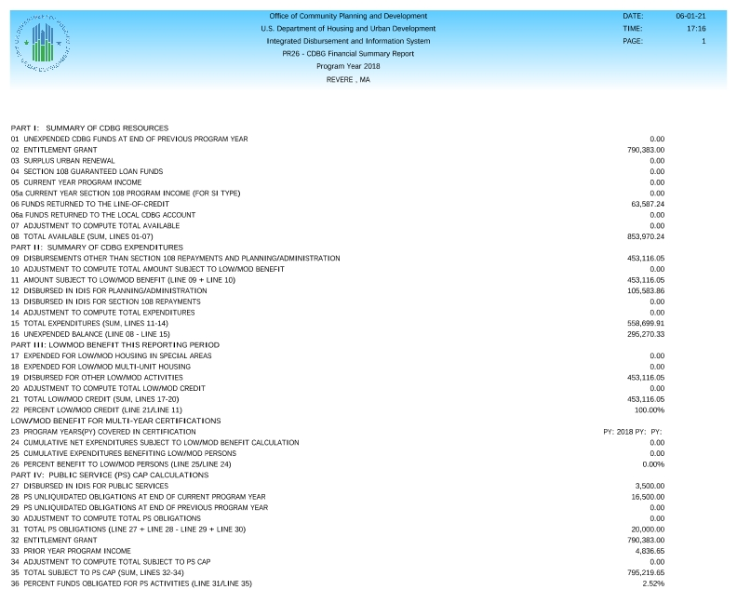

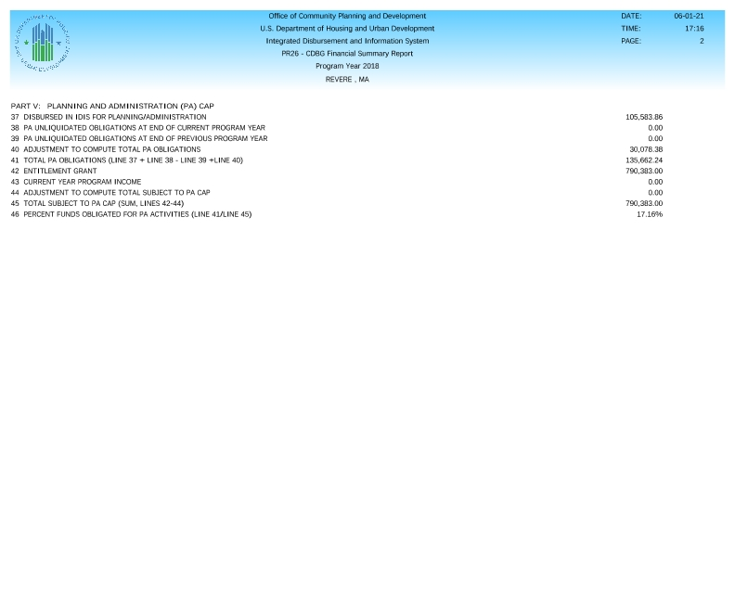

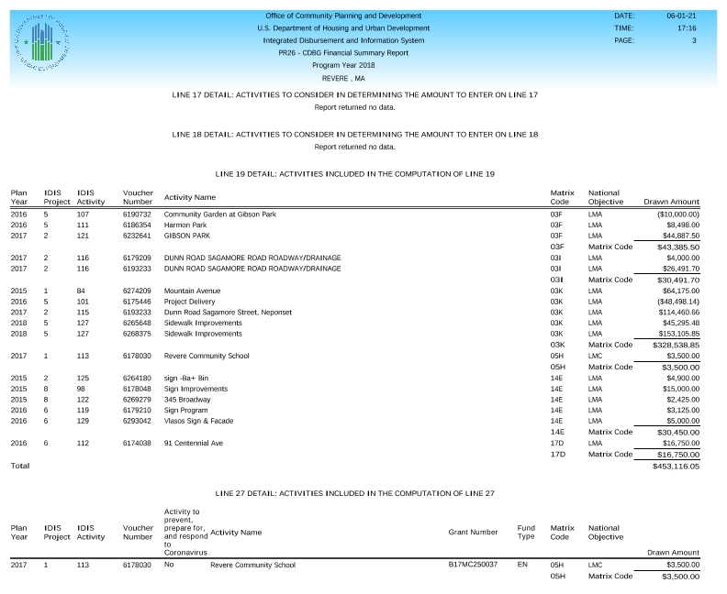

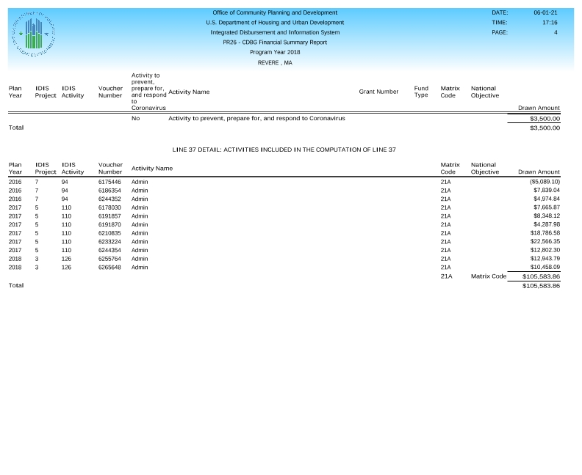

**Public Notice**

**PR 26 Adjustments**