## CR-05 - Goals and Outcomes

**Progress the jurisdiction has made in carrying out its strategic plan and its action plan. 91.520(a)**

This could be an overview that includes major initiatives and highlights that were proposed and executed throughout the program year.

The City of Revere's Consolidated Plan provides the framework that identifies community development and housing priorities. This CAPER reports on the accomplishments and progress made towards the above-mentioned Plan for the 2019 Program Year. During this program year, the implementation of certain projects was postponed or adapted to rededicate staffing, and in some cases, programmatic resources to Revere’s local emergency coronavirus public health response.

One of the City’s goals was the continued rehabilitation and upgrading of commercial properties in the Broadway and Shirley Avenue Business Districts. The Office of Planning and Development (OPD) has met on an ongoing basis with existing businesses and property owners about the storefront and signage improvement program, which has generated a strong pipeline of participants in the target areas. This CDBG-funded program complements two state-funded MassWorks grant projects, one completed along the Broadway Central Business District and another which is nearing completion along the Shirley Avenue Business District. The reconstruction of sidewalk and roadway has improved accessibility for both residents and visitors and generated opportunities for business and property owners to collaborate with OPD on commercial property improvements. Approximately one dozen signs were in various stages of design, fabrication, and installation during the program year, despite postponement of most public construction activity due to pandemic restrictions. The project will continue to leverage private funds alongside the over five million in other public funds, and aids in attracting economic development, job creation and retention in these business corridors that benefit the city and its residents.

Another Community Development goal was the improvement of public facilities and public open spaces. During the program year, the City advanced two adjacent projects, the reconstruction of Sonny Myers Park and the substantial rehabilitation of the publicly-owned, long underutilized Revere History Museum building at 108 Beach Street, which additionally houses the not-for-profit Revere Society for Cultural and Historic Preservation. With City and State funds covering the upgrading of equipment and surfacing at the heavily-used Sonny Myers Park, CDBG funds have been dedicated toward accessibility improvements for the Museum building and ensuring accessible travel for users of the parking lot that serves both the Museum and the abutting playground.

The City’s Public Service goal is to provide/sustain a suitable living environment for L/M Revere residents. Subrecipients provided valuable workforce and adult education training to low-moderate income residents and provided critical supports for food access to low income residents including senior citizens of Revere. Through the City’s CDBG CARES allocations, additional support was provided to non-profit organizations providing essential health, housing, food, domestic violence, and other social service assistance.

During this program year, the City of Revere was among the Massachusetts communities most severely and negatively impacted by the health and economic impacts of the coronavirus pandemic. Two of the City’s program year goals, improving public infrastructure and providing improved living environments through affordable housing, were delayed due to pandemic restrictions. As the City continues to administer CV/CARES resources to support pandemic response and recovery for its most impacted communities, the City is continuing to improve its capacity to advance implementation and progress toward its core community development goals.

**Comparison of the proposed versus actual outcomes for each outcome measure submitted with the consolidated plan and explain, if applicable, why progress was not made toward meeting goals and objectives. 91.520(g)**

Categories, priority levels, funding sources and amounts, outcomes/objectives, goal outcome indicators, units of measure, targets, actual outcomes/outputs, and percentage completed for each of the grantee’s program year goals.

|  |  |  |  |  |  |  |  |  |  |  |
| --- | --- | --- | --- | --- | --- | --- | --- | --- | --- | --- |
| **Goal** | **Category** | **Source / Amount** | **Indicator** | **Unit of Measure** | **Expected – Strategic Plan** | **Actual – Strategic Plan** | **Percent Complete** | **Expected – Program Year** | **Actual – Program Year** | **Percent Complete** |
| Commercial Property Improvements | Non-Housing Community Development | CDBG: $ | Facade treatment/business building rehabilitation | Business | 28 | 0 | 0.00% | 5 | 14 | 280.00% |
| Economic Development | Non-Housing Community Development | CDBG: $ | Businesses assisted | Businesses Assisted | 3 | 0 | 0.00% |  |  |  |
| Housing Development | Affordable Housing | CDBG: $ | Rental units rehabilitated | Household Housing Unit | 10 | 0 | 0.00% |  |  |  |
| Housing Development | Affordable Housing | CDBG: $ | Direct Financial Assistance to Homebuyers | Households Assisted | 5 | 0 | 0.00% |  |  |  |
| Housing Rehabilitation | Affordable Housing | CDBG: $ | Rental units rehabilitated | Household Housing Unit | 13 | 0 | 0.00% | 2 | 0 | 0.00% |
| Housing Rehabilitation | Affordable Housing | CDBG: $ | Homeowner Housing Rehabilitated | Household Housing Unit | 15 | 0 | 0.00% | 2 | 0 | 0.00% |
| Planning and Adminstration | Planning and Administration | CDBG: $ | Other | Other | 1 | 0 | 0.00% |  |  |  |
| Public Facilities, Parks, and Open Spaces | Non-Housing Community Development | CDBG: $ | Public Facility or Infrastructure Activities other than Low/Moderate Income Housing Benefit | Persons Assisted | 20000 | 0 | 0.00% | 7560 | 0 | 0.00% |
| Public Infrastructure | Non-Housing Community Development | CDBG: $ | Public Facility or Infrastructure Activities other than Low/Moderate Income Housing Benefit | Persons Assisted | 20000 | 0 | 0.00% | 4170 | 0 | 0.00% |
| Public Services | Homeless Non-Homeless Special Needs Non-Housing Community Development | CDBG: $ | Public service activities other than Low/Moderate Income Housing Benefit | Persons Assisted | 300 | 0 | 0.00% | 675 | 0 | 0.00% |
| Public Services | Homeless Non-Homeless Special Needs Non-Housing Community Development | CDBG: $ | Homeless Person Overnight Shelter | Persons Assisted | 24 | 0 | 0.00% |  |  |  |

Table 1 - Accomplishments – Program Year & Strategic Plan to Date

**Assess how the jurisdiction’s use of funds, particularly CDBG, addresses the priorities and specific objectives identified in the plan, giving special attention to the highest priority activities identified.**

As in the prior year, the City of Revere utilized its CDBG funding to complement two MassWorks grants for major infrastructure improvements along the Broadway Central Business District and the Shirley Avenue Business District (improved sidewalk and road conditions, enhanced lighting and public safety, and improved accessibility). CDBG’s economic development and community objectives were to provide existing business owners with the opportunity to improve the appearance of their storefronts or business signs in order to encourage consumer activity, support business retention, and further complement the public infrastructure improvements. Significant interest and follow-on participation by businesses within the Shirley Avenue District in particular have complemented increases in foot traffic, the opening of four new businesses, along with job creation opportunities for local residents.

Comprehensive assessments and planning initiatives, including a citywide Open Space and Recreation Plan and citywide visioning and master planning process, are providing additional insight for community development priorities including public facilities, housing, and economic development goals for the City of Revere.

Public Service activities continue to include important education and training benefits to low income residents, as well as addressing food security needs prior to and through the coronavirus pandemic. New and existing City staff are coordinating ongoing support and technical assistance to public service subrecipients that are providing services to Revere residents.

## CR-10 - Racial and Ethnic composition of families assisted

**Describe the families assisted (including the racial and ethnic status of families assisted). 91.520(a)**

|  |  |
| --- | --- |
|  | **CDBG** |
| White | 1,961 |
| Black or African American | 1,567 |
| Asian | 96 |
| American Indian or American Native | 0 |
| Native Hawaiian or Other Pacific Islander | 0 |

|  |  |  |
| --- | --- | --- |
|  |  | |
| **Total** | **3,624** |

|  |  |  |
| --- | --- | --- |
|  |  | |
| Hispanic | 370 |
| Not Hispanic | 3,254 |

**Table 2 – Table of assistance to racial and ethnic populations by source of funds**

**Narrative**

## CR-15 - Resources and Investments 91.520(a)

**Identify the resources made available**

|  |  |  |  |
| --- | --- | --- | --- |
| **Source of Funds** | **Source** | **Resources Made Available** | **Amount Expended During Program Year** |
| CDBG | public - federal | 784,221 | 103,495 |

Table 3 - Resources Made Available

**Narrative**

**Identify the geographic distribution and location of investments**

|  |  |  |  |
| --- | --- | --- | --- |
| **Target Area** | **Planned Percentage of Allocation** | **Actual Percentage of Allocation** | **Narrative Description** |
|  |  |  |  |

Table 4 – Identify the geographic distribution and location of investments

**Narrative**

The Commercial Property Sign Program was designated for the Central Business District-Broadway and the Shirley Avenue Business District. Fourteen new signs have been completed and installed in these two districts, with an additional seven at various stages of planning, construction, or fabrication.

**Leveraging**

**Explain how federal funds leveraged additional resources (private, state and local funds), including a description of how matching requirements were satisfied, as well as how any publicly owned land or property located within the jurisdiction that were used to address the needs identified in the plan.**

Revere History Museum project leverages over $227,000 of City funds and $55,000 of Massachusetts Historical Commission funds; this complements a playground improvement project funded through $129,000 of City funds and over $266,000 of State PARC funds.

## CR-20 - Affordable Housing 91.520(b)

**Evaluation of the jurisdiction's progress in providing affordable housing, including the number and types of families served, the number of extremely low-income, low-income, moderate-income, and middle-income persons served.**

|  | One-Year Goal | Actual |
| --- | --- | --- |
| Number of Homeless households to be provided affordable housing units | 0 | 0 |
| Number of Non-Homeless households to be provided affordable housing units | 0 | 0 |
| Number of Special-Needs households to be provided affordable housing units | 0 | 0 |
| **Total** | **0** | **0** |

Table 11 – Number of Households

|  | One-Year Goal | Actual |
| --- | --- | --- |
| Number of households supported through Rental Assistance | 0 | 0 |
| Number of households supported through The Production of New Units | 52 | 52 |
| Number of households supported through Rehab of Existing Units | 0 | 0 |
| Number of households supported through Acquisition of Existing Units | 0 | 0 |
| **Total** | **52** | **52** |

Table 12 – Number of Households Supported

**Discuss the difference between goals and outcomes and problems encountered in meeting these goals.**

The City of Revere in conjunction with the North Suburban Consortium is now offering Down payment and closing cost assistance to first time homebuyers through NSC HOME funding. Chelsea Restoration Corporation and Medford Community Housing are both agencies that provide HUD certified housing counseling services. The Neighborhood Developers have resumed construction of  a HOME funded project at 571 Revere Street, which will create 52 units of deed-restricted affordable housing in a transit-oriented development. A lottery will be completed for these units, are expected to be leased and occupied by summer 2021.

**Discuss how these outcomes will impact future annual action plans.**

These goals and outcomes will increase the supply of deed-restricted affordable housing units in the City of Revere. In collaboration with the Metropolitan Area Planning Council, the area’s regional planning agency, the City is completing a master planning process expected to finish in early 2020. Additionally, the Citizens Housing and Planning Association has  designated the City of Revere as an MEI (Municipal Engagement Initiative) community and will assist the City in program development and capacity building to support affordable housing preservation and construction. Primary goals of this partnership include encouraging the passage of an inclusionary zoning ordinance requiring future developments in the City to provide affordable housing, as well as improving resident access to and awareness of available housing programs and resources.

**Include the number of extremely low-income, low-income, and moderate-income persons served by each activity where information on income by family size is required to determine the eligibility of the activity.**

|  |  |  |  |
| --- | --- | --- | --- |
| **Number of Households Served** | **CDBG Actual** | **HOME Actual** | |
| Extremely Low-income | 0 | 0 |
| Low-income | 0 | 0 |
| Moderate-income | 0 | 0 |
| **Total** | **0** | **0** |

Table 13 – Number of Households Served

**Narrative Information**

## CR-25 - Homeless and Other Special Needs 91.220(d, e); 91.320(d, e); 91.520(c)

**Evaluate the jurisdiction’s progress in meeting its specific objectives for reducing and ending homelessness through:**

**Reaching out to homeless persons (especially unsheltered persons) and assessing their individual needs**

The City of Revere is not the direct recipient of any public or private resources with which to address homeless needs and prevent homelessness. Revere is part of the “Balance of State” continuum which is overseen by the state Department of Transitional Assistance (DTA) and Department of Housing and Community Development (DHCD). Revere supports efforts of regional providers and nonprofits working in Revere to apply to the state for homelessness assistance to support a variety of housing programs for homeless families and individuals in Revere. The state applies for this funding annually, with the communities in the “Balance of State” continuum, for specific projects. CAPIC, the local anti-poverty agency, has been designated by the Massachusetts Department of Housing and Community Development as the official Continuum of Care -balance of State Homeless Providers for Chelsea, Revere, and Winthrop. CAPIC completes the Point In Time count.

**Addressing the emergency shelter and transitional housing needs of homeless persons**

There are no emergency shelters within Revere nor within the North Suburban Consortium, of which Revere is a member community. CAPIC will screen unsheltered homeless persons for mainstream resources and assist them with the application process, and assist unsheltered persons access emergency shelters. Since 2016, Revere has also operated an active Substance Use Disorders Initiative (SUDI) Office which works closely with the City's Veterans Affairs agency and other area providers; both agencies provide ongoing dedicated case management and housing, health, and social service referrals for vulnerable and chronically unsheltered Revere residents.

**Helping low-income individuals and families avoid becoming homeless, especially extremely low-income individuals and families and those who are: likely to become homeless after being discharged from publicly funded institutions and systems of care (such as health care facilities, mental health facilities, foster care and other youth facilities, and corrections programs and institutions); and, receiving assistance from public or private agencies that address housing, health, social services, employment, education, or youth needs**

Non-profits within the NSC communities operate a range of programs that provide essential services designed to help low income persons and families to avoid homelessness. Specifically: Just-A-Start Corporation provides court mediation services; it also stabilizes families through housing assistance via HomeBASE- rental assistance and security deposit to at-risk households. Housing Families provides pro-bono legal services to housing-unstable residents and maintains a portfolio of scattered-site units in Revere serving local families. Bread of Life provides free meals and food pantry to low-income families and food deliveries to at-risk elders and homeless families displaced into area motels; and Revere’s First Congregational Church has operated a nondenominational food pantry supporting food-insecure residents. HarborCov provides holistic services to victims of domestic violence, often in partnership and through referrals from public safety agency personnel at the Revere Police Department. Heading Home offers case management, supportive services, advocacy, access to job training and employment services, life-skills and housing search. CAPIC provides a tremendous amount of housing support from basic needs to emergency housing services and rental assistance. The Neighborhood Developers also operates CONNECT, a financial opportunity center (FOC) providing drop-in supports and conducting screening for benefits eligibility among residents seeking economic stability and mobility.

**Helping homeless persons (especially chronically homeless individuals and families, families with children, veterans and their families, and unaccompanied youth) make the transition to permanent housing and independent living, including shortening the period of time that individuals and families experience homelessness, facilitating access for homeless individuals and families to affordable housing units, and preventing individuals and families who were recently homeless from becoming homeless again**

Revere as part of the North Suburban Consortium has been successful at forging partnerships with several non-profit service providers as well as the development community. The North Suburban Consortium, through the development of dedicated affordable housing units, has assisted homeless families to obtain and sustain affordable housing. CAPIC will assume the responsibility to coordinate homelessness prevention which includes outreach to identify unsheltered homeless individuals and foster relationships with them in an effort to encourage these individuals to accept additional resources, shelter and housing.

## CR-30 - Public Housing 91.220(h); 91.320(j)

**Actions taken to address the needs of public housing**

The Revere Housing Authority (RHA) will continue to make gains in the areas of administrative management, finance & accounting, maintenance, asset management, housing management, tenant selection and the Housing Choice Voucher Program. As in past years, the RHA will again seek tenant input on housing quality and the improvement of authority developments by means of public meetings, posting of plans and documents, and open communication.

**Actions taken to encourage public housing residents to become more involved in management and participate in homeownership**

The RHA has a well-established Family Self-Sufficiency (FSS) Program and continues to work at moving resident families from "welfare to work". The FSS program is structured to provide an avenue to homeownership opportunities for RHA voucher holders. The RHA  initiated its FSS program within the Section 8 program.

**Actions taken to provide assistance to troubled PHAs**

N/A

## CR-35 - Other Actions 91.220(j)-(k); 91.320(i)-(j)

**Actions taken to remove or ameliorate the negative effects of public policies that serve as barriers to affordable housing such as land use controls, tax policies affecting land, zoning ordinances, building codes, fees and charges, growth limitations, and policies affecting the return on residential investment. 91.220 (j); 91.320 (i)**

Throughout the program year, the City of Revere partnered with its regional planning agency to conduct a citywide visioning and master planning process, which identified affordable housing preservation and development as among one of its primary goals. Barriers to increasing the availability of high-quality, affordable housing included extremely limited public funding, minimal private sector interest in developing affordable housing, and the significant costs of land and construction in the region. The City’s master planning efforts and subsequent nonprofit partnerships with CHAPA have generated additional support for the City’s longstanding efforts to encourage nonprofit and for-profit partners to collaborate and otherwise create or preserve affordable housing opportunities in the community. Prior to the onset of the pandemic, The Neighborhood Developers committed to the creation of 52 affordable workforce units at 571 Revere Street, a project that is expected to reach its occupancy stages by summer 2021.

During the program year, the master planning process allowed the City to engage actively with The Neighborhood Developers and other housing developers to assess constraints on affordable housing construction. This plan has provided the most comprehensive overview of the City’s housing needs and land use policies in decades, also identifying additional programmatic approaches, policy changes, and development incentives that could facilitate an increase in supply and access. Barriers to affordable housing in Revere, both pre-pandemic and following its peak, continue to result from market forces affecting the larger Greater Boston area, where rents and sale prices continue to remain out of reach for many low and moderate income households. The instability of employment, limited availability of credit and mortgage financing, competition for transit-accessible housing, and general high cost of living all remain barriers for low and moderate income households.

The City continues to adopt and practice transit-oriented development principles, including through overlay zoning, that permits less stringent parking requirements for units within a quarter mile of rapid transit at sites near its Wonderland, Revere Beach, and Beachmont public transit stations. The City, particularly in the Shirley Avenue neighborhood, has permitted projects proposed by local developers to redevelop blighted or vacant sites such as surface parking lots to increase the supply of affordable, non deed-restricted rental housing. The City approved the expansion for the Highway Business District Zone (from single-family) in North Revere to permit Roseland Property Company to develop more multi-family units in the Overlook Ridge project; construction of new units is currently under consideration.

**Actions taken to address obstacles to meeting underserved needs. 91.220(k); 91.320(j)**

A significant obstacle to addressing unmet needs is the lack of resources and local capacity, made more challenging during the coronavirus pandemic.

The City also recognizes the significant impact of limited local employment opportunities and on its community development goals. Hundreds of jobs have resulted from the siting of two Amazon e-commerce distribution centers in Revere; however, hundreds of the hotel and hospitality jobs that had been active or expected to come online have been stalled, affecting residents across Revere and the region. The City continues to build on existing relationships with service providers, local businesses, and regional workforce agencies to identify opportunities to provide residents with greater access to education, training, and employment to complement many of its existing housing and community development programs.

**Actions taken to reduce lead-based paint hazards. 91.220(k); 91.320(j)**

Since any lead-based paint presents a serious and unacceptable threat to children, the City of Revere has carried out housing rehabilitation activities for many years, routinely testing for lead paint in any unit to be rehabilitated. Efforts to decrease the overall impact of lead paint in Revere’s older housing stock has been relatively successful, given limited availability of funds and the stringent requirements of Title X, HUD’s “Lead Based Paint Hazard Reduction Act”. All housing rehabilitation projects are first tested for lead paint. If the property tests positively for lead paint, it is included in the project work write–up and must be removed before any other work is started. Some lead paint was remediated in one housing rehabilitation project and was done within the scope of that project with CDBG funds No other lead paint remediation was done in FY2018 program year using CDBG funds. HOME and Mass Housing funded programs are also available to assist in the removal of lead paint.

**Actions taken to reduce the number of poverty-level families. 91.220(k); 91.320(j)**

<p dir="ltr">Revere continues its active engagement in a network of regional and local organizations operating programs and initiatives intended to help reduce the number of persons living in poverty. Approximately 13% of Revere residents live in poverty. To reduce this number, the City will continue its focus on the following Anti-poverty initiatives: Support for economic development, particularly adult education and workforce initiatives that result in employment opportunities for low and moderate income residents; the provision of training, technical assistance, and resources to support emerging and existing small business owners; provision of job readiness and job training programs for low-income residents; removal of Barriers to Education and Employment; and provision of services that support self-sufficiency. Program year funding has been provided to public service agencies supporting 151 adults in English for Speakers of Other Language (ESOL) classes to improve their functional English language skills; and to those providing over 3000 households to avoid critical food insecurity affecting resident health, job retention, or school-age youth wellbeing. </p>

**Actions taken to develop institutional structure. 91.220(k); 91.320(j)**

The Office of Planning & Development continues to implement the City’s goals and our institutional structure has been realigned to better meet the needs of our residents and partners. The Office of Planning & Development works closely with the Healthy Community Initiatives Department, Revere on the Move, Parks and Recreation, Elder Affairs, and other City agencies and community partners in elevating healthy living as an essential and achievable priority within the community and economic development agenda for the City of Revere, through strategic coalition-building and the creation of new programs. During the program year, the OPD participated in multiple working groups as part of the Massachusetts General Hospital’s Integrated Community Health Needs Assessment (ICHNA), a process conducted every three years to determine resident well-being, health systems capacity, and environmental impacts on community and public health needs in the North Suffolk Region (Chelsea, Revere, and Winthrop). In collaboration with dozens of agencies operating in and serving this region, the OPD continues to expand partnerships, adopt evidence-based best practices, participate in rigorous evaluation, and improve its ability to respond to the needs of low and moderate income residents.

The City will continue to enhance its program coordination functions, largely in the areas of prioritization of projects and of performance monitoring. Through inter-departmental communication that is further informed by the City’s Open Space and Master Plans, The Office of Planning & Development will be readily available to identify those public works and facility projects which are ready to proceed. The City will evaluate its process for selection of public service projects to include a greater focus on outcome measures.

**Actions taken to enhance coordination between public and private housing and social service agencies. 91.220(k); 91.320(j)**

The City benefits from a strong network of Revere-based providers as well as a network of regional housing and human services providers.The City will continue to participate as a member of the North Suburban HOME Consortium. Through this participation, the City is able to effectively coordinate its housing agenda with the surrounding communities. One Beach at Broadway, a project of the Neighborhood Developers, utilized several participants including the North Suburban HOME Consortium that provided 30 units of elderly housing.

Another project at 571 Revere Street, an anticipated workforce housing project by The Neighborhood Developers, will utilize several participants including the North Suburban HOME Consortium. As part of its master planning process, the City has identified the creation of a Housing Stability Office as priority initiative for enhancing coordination among providers and increased access to services and information.

**Identify actions taken to overcome the effects of any impediments identified in the jurisdictions analysis of impediments to fair housing choice. 91.520(a)**

The Office of Planning and Development has worked with the Building, Fire and Health Departments to utilize “Language Line” and to aggressively communicate local rules and procedures to all new residents buying property in Revere. The Office of Planning & Development has continued to urge these departments to make existing homeowners aware of these provisions during any permitting processes. The City has targeted its Certificate of Occupancy process as a good vehicle through which to do so. Furthermore, the City continues to work with local real estate agents providing them with comprehensive information and education so as to ensure their clients are treated fairly in both purchasing and renting properties.

## CR-40 - Monitoring 91.220 and 91.230

**Describe the standards and procedures used to monitor activities carried out in furtherance of the plan and used to ensure long-term compliance with requirements of the programs involved, including minority business outreach and the comprehensive planning requirements**

The Office of Planning and Development is responsible for administering all program requirements and for ensuring complete consistency with comprehensive planning requirements. The OPD has worked to ensure that the implementation of projects and activities complied with all federal laws and regulations and state laws and local ordinances as relevant.

For its public facilities, infrastructure, and commercial property improvement projects, OPD was itself responsible for monitoring compliance with labor standards in all construction projects and for minority business outreach as well as comprehensive planning requirements. Projects or programs undertaken directly by subrecipients were governed by subrecipient agreements which referenced labor standards and all other applicable federal regulations and cited specific penalties for failure to comply with those regulations.

For each funded activity, OPD worked to ensure compliance with HUD regulations through oversight and monitoring, including specific steps as follows:

housing development/rehabilitation/buyer assistance: reviewed records for compliance with labor standards, reviewed tenant selection processes, reviewed annual income verification records, conducted annual inspections for code compliance in rental units, conducted outreach to non-English speaking and minority groups, reviewed income eligibility by means of credible income verification, emplaced recapture provisions by means of liens to prevent speculation and to require repayment within specified time periods, reviewed annual incomes verification to ensure affordability of rental units

public services: required quarterly reports verifying number of low and moderate income persons served as well as the ethnicity and racial characteristics of those served; reviewed reports to ensure compliance; conducted periodic site visits according to sub-recipient's experience level and past performance; provided technical support to those identified as risking non-compliance; and screened each sub-recipient with goal of improving standards and compliance with subrecipient agreements, monitoring, and refinement of activity goals and outcomes measurements

public facilities: required Minority Business Enterprise (MBE) and Women Business Enterprise (WBE) participation in all construction contracts; reviewed weekly payroll forms to ensure prevailing wage compliance; conducted site visits to interview workers on wage payments

economic development – façade and signage grants/loans: monitored and certified creation/retention of jobs; maintained records as to racial and socio-economic characteristics of job entrepreneur and employee beneficiaries; and ensured quality control and completion of improvements

Staff have identified, with the input of HUD, opportunities for improvement and strengthened oversight. This has included identifying opportunities for technical assistance for both the Office and for its subrecipients. A monitoring guide and policy and procedures have been completed for public services.

**Citizen Participation Plan 91.105(d); 91.115(d)**

**Describe the efforts to provide citizens with reasonable notice and an opportunity to comment on performance reports**.

The Office of Planning & Development holds a public hearing to inform the public of the progress of current/ongoing programs.  Notices of this public hearing are published in the local newspaper, posted on the City's website, and City Hall bulletin board.  Citizens will have an opportunity to comment on the performance report.  The performance report will be posted on the City's website once complete and before submittal.

**CR-45 - CDBG 91.520(c)**

**Specify the nature of, and reasons for, any changes in the jurisdiction’s program objectives and indications of how the jurisdiction would change its programs as a result of its experiences.**

The City of Revere conducts its management and oversight of the CDBG program in alignment and compliance with the needs identified, and objectives set forth, in its Five Year and Annual Action Plans. These plans set the priorities for identifying and supporting eligible activities to be funded through CDBG, which is one of a number of critically important resources for the City to continue addressing consistent community needs. At this time, no changes are anticipated in the City's program objectives; the City continues to advance its efforts to increase and improve its capacity to implement projects and activities aligned with outlined program objectives.

**Does this Jurisdiction have any open Brownfields Economic Development Initiative (BEDI) grants?**

No

**[BEDI grantees] Describe accomplishments and program outcomes during the last year.**

**CR-45 - CDBG 91.520(c)**

**Specify the nature of, and reasons for, any changes in the jurisdiction’s program objectives and indications of how the jurisdiction would change its programs as a result of its experiences.**

The City of Revere conducts its management and oversight of the CDBG program in alignment and compliance with the needs identified, and objectives set forth, in its Five Year and Annual Action Plans. These plans set the priorities for identifying and supporting eligible activities to be funded through CDBG, which is one of a number of critically important resources for the City to continue addressing consistent community needs. At this time, no changes are anticipated in the City's program objectives; the City continues to advance its efforts to increase and improve its capacity to implement projects and activities aligned with outlined program objectives.

**Does this Jurisdiction have any open Brownfields Economic Development Initiative (BEDI) grants?**

No

**[BEDI grantees] Describe accomplishments and program outcomes during the last year.**

**Attachment**

**2019 PR 26**

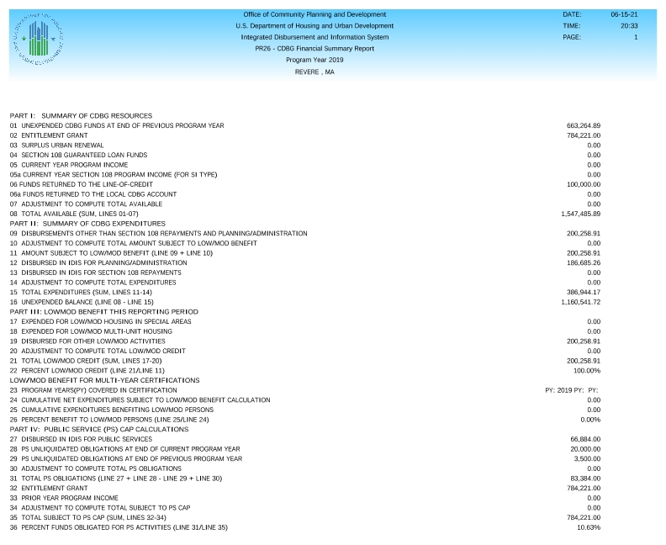

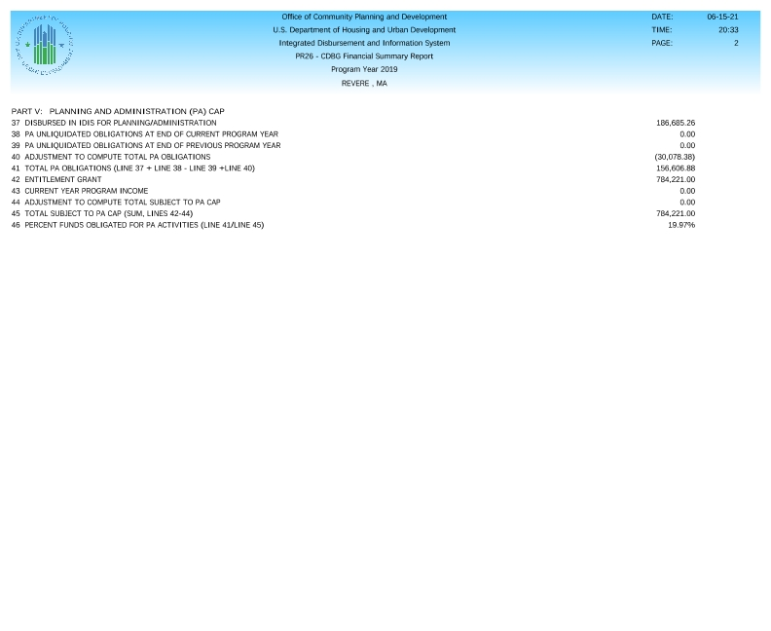

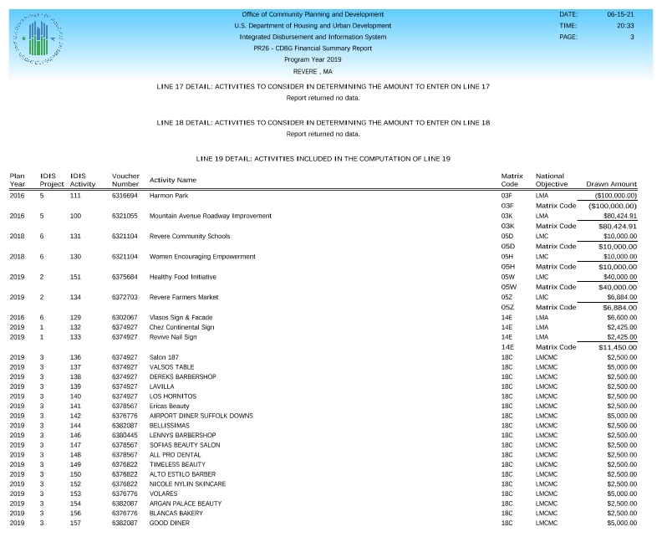

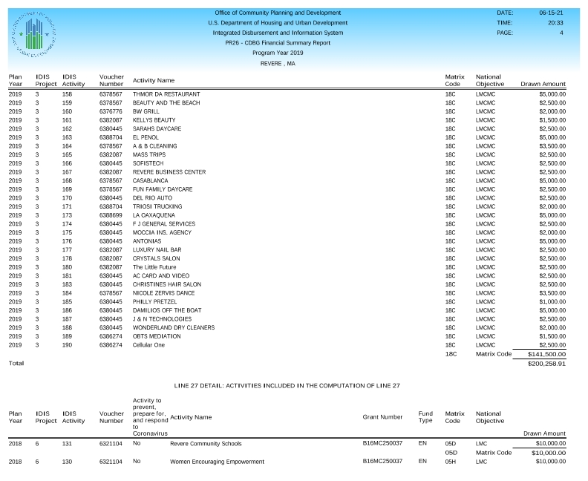

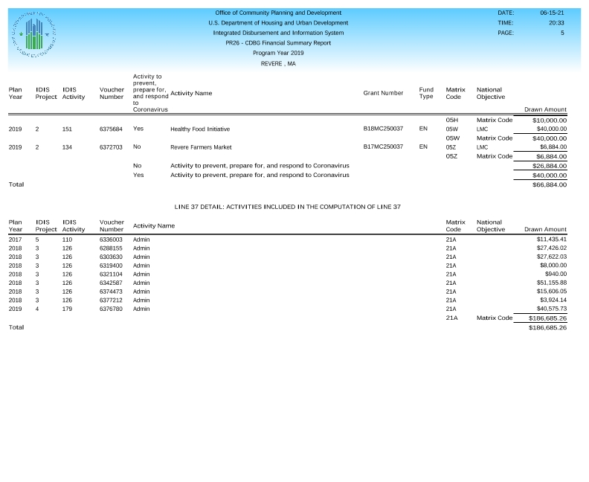

**CAPER Public Notice**

**2019 PR 26 Adjustments**

**CAPER Legal Notice**

