Executive Summary

ES-05 Executive Summary – 24 CFR 91.200(c), 91.220(b)
1. Introduction
Every five years, the U.S. Department of Housing and Urban Development (HUD) requires entitlement communities to develop a Consolidated Plan to assist in determining community needs and establishing affordable housing and community development priorities. This 2020-2024 Consolidated Plan serves as the strategic plan for allocating federal funds to maximize positive impact for low and moderate-income persons.
The City of Revere, as an entitlement community for Community Development Block Grant (CDBG) funds, has undertaken a community-wide dialogue in the development of this Consolidated Plan. The City, as a member of the North Suburban HOME Consortium, further assisted in the development of the Consortium’s Consolidated Plan, which identifies the regional Affordable Housing needs and priorities.
The Consolidated Plan consists of the following Sections:
2. Summary of the objectives and outcomes identified in the Plan Needs Assessment Overview
The primary objective of HUD’s Entitlement Programs is to develop viable communities through the provision of decent housing, a suitable living environment, and expanded economic opportunities. Four priority needs were identified with goals corresponding to those needs. The priority needs were determined by review of data, community meetings, public and stakeholder engagement, and NSC member consultations.
NSC Consortium Priority Needs:
Affordable Housing – There is a continuing need for the development of affordable owner-occupied and rental housing, rehabilitation of existing housing to ensure affordability and livability, and support to homebuyers. The escalating housing costs in the Greater Boston area have exacerbated an affordable housing crisis among low-and moderate-income households. The NSC communities have prioritized the creation and preservation of affordable housing, including development of affordable rental and owner-occupied housing, as a strategy to address escalating housing costs for low- and moderate-income households.
City of Revere Priority Needs:
Economic Development – There is a need to provide economic opportunities to low- and moderate-income residents through redevelopment or investment in commercial districts, supporting entrepreneurship, promoting a dynamic business climate, and preserving a strong employment base.
Public Facilities, Infrastructure and Parks – The City of Revere has identified a need to improve City parks, public facilities, and infrastructure to address accessibility, climate resiliency, and other needs disproportionately affecting low- and moderate-income residents. Investing in the improvement and/or reconstruction of City infrastructure, public facilities, parks and open spaces is essential to improving the quality of life for low- and moderate-income residents. The removal of architectural barriers permits expanded utilization of public spaces and facilities by persons with disabilities and/or mobility limitations. In addition, the City is committed to ensuring environmental resiliency, specifically through flood drainage improvements in low- and moderate-income neighborhoods.
Public Services – The City of Revere recognizes the diverse range of economic, housing and health challenges facing Revere’s low- to-moderate income residents and is therefore committed to investing in a variety of public service activities aimed at providing essential services and furthering goals of self-sufficiency. Crucial needs within the Revere community continue to include: transportation and recreational opportunities for the elderly, critically ill, and physically and developmentally disabled, affordable child care, access to food and emergency services, transitional housing, life-skill building, supportive services and advocacy, ESOL classes and job preparedness. Strong interagency coordination with the City’s network of service providers is vital to improving quality of life and shaping viable neighborhoods.
3. Evaluation of past performance
When assigning priority to local housing and community development needs, the City of Revere continues to rely on census and other publically available data as pertains to socio-economic conditions, population growth and population trends. It has also reviewed and consulted its own municipal data, reports and plans. For this Consolidated Plan, public input again was sought through public hearings in order to help establish priorities, with additional community needs and priorities identified during the City’s ongoing comprehensive planning process. The City further consulted with knowledgeable parties in both the public and private sectors as well as community-based agencies and organizations operating in the City to obtain further input.
In its selection of Public Service activities for PY 2020, in particular, the City of Revere prioritized the funding of applications that outlined clear goals and outcomes measurements reflecting service to both low and moderate income Revere residents and small businesses that have been economically impacted by COVID-19.
4. Summary of citizen participation process and consultation process
Public Input on Housing and Community Development Needs
The City of Revere and the North Suburban Consortium implemented broad-based approach to maximizing Stakeholder and citizen participation. These efforts included a stakeholder survey, consultation interviews and focus groups with key stakeholders and community organizations, and two periods of public comment. Further details regarding these consultation efforts are included in the Process section of this plan.
Public Hearing and Comment Period on Draft Plan.
The public hearing for both the five-year Consolidated Plan and 2020 Annual Action Plan took place on April 24, 2020 and was followed by a 30-day public comment period on the final draft plan. No comments were received.
5. Summary of public comments
No public comments were received.
6. Summary of comments or views not accepted and the reasons for not accepting them
No public comments were received, nor had any comments or views been rejected.
7. Summary
No additional summary is necessary.

The Process

PR-05 Lead & Responsible Agencies - 91.200(b)
1. Describe agency/entity responsible for preparing the Consolidated Plan and those responsible for administration of each grant program and funding source
The following are the agencies/entities responsible for preparing the Consolidated Plan and those responsible for administration of each grant program and funding source.
Agency Role | Name | Department/Agency

CDBG Administrator | REVERE | Department of Planning and Community Development
Table 1– Responsible Agencies

Narrative
The Department of Planning and Community Development is the agency charged with the administration of the federal CDBG funds. The Department prepares all plans and reports, provides financial oversight, and monitors program compliance.
The Department also is representing the City within the North Suburban Consortium, the administrating entity for federal HOME funds.
Consolidated Plan Public Contact Information
Tach Leng
City of Revere
281 Broadway
Revere, MA 02151
(781) 286-8137
tleng@revere.org

PR-10 Consultation - 91.100, 91.110, 91.200(b), 91.300(b), 91.215(l) and 91.315(l)
1. Introduction
The City of Revere through its Office of Strategic Planning and Economic Development undertook extensive consultations with relevant agencies, organizations, and community-based groups to obtain input on priority needs, recommended strategies, and investment opportunities. The consultations were conducted through a variety of methods including one-on-one interviews, stakeholder sessions, a web-based stakeholder survey, and meetings with a variety of community organizations.
Stakeholder Interviews: In June thru October 2019, a series of stakeholder meetings and interviews was conducted to discuss issues and opportunities related to housing and community development needs, as well as fair housing issues, throughout the City of Revere and the North Suburban Consortium. Individuals representing government and policy makers, nonprofit organizations, affordable housing providers, and other interested parties were invited to participate to ensure that as many points of view as possible were heard.
Stakeholder Web-based Survey: This survey sought input from housing and community development stakeholders for the purposes of identifying priority needs and providing feedback on the housing and community development conditions in Revere and the other NSC communities. A total of 34 survey responses were received, consisting of a range of organizations including: city agencies, regional housing agencies, housing providers, lenders, for-profit developers, social service providers and advocate groups, and citizen representatives. The participating agencies included social service providers that support low-income and near-homeless populations to maintain housing and secure available public and private resources. Agencies providing temporary and transitional housing to at-risk population like single mothers, victims of domestic abuse, elderly, people with disabilities and/or mental illnesses etc. were identified and reached out to for information through the survey as well as in-depth interviews.
Public Input Sessions: One public hearing for the North Suburban Consortium Consolidated Plan took place in February 2020 and a second public hearing for the City of Revere’s Draft Consolidated Plan and 2020 Annual Action Plan is scheduled for April 24, 2020. The first public input session was focused on the findings of the Needs Assessment, Market Analysis, and Strategic Plan. The objective of this session was to seek public input regarding the priority needs and goals set forth for the next five years. The purpose of the second public hearing is receiving and address comments regarding both the Consolidated Plan sections, including the 2020 Annual Action Plan. Public notice of each hearing and 30-day comment period was published on April 22, 2020 through the Revere Journal.
Provide a concise summary of the jurisdiction’s activities to enhance coordination between public and assisted housing providers and private and governmental health, mental health and service agencies (91.215(I)).
The Department of Planning and COmmunity Development, which is City Department responsible for the development of the Consolidated Plan, coordinates many of the planning, community development and housing initiatives within the City. The Department maintains continued collaboration with the relevant City Departments, Human Service Organizations, and homeless Continuum of Care members. The on-going collaboration enables the coordination of efforts and investments.
The City of Revere participates in the North Suburban Consortium, the HOME Program Consortium. As a member within the Consortium, the Community Development Department seeks to coordinate HOME investments to best address the needs and priorities of City of Revere.
Describe coordination with the Continuum of Care and efforts to address the needs of homeless persons (particularly chronically homeless individuals and families, families with children, veterans, and unaccompanied youth) and persons at risk of homelessness
The City of Revere as a member of the Balance of State CoC has adopted the goals within the Massachusetts Plan to End Homelessness. The City of Revere shares the State's goals of 1. increasing the number of permanently supportive housing units; 2. improve job readiness and achieve employments; 3. provide homeless prevention and rapid rehousing assistance; and 4. provide case management services to increase the likelihood of residential stability.
Describe consultation with the Continuum(s) of Care that serves the jurisdiction's area in determining how to allocate ESG funds, develop performance standards and evaluate outcomes, and develop funding, policies and procedures for the administration of HMIS
The City of Revere has been an active participant in the Balance of State Continuum of Care. The City of Revere has consulted with CoC and regularly consults with non-profits, housing authorities, state agencies, advocacy groups, and property developers.
2. Describe Agencies, groups, organizations and others who participated in the process and describe the jurisdictions consultations with housing, social service agencies and other entities

Table 2– Agencies, groups, organizations who participated
1 | Agency/Group/Organization | The Neighborhood Developers, Inc., fka CHELSEA NEIGHBORHOOD HOUSING SERVICES
 | Agency/Group/Organization Type | Housing  Services - Housing  Services-Employment  Civic Leaders
 | What section of the Plan was addressed by Consultation? | Housing Need Assessment  Market Analysis
 | How was the Agency/Group/Organization consulted and what are the anticipated outcomes of the consultation or areas for improved coordination? | The agency was consulted in a small group meeting. The agency spoke of the need to produce desirable affordable housing, the need to focus neighborhood redevelopment efforts, and the need to improve commercial corridors. The agency spoke of current efforts of concentrated neighborhood revitalization and the City' commitment to comprehensive redevelopment. Identified issues were that there was less housing and more parking created, and owners do not adequately split properties. The anticipated outcome is the cooperative identification of affordable housing development opportunities.
2 | Agency/Group/Organization | Balance of State Continuum of Care
 | Agency/Group/Organization Type | Housing  Services - Housing  Planning organization  Civic Leaders  Business and Civic Leaders
 | What section of the Plan was addressed by Consultation? | Housing Need Assessment  Market Analysis  Anti-poverty Strategy
 | How was the Agency/Group/Organization consulted and what are the anticipated outcomes of the consultation or areas for improved coordination? | The group was consulted in a small group meeting. The priority needs identified included: the need to produce and preserve affordable housing within this high demand market and the need to support through education and financial assistance homeownership of moderate-income households. The agency spoke of the coordination that exist within the NSC and their efforts to increase housing affordability for low and moderate-income persons. The anticipated outcome is efforts to increase affordable housing resources.
3 | Agency/Group/Organization | HOUSING FAMILIES INC.
 | Agency/Group/Organization Type | Housing  Services - Housing  Services-Children  Services-Persons with Disabilities  Services-Persons with HIV/AIDS  Services-Victims of Domestic Violence  Services-homeless  Service-Fair Housing
 | What section of the Plan was addressed by Consultation? | Housing Need Assessment  Public Housing Needs  Homelessness Strategy  Economic Development  Market Analysis  Anti-poverty Strategy
 | How was the Agency/Group/Organization consulted and what are the anticipated outcomes of the consultation or areas for improved coordination? | The organization was consulted in a small group meeting. The agency spoke of exploring efforts to establish a Community Preservation Act (CPA) to address the housing needs of Revere residents. The city would like to create an overall trust within the community through the CPA initiative. Anticipated outcomes are to work with community members and banks to create an Affordable Housing Trust Fund to support tenant organizing and tenant rights. This organization was also separately consulted by another NSC community.
4 | Agency/Group/Organization | Revere Elders Affairs
 | Agency/Group/Organization Type | Housing  Services-Elderly Persons  Services-Health  Service-Fair Housing  Publicly Funded Institution/System of Care
 | What section of the Plan was addressed by Consultation? | Housing Need Assessment  Market Analysis
 | How was the Agency/Group/Organization consulted and what are the anticipated outcomes of the consultation or areas for improved coordination? | The agency was consulted in a small group meeting. Issues identified included long waitlists and being unable to access housing needs where housing needs are provided. Many seniors have lost housing due to high rent and do not know of available support programs to support them in such instances. The anticipated outcome is the cooperative identification of affordable housing development opportunities targeted towards the elderly. This agency was also consulted through an in-person session held on September 18, 2019.
5 | Agency/Group/Organization | Community Action Programs Inter-City, Inc.
 | Agency/Group/Organization Type | Services - Housing  Services-Children  Services - Narrowing the Digital Divide  Publicly Funded Institution/System of Care
 | What section of the Plan was addressed by Consultation? | Housing Need Assessment  Public Housing Needs  Market Analysis
 | How was the Agency/Group/Organization consulted and what are the anticipated outcomes of the consultation or areas for improved coordination? | The agency was consulted in a small group meeting. The agency spoke of low-income senior individuals and families being priced out of the housing market, often losing their homes to the bank. The anticipated outcome is to continue working towards addressing community needs, providing support through paying back rents, first, last, and security deposits, and providing referrals with available resources.
6 | Agency/Group/Organization | Revere Housing Authority
 | Agency/Group/Organization Type | Housing  PHA  Services - Housing  Services - Narrowing the Digital Divide  Publicly Funded Institution/System of Care  Planning organization
 | What section of the Plan was addressed by Consultation? | Housing Need Assessment  Public Housing Needs  Economic Development  Market Analysis
 | How was the Agency/Group/Organization consulted and what are the anticipated outcomes of the consultation or areas for improved coordination? | The agency was consulted in a small group meeting. The agency spoke on the lack of availability for affordable housing units for working families. There is also a great need for 2- 3-bedroom housing units and the rising increase of those accommodations. The outcome is anticipated to be the PHAs involvement in future affordable housing projects.
7 | Agency/Group/Organization | North Suburban Consortium
 | Agency/Group/Organization Type | Housing  Services - Housing  Regional organization  Planning organization
 | What section of the Plan was addressed by Consultation? | Housing Need Assessment  Economic Development  Market Analysis
 | How was the Agency/Group/Organization consulted and what are the anticipated outcomes of the consultation or areas for improved coordination? | The agency was consulted in a small group meeting. The agency spoke on the community exploring different spaces and looking towards dense development to replace the inefficient use of land in the city. Anticipated outcomes are to work with community banks to create new programs and developments that would create more effective use of land while providing adequate housing for individuals and families.
8 | Agency/Group/Organization | D'Ambrosio Brown, LLC
 | Agency/Group/Organization Type | Business and Civic Leaders
 | What section of the Plan was addressed by Consultation? | Housing Need Assessment  Market Analysis
 | How was the Agency/Group/Organization consulted and what are the anticipated outcomes of the consultation or areas for improved coordination? | This business was consulted in a small group meeting on September 18, 2019.
9 | Agency/Group/Organization | Traggorth Companies LLC
 | Agency/Group/Organization Type | Housing  Planning organization
 | What section of the Plan was addressed by Consultation? | Housing Need Assessment  Market Analysis
 | How was the Agency/Group/Organization consulted and what are the anticipated outcomes of the consultation or areas for improved coordination? | This organization was consulted through an in-person session held on September 18, 2019.
10 | Agency/Group/Organization | TD Bank of Revere
 | Agency/Group/Organization Type | Business and Civic Leaders
 | What section of the Plan was addressed by Consultation? | Housing Need Assessment  Market Analysis
 | How was the Agency/Group/Organization consulted and what are the anticipated outcomes of the consultation or areas for improved coordination? | This organization was consulted through an in-person session held on September 18, 2019.
11 | Agency/Group/Organization | METROPOLITAN AREA PLANNING COUNCIL
 | Agency/Group/Organization Type | Services - Narrowing the Digital Divide  Regional organization  Planning organization
 | What section of the Plan was addressed by Consultation? | Housing Need Assessment  Economic Development  Market Analysis  Non-Housing Needs Assessment
 | How was the Agency/Group/Organization consulted and what are the anticipated outcomes of the consultation or areas for improved coordination? | This organization was consulted through an in-person session held on September 18, 2019. Anticipated outcomes and topics discussed include intiatives for sound management, sustainable land use, protection of natural resources, efficient and affordable transportation, a diverse housing stock, public safety, economic development, clean energy, and narrowing the digital divide among low- and moderate-income households throughout the City of Revere.
12 | Agency/Group/Organization | CITIZEN HOUSING AND PLANNING ASSOCIATION
 | Agency/Group/Organization Type | Services - Housing  Services-Children  Services-Health  Services - Narrowing the Digital Divide  Regional organization  Planning organization
 | What section of the Plan was addressed by Consultation? | Housing Need Assessment  Public Housing Needs  Market Analysis
 | How was the Agency/Group/Organization consulted and what are the anticipated outcomes of the consultation or areas for improved coordination? | This organization was consulted through an in-person session held on September 18, 2019.
13 | Agency/Group/Organization | Eastern Equity Partners, LLC
 | Agency/Group/Organization Type | Business and Civic Leaders
 | What section of the Plan was addressed by Consultation? | Housing Need Assessment  Market Analysis
 | How was the Agency/Group/Organization consulted and what are the anticipated outcomes of the consultation or areas for improved coordination? | This company was consulted through an in-person session held on September 18, 2019.
14 | Agency/Group/Organization | Joseph Festa Construction Company, LLC
 | Agency/Group/Organization Type | Business and Civic Leaders
 | What section of the Plan was addressed by Consultation? | Housing Need Assessment  Market Analysis
 | How was the Agency/Group/Organization consulted and what are the anticipated outcomes of the consultation or areas for improved coordination? | This company was consulted through an in-person session held on September 18, 2019.
15 | Agency/Group/Organization | Suffolk Downs
 | Agency/Group/Organization Type | Planning organization  Business and Civic Leaders
 | What section of the Plan was addressed by Consultation? | Housing Need Assessment  Market Analysis
 | How was the Agency/Group/Organization consulted and what are the anticipated outcomes of the consultation or areas for improved coordination? | This agency was consulted through an in-person session held on September 18, 2019.
16 | Agency/Group/Organization | REVERE
 | Agency/Group/Organization Type | Agency - Managing Flood Prone Areas  Agency - Management of Public Land or Water Resources  Agency - Emergency Management  Publicly Funded Institution/System of Care  Other government - Local  Planning organization
 | What section of the Plan was addressed by Consultation? | Housing Need Assessment  Economic Development  Market Analysis  Non-Housing Needs Assessment
 | How was the Agency/Group/Organization consulted and what are the anticipated outcomes of the consultation or areas for improved coordination? | The City of Revere's Mayors Office was consulted through an in-person session held on September 18, 2019. The Mayor's Office oversees all municipal services delivered throughout Revere, including the HUD programs administered by the Office of Strategic Planning and Economic Development. Topics discussed included emergency management and its mitigation plans in events of natural hazards and services to low-and moderate-income populations, as well as economic development and housing needs in Revere.
17 | Agency/Group/Organization | Revere Department of Public Works
 | Agency/Group/Organization Type | Agency - Managing Flood Prone Areas  Agency - Management of Public Land or Water Resources  Other government - Local
 | What section of the Plan was addressed by Consultation? | Market Analysis  Non-Housing Needs Assessment
 | How was the Agency/Group/Organization consulted and what are the anticipated outcomes of the consultation or areas for improved coordination? | The Revere Department of Public Works was consulted through a focus groups session held with City departments on September 18, 2019. Topics discussed and anticipated outcomes include improvements to City infrastructure, water, and sewer.
18 | Agency/Group/Organization | Revere Conservation Commission
 | Agency/Group/Organization Type | Agency - Managing Flood Prone Areas  Agency - Management of Public Land or Water Resources  Other government - Local
 | What section of the Plan was addressed by Consultation? | Market Analysis  Non-Housing Needs Assessment
 | How was the Agency/Group/Organization consulted and what are the anticipated outcomes of the consultation or areas for improved coordination? | The Revere Conservation Commission was consulted during a City agency focus group session on September 18, 2019. Topics and anticipated outcomes discussed include the protection of wetlands, public and private water supply, groundwater, flood control, erosion control, storm damage prevention, and water pollution.
19 | Agency/Group/Organization | Mystic River Watershed Association
 | Agency/Group/Organization Type | Agency - Managing Flood Prone Areas  Agency - Management of Public Land or Water Resources  Regional organization  Planning organization
 | What section of the Plan was addressed by Consultation? | Market Analysis  Non-Housing Needs Assessment
 | How was the Agency/Group/Organization consulted and what are the anticipated outcomes of the consultation or areas for improved coordination? | The Mystic River Watershed Association was consulted by the Town of Arlington, on behalf of the NSC Consortium, as part of a community stakeholder session. The agency focuses on the whole Mystic River watershed and specifically on greenways and building resiliency. Anticipated outcomes include supporting appropriate resiliency projects within the watershed.
20 | Agency/Group/Organization | Comcast
 | Agency/Group/Organization Type | Services - Broadband Internet Service Providers  Services - Narrowing the Digital Divide
 | What section of the Plan was addressed by Consultation? | Market Analysis
 | How was the Agency/Group/Organization consulted and what are the anticipated outcomes of the consultation or areas for improved coordination? | Comcast was consulted on July 20, 2020 by the City of Medford on behal of the NSC Consortium. Comcast's Internet Essentials program provides affordable home internet for income-eligible households, so there can be greater access to homework, job opportunities, healthcare and benefits, and education resources. Once a customer of Internet Essentials, there is the option to purchase a laptop or desktop computer at a discounted price. Internet Essentials has connected more than 8 million customers with high-speed Internet at home since 2011.

Identify any Agency Types not consulted and provide rationale for not consulting
The Revere Office of Strategic Planning & Economic Development and the NSC Consortium made a good faith effort to reach out to all appropriate agency types, as specified through the City’s Citizen Participation Plan and 24 CFR Part 91.100. The only organization type that was not covered through direct consultation was Service - Broadband Internet Service Provider. The Town of Arlington made efforts to reach out to RCN on behalf of Arlington and Revere, while the City of Malden made multiple efforts to identify contacts for consultation with Xfinity and Verizon on behalf of Malden, Medford, and the other non-entitlement consortium members. No response to requests for consultation was received by either broadband service provider. However, the NSC Consultation Questions documents used by each community as a guide through stakeholder consultations included questions specific to challenges with broadband access and availability, as well as narrowing the digital divide. These questions were discussed with housing agencies and community organizations.
UPDATE: In July 20, 2020 the City of Medford made contact with a Comcast representative from the Internet Essentials program. More detail regarding this outreach and the Internet Essentials program is provided in the description box for Comcast in the Organizations Consulted table.

Other local/regional/state/federal planning efforts considered when preparing the Plan
Name of Plan | Lead Organization | How do the goals of your Strategic Plan overlap with the goals of each plan?
Continuum of Care | Massachusetts Department of Housing and Community Development | Increase affordable housing opportunities for low and very low-income households; increase supportive services for special needs households.
Table 3– Other local / regional / federal planning efforts

Describe cooperation and coordination with other public entities, including the State and any adjacent units of general local government, in the implementation of the Consolidated Plan (91.215(l))
During the Consolidated Planning process, the City of Revere sought input and guidance from all the major housing, health, mental health and service agencies. Many of the key stakeholders operate on a regional basis and therefore their input demonstrates the cooperation and coordination that exist. As members of the Balance of State Continuum of Care and of the regional North Suburban HOME Consortium, the City of Revere plans and implements key housing and homeless initiatives on a regional basis.
The City of Revere coordinated the development of the Consolidated Plan through its participation in two regional efforts: public hearings and a web-based survey. The implementation of Consolidated Plan's strategies will be coordinated with regional efforts while responding to the identified needs of Revere's low- and moderate-income persons.
The City of Revere has proactively engaged residents and key stakeholders in the development of this Consolidated Plan. Stakeholder sessions, consultations with key organizations, and well-publicized public hearings complemented the City’s regular, on-going interactions with key agencies and the business community. Over the years, the City has developed excellent working relationship with housing agencies, private developers, human service providers, agencies and private business operators.
As part of the North Suburban HOME Consortium, the City of Revere collaborates on regional housing needs and priorities.
Narrative
No additional narrative.

PR-15 Citizen Participation - 91.105, 91.115, 91.200(c) and 91.300(c)
1. Summary of citizen participation process/Efforts made to broaden citizen participation
Summarize citizen participation process and how it impacted goal-setting

The City of Revere reviewed its existing Citizen Participation Plan and compared its efforts to the best practices identified by HUD. Many of its past practices were consistent with the HUD recommendations. These successful efforts included broadly advertised hearings held at convenient locations during evening hours, utilization of relevant community-focused plans, and an ongoing dialogue with key stakeholder organizations. The City expanded upon these past practices to include a web-based resident survey conducted in coordination with all members of the North Suburban HOME Consortium.
The citizen participation process enabled the City to establish Consolidated Planning goals that capitalized on existing networks, identified opportunities to leverage existing investments, and to focus the investment of public resources on the highest priority needs.
As part of the North Suburban HOME Consortium, the City of Revere supported outreach efforts of the Malden Redevelopment Authority to obtain input on regional housing market assessment and housing needs.
Input from this extensive participation process was utilized to establish the funding priorities for CDBG.

Citizen Participation Outreach
Sort Order | Mode of Outreach | Target of Outreach | Summary of  response/attendance | Summary of  comments received | Summary of comments not accepted and reasons | URL (If applicable)
1 | Public Meeting | Non-targeted/broad community | Public Hearing is scheduled to take place on April 24, 2020. | No comments received. | None.
2 | Public Meeting | North Suburban Consortium | Public Meeting held by the Malden Redevelopment Authority in February 2020 for purposes of the North Suburban Consortium (NSC) Consolidated Plan. The public meeting was advertised in Revere and attended by some of Revere's residents and interested parties. | No comments specific to Revere were received. | None.
3 | Newspaper Ad | Non-targeted/broad community | The Public Notice for the Consolidated Plan and virtual public hearing was published on April 22, 2020, through the Revere Journal. A copy of the notice is provided as an attachment on AD-25 Administration screen. | No written comments were received. | None.
Table 4– Citizen Participation Outreach

Needs Assessment

NA-05 Overview
Needs Assessment Overview
The Needs Assessment examines needs related to affordable housing, special needs housing, community development, and homelessness. Furthermore, it identifies those needs with the highest priorities which form the basis for the Strategic Plan section and the programs and projects to be administered. Specific detail and data regarding the City of Revere’s housing needs is available in the North Suburban Consortium’s 2020-2024 Consolidated Plan.
The City of Revere, with nearly 13% of its 20,230 households living in poverty, is a community with significant needs, many of which require coordinated, place-based responses. The City, through its Department of Planning and Community Development, is committed to the identification and implementation of housing and community development strategies that provide the greatest impact given funding restrictions. Like most of the North Suburban Consortium communities, the City of Revere is experiencing an affordable housing crisis. According to ACS data, 46% of the City’s households experience a housing cost burden; this equates to 9,365 low- and moderate-income households. Of this amount, 4,735 households are considered severely cost-burdened, where more than 50% of monthly income is spent on housing costs. This housing cost burden disproportionally affects extremely low-income renters.
The CDBG program operates under federally-established income limits. Revere is the direct recipient of CDBG funds. These limits are based on median family income for the Boston-Cambridge-Quincy Metropolitan Statistical Area (MSA), currently defined as Essex, Middlesex, Norfolk, Plymouth, Suffolk, and Rockingham counties, and are adjusted annually.
Generally, very low-income refers to incomes at or below 30% of AMI; low-income refers to incomes between 31 and 50% of AMI; moderate-income refers to incomes between 51 and 80% of AMI; all adjusted for family size. The CDBG program targets low- and moderate-income beneficiaries.
The City of Revere and the NSC communities are all part of the Boston-Cambridge-Quincy, MA-NH HUD Metro FMR Area. Based on HUD’s FY 2019 Income Limit Summary for this area, the Median Family Income (MFI) is $113,300. The following table provides the current income limits subject to annual adjustments by HUD.
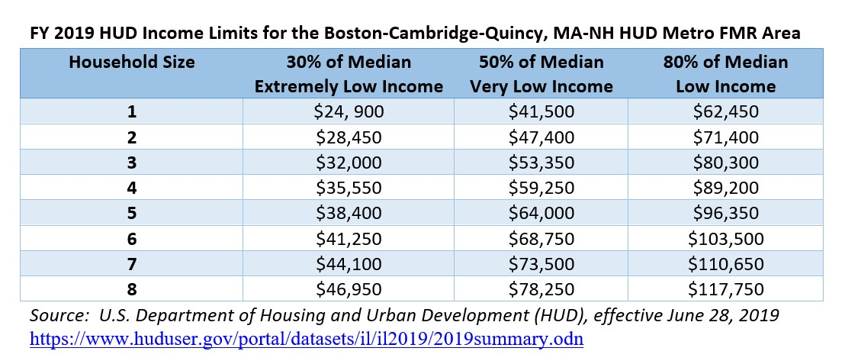
FY 2019 HUD Income Limits for the Boston-Cambridge-Quincy, MA-NH HUD Metro FMR Area

NA-50 Non-Housing Community Development Needs - 91.415, 91.215 (f)
Describe the jurisdiction’s need for Public Facilities:
Non-housing community development covers a broad range of needs, including public facilities, infrastructure and transportation, human services, and neighborhood services. The City of Revere recognizes the importance of public facilities, community facilities, and recreational facilities. These needs are primarily addressed by a broad range of funding sources, supplemented with targeted HUD funding. Existing local and regional plans helped identify needs and were complemented by resident surveys and stakeholder focus groups.
How were these needs determined?
These needs were determined through surveys, public meetings, stakeholder focus groups and through existing policy and plans.

Describe the jurisdiction’s need for Public Improvements:
The City of Revere needs for public improvements include, but are not limited to, the following areas noted by participants in focus groups and surveys:
- Revere Historic Museum
- Open space
- Streets and sidewalks
- Wetland preservation (Rumney and Belle Isle Marshes)
- Improve transportation, walkability, complete streets
- Indoor recreational facilities, skate parks, ADA accessibility
- Arts and culture along beachfront
- Place making initiatives
- Community gardens
- Northern Strand Community Trail improvements (bike to the sea)
- Tree plantings
- Commercial kitchen (incubator programs to businesses)

How were these needs determined?
These needs were determined through surveys, public meetings, stakeholder focus groups, and existing policy and plans.

Describe the jurisdiction’s need for Public Services:
The City of Revere has a high concentration of low- and very low-income residents that face several significant challenges related to health, vocational training, housing, nutrition, and educational attainment. Through an assessment of data related to educational attainment, employment, and community health outcomes, the City has identified a high demand for public services such as housing, emergency services, job training, domestic violence, after school programming, youth programs, access to healthy food, small business assistance.
How were these needs determined?
<p align="left" class="BulletArrows">These needs were determined through surveys, public meetings, stakeholder focus groups and through existing policy and plans. The City is currently in the process of developing its Master Plan, which is anticipated to be made available for public comment January 2020.</p>

Based on the needs analysis above, describe the State's needs in Colonias

Housing Market Analysis

MA-05 Overview
Housing Market Analysis Overview:
Consistent with HUD's objectives, the City of Revere has prioritized the expansion of economic opportunity, the availability of safe, decent, affordable housing, and creation of suitable living environments. An analysis of the existing market and community data supports the City’s investment in preserving and producing affordable housing, improving the condition of existing housing stock, retaining and expanding its employment base, and investing in public facilities, parks, and infrastructure.
The housing market data clearly demonstrates the lack of enough safe, affordable housing stock. An analysis of median contract rents shows a substantial increase in rents from 2009-2017. The median rent increased by more than 20%, reaching a high median rent of $1,173. Even though the City has seen a 4% decrease in median home value between 2009-2017, there is still a significant lack of affordable housing and the median value of $332,100 (ACS 2013-2017) makes homeownership unachievable for low- and moderate-income households. The data supports a recurring theme, which is that many people who grew up in Revere can no longer afford to live in Revere.
More data and information regarding Revere’s Housing Market Analysis is available in the North Suburban HOME Consortium’s Consolidated Plan.
North Suburban Consortium MA-05 Overview
The North Suburban Consortium housing market has been and is expected to continue to be significantly influenced by the Greater Boston Metro market, of which it is a part. The NSC communities have become and continue to be highly desirable areas to reside, in large part due to their proximity to the region’s economic centers and accessible public transit choices, which include bus, subway, and commuter rail services provided by the Massachusetts Bay Transportation Authority (MBTA). The region’s population growth has driven unmet demand for housing in the urban core, raising housing costs in those communities closest to the economic center. Worsening traffic and longer commute times, coupled with the recent expansion of the Silver Line to Chelsea and the Green Line Extension project currently underway in Medford, have increased the demand for housing approximate to Boston’s job centers. This demand has resulted in the conversion of long-standing affordable multi-family units into market-rate condominiums, the conversion of small two- and three-family stock into high-end homes, and the conversion of non-residential properties into market-rate residential units. Naturally occurring affordable housing, or those homes that are rented or sold at an affordable rate without government subsidy or regulation, is rapidly becoming market rate.
With single-family residences making up nearly 37% of the housing stock, the NSC had prioritized affordable homeownership as an appropriate strategy in the last 5-year Consolidated Plan. However, the increased house prices just in the past two years have made this strategy infeasible because most houses are unaffordable for low-and moderate-income buyers.
Supporting the development of multifamily housing with five or more units would create opportunities for deeply affordable housing as well as housing for specific subpopulations. These properties, which comprise 25% of the housing stock, are developed more efficiently by experienced developers who can secure the required public resources required to make these properties sustainable. The availability of Low Income Housing Tax Credits (LIHTC) often makes multifamily rental development the most efficient and effective use of HOME resources.

MA-45 Non-Housing Community Development Assets - 91.410, 91.210(f)
Introduction
Like much of the Metro-North region, the City of Revere labor force has benefited from the national economic recovery and Boston’s economic growth. With a civilian labor force of 30,340, Revere has a relatively low unemployment rate of 5.96% for adults over the age of 25 (ACS 2011-2015).
Average commute time is perhaps the best indicator of Boston’s impact on Revere’s employment statistics. 55% of Revere’s employed residents travel more than 30 minutes to work, suggesting residents are commuting into Metro-Boston. While Metro-Boston provides employment opportunities, Revere recognizes the importance of local economic growth on tax revenue and the City’s financial stability.
Local economic growth has been identified as a priority need throughout the Consolidated Plan process. The City, through its Department of Planning and Community Development, seeks an environment that is “conducive to growing and attracting business in order to strengthen and revitalize the City’s neighborhoods and communities and to stabilize and transform our physical, social, and economic development.” CDBG funds are a critical resource that can support business growth through direct financial assistance, commercial property improvements, and infrastructure upgrades.
The City, along with all NSC member communities are being served by the Metro-North Regional Employment Board (REB). The REB is a “public-private partnership whose mission is to enable area residents to gain the skills to maximize their economic sufficiency and provide employers with the workforce they need to effectively compete in the changing world economy”. The REB charters two career centers, both operated by Middlesex Community College. Initiatives of the REB are supported by local programs that aim to bolster English language skills, family stability, education, and employment readiness.
Economic Development Market Analysis
Business Activity
Business by Sector | Number of Workers | Number of Jobs | Share of Workers  % | Share of Jobs  % | Jobs less workers  %
Agriculture, Mining, Oil & Gas Extraction | 19 | 0 | 0 | 0 | 0
Arts, Entertainment, Accommodations | 3,648 | 0 | 17 | 0 | -17
Construction | 888 | 0 | 4 | 0 | -4
Education and Health Care Services | 5,217 | 0 | 25 | 0 | -25
Finance, Insurance, and Real Estate | 1,659 | 0 | 8 | 0 | -8
Information | 503 | 0 | 2 | 0 | -2
Manufacturing | 1,093 | 0 | 5 | 0 | -5
Other Services | 1,037 | 0 | 5 | 0 | -5
Professional, Scientific, Management Services | 2,243 | 0 | 11 | 0 | -11
Public Administration | 0 | 0 | 0 | 0 | 0
Retail Trade | 2,816 | 0 | 13 | 0 | -13
Transportation and Warehousing | 1,123 | 0 | 5 | 0 | -5
Wholesale Trade | 821 | 0 | 4 | 0 | -4
Total | 21,067 | 0 | -- | -- | --
Table 11 - Business Activity
Data Source: | 2011-2015 ACS (Workers), 2015 Longitudinal Employer-Household Dynamics (Jobs)

Labor Force
Total Population in the Civilian Labor Force | 30,340
Civilian Employed Population 16 years and over | 27,670
Unemployment Rate | 8.73
Unemployment Rate for Ages 16-24 | 40.00
Unemployment Rate for Ages 25-65 | 5.96
Table 12 - Labor Force
Data Source: | 2011-2015 ACS

Occupations by Sector | Number of People
Management, business and financial | 4,675
Farming, fisheries and forestry occupations | 1,690
Service | 3,900
Sales and office | 6,990
Construction, extraction, maintenance and repair | 2,560
Production, transportation and material moving | 1,850
Table 13 – Occupations by Sector
Data Source: | 2011-2015 ACS

Travel Time
Travel Time | Number | Percentage
< 30 Minutes | 11,940 | 45%
30-59 Minutes | 11,130 | 42%
60 or More Minutes | 3,425 | 13%
Total | 26,495 | 100%
Table 14 - Travel Time
Data Source: | 2011-2015 ACS

Education:
Educational Attainment by Employment Status (Population 16 and Older)
Educational Attainment | In Labor Force
 | Civilian Employed | Unemployed | Not in Labor Force
Less than high school graduate | 3,080 | 190 | 1,555
High school graduate (includes equivalency) | 8,805 | 655 | 2,325
Some college or Associate's degree | 6,540 | 490 | 1,300
Bachelor's degree or higher | 5,515 | 565 | 755
Table 15 - Educational Attainment by Employment Status
Data Source: | 2011-2015 ACS

Educational Attainment by Age
 | Age
 | 18–24 yrs | 25–34 yrs | 35–44 yrs | 45–65 yrs | 65+ yrs
Less than 9th grade | 80 | 880 | 455 | 1,380 | 1,330
9th to 12th grade, no diploma | 510 | 315 | 775 | 1,020 | 820
High school graduate, GED, or alternative | 1,255 | 2,890 | 2,800 | 6,095 | 3,330
Some college, no degree | 1,545 | 2,090 | 1,855 | 2,480 | 775
Associate's degree | 155 | 420 | 430 | 1,055 | 355
Bachelor's degree | 365 | 2,090 | 1,150 | 1,510 | 475
Graduate or professional degree | 130 | 940 | 425 | 740 | 305
Table 16 - Educational Attainment by Age
Data Source: | 2011-2015 ACS

Educational Attainment – Median Earnings in the Past 12 Months
Educational Attainment | Median Earnings in the Past 12 Months
Less than high school graduate | 27,410
High school graduate (includes equivalency) | 29,776
Some college or Associate's degree | 36,464
Bachelor's degree | 43,093
Graduate or professional degree | 66,875
Table 17 – Median Earnings in the Past 12 Months
Data Source: | 2011-2015 ACS

Based on the Business Activity table above, what are the major employment sectors within your jurisdiction?
According to the ACS data, the two highest percentages of jobs exist within the following sectors: Education and Health Care Services (22%) and Arts, Entertainment, Accommodations (16%). The major occupation by sector is overwhelmingly Management (business and financial) followed by Sales and Office.
The Massachusetts Office of Labor and Workforce Development tabulates employment and wage statistics for Workforce Investment Areas. The Metro-North WIA includes the NSC as well as other regions of Metro-North Boston. The largest occupation is Professional and Technical Services, followed by Management, Sales, and Healthcare.
In terms of projected growth for the Metro-North WIA by 2024, the Office of Labor and Workforce Development projects that the health care and social assistance industry will add nearly 10,283 jobs and the industry category of professional, scientific and technical services will add 4,284 jobs. The accommodation and food services industry are projected to add 1,927 jobs, while educational services are projected to add 1,375 jobs by 2024.
Metro-North Regional Employment Board FY2017-2020 strategic plan is available at: https://masshiremetronorth.org/regionaldata/#_localplan/
Describe the workforce and infrastructure needs of the business community:
The manufacturing industry has identified a critical need for new workers to replace older, highly-skilled workers who are about to retire. The Advanced Manufacturing sector presents numerous career pathway opportunities for the region’s residents to enter a growing sector. The industry offers a variety of positions that either requires a high school diploma or equivalent, associate degree, or bachelor’s degree.
The healthcare industry has the second highest employment in the Metro-North, under the Professional, Technical, and Scientific industry, with 57,739 workers employed in the region. When compared to the state, the location quotient for healthcare (the Healthcare and Social Assistance Industry Sector) in the Metro-North region is .77 (13.8% of Metro-North’s employment). Private hospitals, physician offices, nursing care facilities, and home healthcare services have the highest number of jobs in the Metro-North region within the healthcare industry. Home Health Care Services added the highest number of jobs from 2013 to 2015. The sheer volume of employment in the healthcare sector virtually demands a REB focus on the healthcare industry. Further, the growing number of retirees in the healthcare workforce in combination with the growth in the aging population in need of healthcare services also presents future workforce areas to address.
Overall, the Industrial Technology (IT) sector has seen major growth nationally and regionally and will continue to do so. Employers within the region have expressed the challenges they have faces in recruiting IT professionals for positions domestically and therefore have had to apply for H1B visas in order to fill local positions. In Metro-North, employment for IT occupations is projected to increase 21% from 2012 to 20122. Most of the growth was in the sectors of software and IT services. Domestic training in the IT sector would be beneficial in reducing the number of H1B visas needed while simultaneously filling in the growing number of IT positions within the region.
Metro-North Regional Employment Board FY2017-2020 Strategic Plan is available at: https://masshiremetronorth.org/regionaldata/#strategic
Describe any major changes that may have an economic impact, such as planned local or regional public or private sector investments or initiatives that have affected or may affect job and business growth opportunities during the planning period. Describe any needs for workforce development, business support or infrastructure these changes may create.
The growth of the Boston metropolitan area will continue to put pressure on the housing market, placing additional upward pressure on prices, and making it harder and harder for low-wage workers.
In June 2019, the Encore Boston Harbor resort and casino opened in Everett, MA, at a total cost of $2.6 billion. The resort is in a commercial industrial area on the Mystic River, about five miles from downtown Boston. Its development rehabilitated a 33-acre parcel of land previously used for industrial purposes. After a remediation process to clean the site, Wynn Resorts constructed an integrated resort with a hotel, a harbor walk, restaurants, a casino, spa, retail outlets, and meeting and convention space. Public amenities of the year-round harbor walk include a picnic park, paths for bikers and pedestrians, viewing decks, waterfront dining and retail, a performance lawn, floral displays, and boat docks. The operations of the casino require significant employment training and support. With proper job readiness and job training, currently, unemployed workers may be able to take advantage of the casino and resort-related jobs. This is just the second casino resort located in Massachusetts and offers a large range of new employment opportunities that were not previously offered in the region.
The growth of e-commerce nationally and in the region has led to increased demand in Revere for logistics and transportation services, including at an Amazon distribution center slated for opening in 2020.
How do the skills and education of the current workforce correspond to employment opportunities in the jurisdiction?
The ability of the NSC workforce to access and take advantage of job opportunities in today’s economy varies significantly.
Technological changes are at the forefront. In the midst of the demise of retail and manufacturing, companies are looking for a different “type” of a worker. Companies may increase their use of robotics, but now they need manufacturing workers who are skilled in computers and electronics. A generation ago, manual machines were the predominant driver most business; however, today, even in retail, a straight cashier is no longer enough. There is a need for a generalized customer service worker who can talk to customers and solve problems. According to the Metro-North Workforce Development Board, the 2% of people who are unemployed and have the biggest barriers are those that were affected by automation and technology because the skill set required that is now required in those industries is different now than what it was a generation ago.
Describe any current workforce training initiatives, including those supported by Workforce Investment Boards, community colleges and other organizations. Describe how these efforts will support the jurisdiction's Consolidated Plan.
The Metro-North region has the second-largest labor force in Massachusetts. The labor force has a full spectrum of workers, from professionals to persons on public assistance. The diversity of the workforce requires a broad menu of available services including workshops, individualized assistance, job search, training, and placements. For dislocated workers, low-income adults, and underemployed persons, career training is provided after an assessment of skills and interest. In many cases, occupational skills training, short-term skills development, and intensive job placement assistance is required. The Metro-North Regional Employment Board charters two career centers, both operated by Middlesex Community College, to serve the 20-community Metro-North region. The REB focuses on a continual alignment of curricula with employer needs. The alignment has led to the focus on the four emerging areas listed below (HealthCare, Advanced Manufacturing, Life Sciences, and Information Technology). Initiatives include:
The SCILS Initiative is a 4-year $5 million project led by the Boston Office of Jobs and Community Services (JCS) on behalf of the Metro Boston region. Funded in April 2012 by an H1B Technical Skills Training grant that will improve career opportunities for residents and provide a more highly trained life science workforce for our healthcare and biotechnology sectors. The Initiative will target occupations such as Biological Technicians and Medical Lab Technicians and support occupational training, contextualized learning, customized training, program development and the recruitment, case management and placement of eligible participants.
CONNECT Program - a consortium of service providers in the Chelsea area, USDOL awarded a three-year $3M Workforce Innovation Fund grant to the REB. The CONNECT Partnership represents an innovative strategy focused on co-location and bundling of complementary services for residents (especially Chelsea, Revere, and Everett) in order to increase the impact of services in addressing multiple obstacles to family self-sufficiency. CONNECT is a partnership of six organizations that includes: Bunker Hill Community College; Career Source (a Metro-North career center); The Neighborhood Developers (a community development corporation that provides affordable housing and, financial stability, and other services); Metro Credit Union; Centro Latino (an adult basic education/ESOL provider); and Metropolitan Boston Housing Partnership (a homeless prevention and housing services organization).
Healthcare Partnership: The Healthcare Career Ladders tool was designed to raise awareness of healthcare career options among youth in in-school and out-of-school programs, as well as job seekers and training seekers served through the Metro-North Career Centers and area training providers The tool displays the different occupations in the healthcare field, their corresponding wages, and the steps along a career ladder for each occupation.
Additionally, the Metro-North REB is a collaborative partner within the Mass Casino Career Training Institute (MCCTI). Founded within Massachusetts Casino legislation, the MCCTI will provide training and placement services within the newly developed Everett Casino. Anticipated skills include casino operations, customer service, culinary arts, and hotel operations.
In early 2020, the City completed a comprehensive workforce development plan outlining key workforce priorities including investment in local training facilities, public-private partnerships, educational and career pathways for residents, and reducing upstream barriers to economic mobility among residents. This plan was completed in February 2021 in partnership with the Metropolitan Area Planning Council.

Does your jurisdiction participate in a Comprehensive Economic Development Strategy (CEDS)?
Yes
If so, what economic development initiatives are you undertaking that may be coordinated with the Consolidated Plan? If not, describe other local/regional plans or initiatives that impact economic growth.
The City of Revere participated in the Metropolitan Area Planning Council's 2020-2025 Comprehensive Economic Development Strategy (CEDS), and also contributes as members of the Advisory Committe. The full plan is available at: https://www.mapc.org/wp-content/uploads/2021/02/Final-CEDS-022521.pdf
The Comprehensive Economic Development Strategy for the MAPC region for the next five years is built on the following goals:
Goal 1: Residents of the region achieve financial stability in order to withstand three to six months of economic hardship.
- Provide effective workforce development supports and address barriers to quality employment for BIPOC through public-private collaboration and private sector leadership.
- Increase protection against predatory lending and expand access to financial services and education through partnerships with financial institutions and partners in the financial technology sector.
- Provide publicly funded income enhancements for those earning less than a living wage and support reduction in household expenses.
Goal 2: There is increased parity between the wealth of BIPOS and White people in the region.
- Expand access to stable housing for BIPOC.
- Build the resiliency and stability of businesses owned by BIPOC.
- Strengthen community-driven economic systems.
- Explore and advance tax reform to address systemic inequity.
Goal 3: Everyone in the region is able to access jobs, goods, and services close to their homes via affordable transportation options, with shorter commutes and fewer transfers.
- Enable the production of affordable housing near employment centers and transit nodes.
- Expand digital access to enable remote work and learning.
- Provide access to affordable, safe, and accessible transportation options.
The City of Revere will address the CEDS goals through Strategic Goals 2) Support the Expansion of Affordable Housing and 3) Increase Economic Development Opportunities. More information on these goals is provided in the Strategic Plan section of this Consolidated Plan.
Discussion
No further discussion needed.

MA-50 Needs and Market Analysis Discussion
Are there areas where households with multiple housing problems are concentrated? (include a definition of "concentration")
Housing problems for Extremely Low, Low Income, and Moderate-Income households exist throughout the City of Revere.
As nearly 50% of the City’s low- and moderate-income households experience housing problems, for the purposes of this evaluation, concentrations are defined as more than 50%.
Are there any areas in the jurisdiction where racial or ethnic minorities or low-income families are concentrated? (include a definition of "concentration")
The concentration is defined as poverty rates or minority concentrations in excess of 20%.
In the southern-end of Revere, there is a large concentration of Hispanic households that exceeds 20%:
- Census Tract 25025170100 is made up of 31% households with persons of Hispanic origin. The number of households living in poverty is 10.03% and 52.48% is cost-burdened.
- Census Tract 25025170601 is made up of 32.16% households with persons of Hispanic origin. The number of households living in poverty is 12.97% and 40.40% is cost burdened.
- Census Tract 25025170702 is made up of 38.73% households with persons of Hispanic origin. The number of households living in poverty is 27.15% and 51.99% is cost burdened.
- Census Tract 25025170701 is made up of 32.92% households with persons of Hispanic origin. The number of households living in poverty is 26.70% and 46.09% is cost burdened.
- Census Tract 25025170800 is made up of 31.75% households with persons of Hispanic origin. The amount of household living in poverty is 10.77% and 47.74% is cost burdened.
What are the characteristics of the market in these areas/neighborhoods?
With higher numbers of low- and moderate-income and minority households, these older, more dense neighborhoods have traditionally been underserved. They tend to have a range of challenges including housing overcrowding, need for public safety services, less access to parks and open space, and aged public infrastructure.
Are there any community assets in these areas/neighborhoods?
The City has continued to invest in improving these neighborhoods both with the use of federal CDBG and HOME funds as well as City Government fund. Street and sidewalk improvements have been and continue to be a priority. The City has been successful in attracting non-federal resources to improve the quality of life and economic opportunities for residents of these neighborhoods.
Are there other strategic opportunities in any of these areas?
Tracts 701.02 and 1705.01 in the City are Federally Designated Opportunity Zones. In addition to these zones, there are three significant development opportunities in the areas of concentration. These opportunities include:
- Broadway Central Business District Revitalization: Revere’s downtown core will be redeveloped with concentrated and well-planned infrastructure improvements that support small business, help create jobs, and facilitate the development of new housing units with ready access to public transportation, services, and urban amenities.
- Shirley Avenue Neighborhood: The Transformative Development Initiative, through MassDevelopment, has enabled the City of Revere and its local collaborative partners, to leverage equity investments to revitalize this area of concentrated poverty.
- 525 Beach Street: The Neighborhood Developer’s invested $10,000,000 into the construction of 30 units of affordable housing on Beach Street during the last Consolidated Plan cycle.

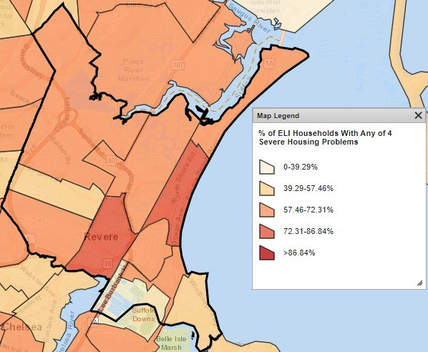
ELI Households with Any of the 4 Severe Housing Problems
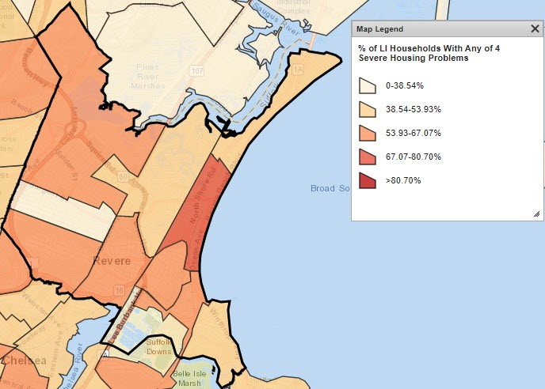
LI Households with Any of the 4 Severe Housing Problems
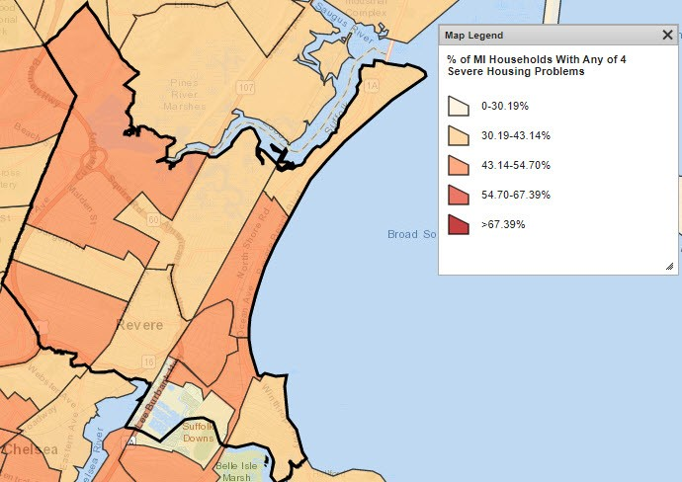
MI Households with Any of the 4 Severe Housing Problems
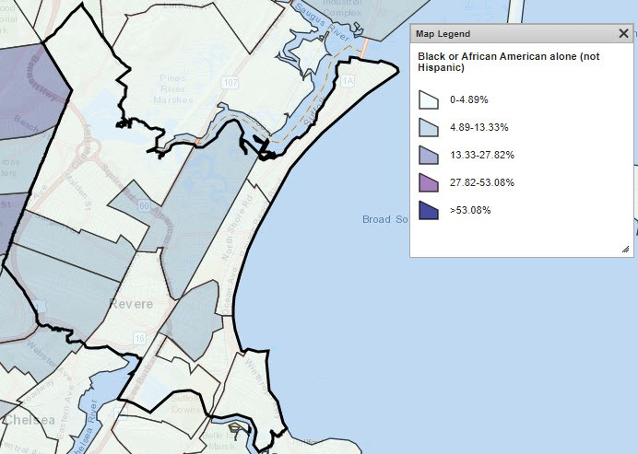
Black/African American Alone
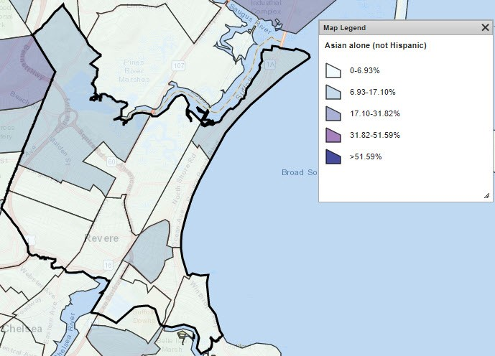
Asian Alone
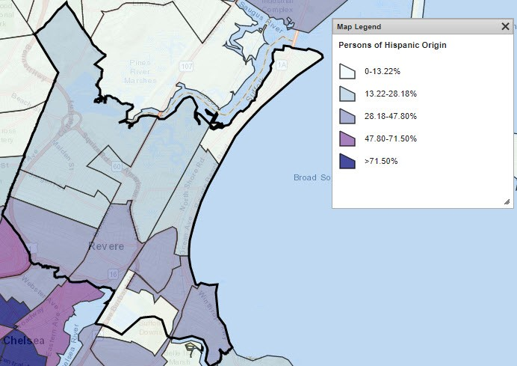
Hispanic (Any Race)

MA-60 Broadband Needs of Housing occupied by Low- and Moderate-Income Households - 91.210(a)(4), 91.310(a)(2)
Describe the need for broadband wiring and connections for households, including low- and moderate-income households and neighborhoods.
Per HUD guidance, all Consolidated Plans submitted after January 1, 2018, must address broadband needs within the jurisdiction. Below is a map outlining the Consortium’s access to providers offering broadband services. The speeds identified are 25Mbps download and 3Mbps upload – the minimum speeds to be considered broadband.
The City of Revere is also actively participating in a Digital Equity Planning process with the Metropolitan Area Planning Council. This process is scheduled to launch in early 2021 and expected to be completed sometime that summer.
Describe the need for increased competition by having more than one broadband Internet service provider serve the jurisdiction.
The Consortium compares well above the national average. Lack of broadband provider competition leaves room for market rigidity – allowing providers to not offer affordable options for low- or moderate-income families. Ultimately, the lack of market options when considering broadband access disproportionately impacts low- and moderate-income households because they often have few financial resources to spend on broadband services. However, the Consortium has relatively high broadband coverage with multiple providers. For those households that do struggle with broadband access, all libraries within the Consortium offer free internet access.
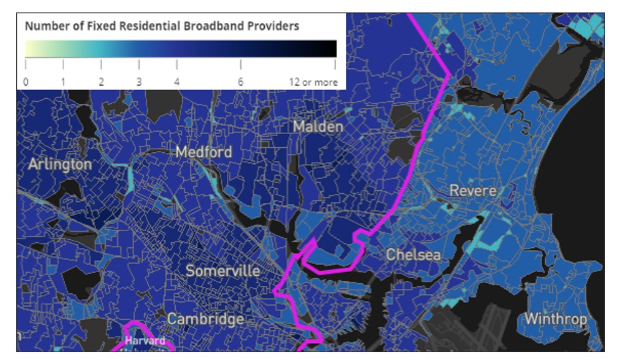
Number of Fixed Residential Broadband Providers
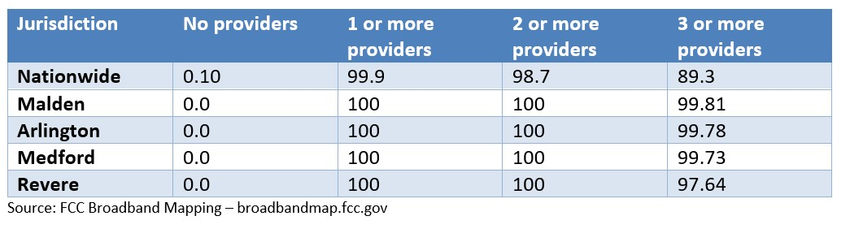
Number of Broadband Providers by Jurisdiction

MA-65 Hazard Mitigation - 91.210(a)(5), 91.310(a)(3)
Describe the jurisdiction’s increased natural hazard risks associated with climate change.
It is the goal of all NSC communities to increase energy efficiency and build resiliency for all low- and moderate-income households. To identify natural hazard risks and other challenges impacting low- and moderate-income residents, the NSC consulted with key stakeholders in resiliency, energy efficiency, environmental planning, and public health.
The most common natural hazard among residents in the region is inland and coastal flooding. Areas most at-risk are Environmental Justice (EJ) or vulnerable communities that had not been previously invested in; consist of predominantly renter-occupied households; and are surrounded by poor infrastructure.
Describe the vulnerability to these risks of housing occupied by low- and moderate-income households based on an analysis of data, findings, and methods.

Strategic Plan

SP-05 Overview
Strategic Plan Overview
The Strategic Plan outlines each jurisdiction’s plan for allocating HUD entitlement grants and identifies local priorities within the regional context. Informed by qualitative and quantitative data gathered through citizen participation and consultation with stakeholders throughout the region, market analysis, and an assessment of U.S. Census and other local data that reflect community needs, the strategic plan identifies the highest priority needs toward which to direct grant dollars. The following goals were identified to meet these high-priority needs (in no particular order or ranking):
Goal 1: Improve the Condition of Existing Housing - Improvements to existing housing conditions including the rehabilitation and preservation of owner- and renter-occupied housing to bring units to code standard or provide safety improvements, energy efficiency improvements, access modifications, or treatment of lead or other home hazards.
Goal 2: Support the Expansion of Affordable Housing - Support the expansion and supply of safe, affordable homeownership and rental housing opportunities. The redevelopment of existing housing will address expanding the supply of affordable housing, improve the quality of an aged housing stock, and cure blighting neighborhood influences.
Goal 3: Increase Economic Development Opportunities - Enhance economic stability and prosperity by increasing economic opportunities for residents through job readiness and skill training, promotion of entrepreneurship (including among culturally diverse populations), and other strategies.
Goal 4: Enhance Parks, Public Facilities, and Infrastructure - Enhance publicly-owned facilities and infrastructure that improves the community and neighborhoods throughout the City of Revere. Improvements may include parks, streets, sidewalks, streetscapes, water/sewer/flood drainage, Historic Preservation and cultural resources, accessibility to meet American with Disabilities Act (ADA), reconstruction of community/recreational facilities, and other infrastructure and facilities.
Goal 5: Enhance Public Services – Provide essential services that improve the quality of life and opportunities to low- and moderate-income persons by Increasing access to jobs, education, health and wellness, recreation, and health and social services activities.

SP-10 Geographic Priorities - 91.415, 91.215(a)(1)
Geographic Area
Table 18 - Geographic Priority Areas

General Allocation Priorities
Describe the basis for allocating investments geographically within the state
The Community Development Block Grant (CDBG) program is intended to predominantly serve the needs of areas and individuals that are low- to moderate-income as defined by HUD. The City of Revere does not have any designated or targeted geographic priority areas; however, investments will be allocated for CDBG-eligible Census tract/block groups.

SP-25 Priority Needs - 91.415, 91.215(a)(2)
Priority Needs
Table 19 – Priority Needs Summary
1 | Priority Need Name | Affordable Housing
 | Priority Level | High
 | Population | Extremely Low  Low  Moderate  Large Families  Families with Children  Elderly  Chronic Homelessness  Individuals  Mentally Ill  Chronic Substance Abuse  veterans  Persons with HIV/AIDS  Victims of Domestic Violence
 | Geographic Areas Affected
 | Associated Goals | Improve the Condition of Existing Housing  Support the Expansion of Affordable Housing  Enhance Public Services
 | Description | Rehabilitation of quality affordable owner-occupied and rental housing.
 | Basis for Relative Priority | The escalating housing costs in the Greater Boston Area has created an affordability crisis among low- and moderate-income households. Revere and the NSC has prioritized the improving the existing affordable rental and homeownership stock as a strategy to address escalating housing costs. The detailed analysis of housing stock, conditions, market trends, and affordability supports this prioritization.
2 | Priority Need Name | Economic Development
 | Priority Level | High
 | Population | Extremely Low  Low  Moderate  Large Families  Families with Children  Chronic Homelessness  Individuals
 | Geographic Areas Affected
 | Associated Goals | Increase Economic Development Opportunities
 | Description | Redevelopment or investment in commercial districts, supporting entrepreneurship, promoting a dynamic business climate, and preserving a strong employment base.
 | Basis for Relative Priority | This priority need was determined through extensive stakeholder consultation and through existing policies and plans. Specifically related to future economic development initiatives, local financial institutions were consulted with to understand the needs of their low- to moderate-income clientele.
3 | Priority Need Name | Public Facilities, Infrastructure, & Parks
 | Priority Level | High
 | Population | Extremely Low  Low  Moderate  Large Families  Families with Children  Elderly  Chronic Homelessness  Chronic Substance Abuse  veterans  Persons with Mental Disabilities  Persons with Physical Disabilities  Persons with Developmental Disabilities  Persons with HIV/AIDS and their Families  Non-housing Community Development
 | Geographic Areas Affected
 | Associated Goals | Enhance Parks, Public Facilities, & Infrastructure
 | Description | Investing in the improvement and/or reconstruction of City infrastructure, public facilities, parks and open spaces is essential to improving the quality of life for low- and moderate-income residents. The removal of architectural barriers permits expanded utilization of public spaces and facilities by persons with disabilities and/or mobility limitations. In addition, the City is committed to ensuring environmental resiliency, specifically through flood drainage improvements in low- and moderate-income neighborhoods.
 | Basis for Relative Priority | Needs were identified through a collaborative process that involves the ongoing evaluation of Revere’s public facilities and infrastructure, consistent coordination and engagement with City departments and assessment of existing policy and plans.
4 | Priority Need Name | Public Services
 | Priority Level | High
 | Population | Extremely Low  Low  Large Families  Families with Children  Elderly  Public Housing Residents  Chronic Homelessness  Individuals  Mentally Ill  veterans  Persons with HIV/AIDS  Victims of Domestic Violence  Elderly  Frail Elderly  Persons with Mental Disabilities  Persons with Physical Disabilities  Persons with Developmental Disabilities  Persons with Alcohol or Other Addictions  Persons with HIV/AIDS and their Families  Victims of Domestic Violence
 | Geographic Areas Affected
 | Associated Goals | Enhance Public Services
 | Description | Recognizing the diverse range of economic, housing and health challenges facing Revere’s low-to-moderate income residents, the City is committed to investing in a variety of public service activities aimed at providing essential services and furthering goals of self-sufficiency. Crucial needs within the Revere community continue to include: housing, emergency services, job training, domestic violence, after school programming, youth programs, access to healthy food, and small business assistance.
 | Basis for Relative Priority | Revere’s needs for public services are based on an ongoing evaluation of programmatic needs among low- and moderate-income residents and initiatives designed to expand economic opportunities and improve quality of life. Throughout the program year and Consolidated Planning process, the City has engaged residents, public services providers, experts and officials to identify the diverse human service needs of the community. Consultations with public service agencies offer crucial insight into the needs of low- and moderate-income households and necessitate the continued support of programs providing essential services to Revere’s most vulnerable residents. The City places a high priority on supporting a range of programming, particularly those assisting children, elderly and developmentally and physically disabled persons.

Narrative (Optional)
The City of Revere conducted an extensive needs assessment and consultation process that identifies many priority needs across the jurisdiction. Virtually all housing and community development needs were identified as important; however, pending available resources throughout the course of the next five years, the City may not be able to fund activities to address all priority needs. In some cases, a priority need may not be funded because it is addressed through other community resources.
The Priority Needs Summary Table assigns a “high” or “low” priority to each need, as prescribed by HUD. Generally, designating a need as “high priority” means that the jurisdiction plans to allocate funding to address it during the five-year consolidated plan period. A low priority need indicates that, while the need is a recognized priority, there may be insufficient funds to address it with Federal community development resources. To the extent community partners are able to assume these activities through other funding sources, the Plan would support them. Changes in the availability of resources may allow certain low priority needs to be funded, or, conversely, for high priority needs not to be funded. As conditions and resources available vary by jurisdiction, so does the level of priority attached to each need. A high or low priority designation is assigned to each priority need for each jurisdiction.

SP-35 Anticipated Resources - 91.420(b), 91.215(a)(4), 91.220(c)(1,2)
Introduction
The City of Revere anticipates receipt of CDBG funds in the amount of approximately $812,106 annually. To maximize the impact of CDBG funds, the City expends significant general government funds and encourages all partners and projects to strategically leverage additional funds.
As a member of the North Suburban Consortium, the City has available HOME Investment Partnership program funds to support direct assistance to moderate-income homebuyers and to subsidize the development cost of affordable housing projects
Through the Coronavirus Aid, Relief, and Economic Security Act (CARES Act), which enacted to respond to the growing effects of this historic public health crisis, the City of Revere will receive an additional $477,809 in CDBG-CV allocations for Program Year 2020. The purpose of the special allocations is to assist the City in preventing, preparing for, and responding to the coronavirus (COVID-19).
The City does not anticipate any Program Income in 2020, nor does it intend to reallocate any prior-year funds to 2020 projects and activities.
Anticipated Resources
Program | Source of Funds | Uses of Funds | Expected Amount Available Year 1 |  |  |  | Expected Amount Available Remainder of ConPlan  $ | Narrative Description
 |  |  | Annual Allocation: $ | Program Income: $ | Prior Year Resources: $ | Total:  $
CDBG | public - federal | Acquisition  Admin and Planning  Economic Development  Housing  Public Improvements  Public Services | 812,106 | 0 | 0 | 812,106 | 3,248,424 | Block grant from U.S. Department of Housing and Urban Development to address housing, community development and economic development needs.
Table 20 - Anticipated Resources

Explain how federal funds will leverage those additional resources (private, state and local funds), including a description of how matching requirements will be satisfied
The City anticipates CDBG funds will leverage additional public and private resources. Sources of leveraged funds may include state funds for street and sidewalk improvements; Low-income Housing Tax Credits, State Housing Bond funds, and private mortgage funds for housing programs; and federal, state, and local funds in support of human service programs.
The HOME program matching requirements are met through State Housing Bond funds and the Mass Rental Voucher program. Matching funds requirements are monitored by the Malden Redevelopment Authority as the NSC Lead Entity.
If appropriate, describe publically owned land or property located within the state that may be used to address the needs identified in the plan
No additional publicly owned land is anticipated to be used to address needs. City parks and public facilities will continue to be operated to provide recreation and services to low- and moderate-income persons.
Discussion
The priorities identified within the Strategic Plan are the outcome of an extensive, comprehensive effort to identify community needs. The Strategic Plan assesses the available resources available to meet those needs. The City of Revere’s investments will leverage public and private funds to address the economic development, affordable housing, community development, and special needs populations’ needs.
The City of Revere has a rough estimate of $848,997 in prior year resources available to be committed to activities throughout the course of this strategic planning period (PY2020 - PY2024). Roughly a third ($282,999) of these funds will be included with the PY2021 Action Plan, and the rest will be allocated in the subsequent years for the purposes of ongoing public open space improvements and workforce development and small business incubator. These activities will support the following Strategic Goals: 3) Increase Economic Development Opportunities and 4) Enhance Parks, Public Facilities and Infrastructure.

SP-40 Institutional Delivery Structure - 91.415, 91.215(k)
Explain the institutional structure through which the jurisdiction will carry out its consolidated plan including private industry, non-profit organizations, and public institutions.
Responsible Entity | Responsible Entity Type | Role | Geographic Area Served
City of Revere Department of Planning and Community Development | Government | Economic Development  Non-homeless special needs  Ownership  Rental  neighborhood improvements  public facilities  public services | Jurisdiction
Revere Housing Authority | PHA | Public Housing | Jurisdiction
Table 21 - Institutional Delivery Structure
Assess of Strengths and Gaps in the Institutional Delivery System
The institutional structure of the Department of Planning and Community Development (DPCD) has been developed over years of successful operation. Through clearly defined roles and responsibilities within a collaborative working environment, the City of Revere has a delivery system capable of undertaking projects, programs, and services to meet the priority needs of low- and moderate-income residents.
The DPCD directly provides programs in the areas of housing rehabilitation and lead hazard abatement. The DPCD, with additional technical expertise from relevant city departments and qualified professionals, oversees the Public Improvement projects. If additional funding were to be available, DPCD would expand its staffing to allow for additional long-range strategic planning and project coordination.
Availability of services targeted to homeless persons and persons with HIV and mainstream services
Homelessness Prevention Services | Available in the Community | Targeted to Homeless | Targeted to People with HIV
Homelessness Prevention Services
Counseling/Advocacy | X | X | X
Legal Assistance | X | X
Mortgage Assistance | X | X
Rental Assistance |  | X
Utilities Assistance | X | X

Street Outreach Services
Law Enforcement | X | X
Mobile Clinics
Other Street Outreach Services

Supportive Services
Alcohol & Drug Abuse | X | X | X
Child Care | X | X
Education | X | X
Employment and Employment Training | X | X
Healthcare | X | X | X
HIV/AIDS | X | X | X
Life Skills | X | X
Mental Health Counseling | X | X | X
Transportation | X

Other
Table 22 - Homeless Prevention Services Summary
Describe how the service delivery system including, but not limited to, the services listed above meet the needs of homeless persons (particularly chronically homeless individuals and families, families with children, veterans and their families, and unaccompanied youth)
The City of Revere is not a direct recipient of public or private resources with which to address homelessness or to prevent homelessness. Revere is an active member of the “Balance of State” Continuum of Care (CoC), which is overseen by the Commonwealth of Massachusetts. Revere supports the goals of the CoC and the efforts of regional non-profits and service providers to ensure the adequacy of services for eligible persons and families.
The City of Revere is not a direct recipient of public or private resources of which to address the needs of HIV families.
Despite the lack of direct funding to support these vulnerable households, mainstream services are provided through a network of regional providers. Services are available to homeless individuals, at-risk households, veterans, and persons with HIV.
Describe the strengths and gaps of the service delivery system for special needs population and persons experiencing homelessness, including, but not limited to, the services listed above
The City of Revere is an active member of the Commonwealth’s “Balance of State” Continuum of Care, which coordinates an effective service delivery system for persons experiencing homelessness. The CoC has identified removal of barriers to workforce participation as a leading cause of homelessness. The City of Revere funds several workforce readiness- education and soft employment skills programs- consistent with the CoC’s priorities.
The City of Revere is not a direct recipient of public funds dedicated to homeless or any special needs population but has consistently funded public service programs that serve homeless and special needs persons. Within its funding decisions, the City selected programs that are coordinated with regional programs.
Provide a summary of the strategy for overcoming gaps in the institutional structure and service delivery system for carrying out a strategy to address priority needs
The Institutional Structure and Service Delivery System would benefit from better coordination by the Commonwealth of Massachusetts in relation to the placement of homeless families in hotels/motels. The State’s current methodology of a State-wide placement system has created undue burden on communities like Revere that have hotels/motels under State contract. The State’s practice places high demands on municipal services and service providers as well as creating additional challenges for families experiencing homelessness.

SP-45 Goals - 91.415, 91.215(a)(4)
Goals Summary Information
Sort Order | Goal Name | Start Year | End Year | Category | Geographic Area | Needs Addressed | Funding | Goal Outcome Indicator
1 | Improve the Condition of Existing Housing | 2020 | 2024 | Affordable Housing |  | Affordable Housing | CDBG: $600,000 | Rental units rehabilitated:  18 Household Housing Unit  Homeowner Housing Rehabilitated:  10 Household Housing Unit
2 | Support the Expansion of Affordable Housing | 2020 | 2024 | Affordable Housing |  | Affordable Housing | CDBG: $160,000 | Direct Financial Assistance to Homebuyers:  5 Households Assisted
3 | Increase Economic Development Opportunities | 2020 | 2024 | Non-Housing Community Development |  | Economic Development | CDBG: $700,000 | Facade treatment/business building rehabilitation:  30 Business  Businesses assisted:  35 Businesses Assisted
4 | Enhance Parks, Public Facilities, & Infrastructure | 2020 | 2024 | Non-Housing Community Development |  | Public Facilities, Infrastructure, & Parks | CDBG: $951,876 | Public Facility or Infrastructure Activities other than Low/Moderate Income Housing Benefit:  27500 Persons Assisted
5 | Enhance Public Services | 2020 | 2024 | Affordable Housing  Homeless  Non-Homeless Special Needs  Non-Housing Community Development |  | Affordable Housing  Public Services | CDBG: $687,356 | Public Facility or Infrastructure Activities other than Low/Moderate Income Housing Benefit:  1500 Persons Assisted  Public service activities for Low/Moderate Income Housing Benefit:  10 Households Assisted  Homeless Person Overnight Shelter:  24 Persons Assisted
Table 23 – Goals Summary

Goal Descriptions

1 | Goal Name | Improve the Condition of Existing Housing
 | Goal Description | The age of Revere’s Housing stock, along with data on the number of low- and moderate-income households who live in sub-standard conditions indicates the need for an active housing rehabilitation program. Improvements to existing housing conditions including the rehabilitation and preservation of owner- and renter-occupied housing to bring units to code standard or provide safety improvements, energy efficiency improvements, access modifications, or treatment of lead or other home hazards.
2 | Goal Name | Support the Expansion of Affordable Housing
 | Goal Description | Support the expansion and supply of safe, affordable homeownership and rental housing opportunities. The redevelopment of existing housing will address expanding the supply of affordable housing, improve the quality of an aged housing stock, and cure blighting neighborhood influences.
3 | Goal Name | Increase Economic Development Opportunities
 | Goal Description | Enhance economic stability and prosperity by increasing economic opportunities for residents through job readiness and skill training, promotion of entrepreneurship (including among culturally diverse populations), small business grants, microenterprise loans and revitalizing the major commercial corridors. Programs will include efforts to increase the physical environment through storefront improvements, streetscape improvements, and improved accessibility, in addition to providing direct assistance to eligible businesses.
4 | Goal Name | Enhance Parks, Public Facilities, & Infrastructure
 | Goal Description | Enhance publicly-owned facilities and infrastructure that improves the community and neighborhoods throughout the City of Revere. Improvements may include parks, streets, sidewalks, streetscapes, water/sewer/flood drainage, accessibility improvements for persons with disabilities, improvement of neighborhood/recreational facilities, and other infrastructure and facilities.
5 | Goal Name | Enhance Public Services
 | Goal Description | Increase access to jobs, education, health and wellness, recreation, and health and social services activities. This will include an array of human service programs to support the service needs of low-income households including special needs populations.
Estimate the number of extremely low-income, low-income, and moderate-income families to whom the jurisdiction will provide affordable housing as defined by HOME 91.315(b)(2)
The City of Revere will operate a housing rehabilitation program that assists existing owner-occupied homeowners to improve their properties. CDBG rehabilitation funds will be utilized to address the rehabilitation needs of an estimated number of 10 owner-occupied units and an estimated number of 18 affordable rental units. An estimated number of 10 extremely low-income/low income units will be provided affordable housing.
The City of Revere is a participating member of the North Suburban HOME Consortium (NSC), in which HOME-funds are administered by the City of Malden. The NSC estimates over 100 families/households will benefit from HOME funded housing programs over the course of the next five years. HOME-funded activities will include new construction of rental housing, leased to persons at/below 60% AMI and/or dedicated to formerly homeless households; down payment assistance/buy down subsidy programs targeted to low-income households (at or below 80% AMI); and the rehabilitation of rental and homeowner housing.

SP-65 Lead-based Paint Hazards - 91.415, 91.215(i)
Actions to address LBP hazards and increase access to housing without LBP hazards
Hazards created by lead-based paint are addressed through enforcement of the Lead Paint Notification Laws, the promotion of the MassHousing “Get The Lead Out” Program, which provides Lead Remediation financing to eligible property owners, and the integration of lead remediation in the housing rehabilitation programs and affordable housing development programs.
Public Awareness and Education is the keystone of an effective public health policy. The Commonwealth’s Childhood Lead Paint Prevention Program (CLPP) provides a wealth of information on the hazards, safe treatment, and legal responsibilities related to Lead-based Paint Hazards. The CLPP additionally tracks childhood blood testing rates and incidence of poisoning. The commitment to raise public awareness led to the passage of Massachusetts’ Lead Law that requires property owners to remove or cover all lead paint hazards in homes built before 1978 if a child under 6 resides in the home.
How are the actions listed above integrated into housing policies and procedures?
The City of Revere has fully integrated Lead Hazard education and remediation into housing policies and programs. The City requires compliance with Mass Lead Notification Laws to be documented within all project files. Affordable rental projects are required to be free of lead-based paint hazards prior to occupancy; first-time homebuyers are required to sign the Commonwealth’s Transfer of Property Notification in the case of purchasing of existing properties; and, any new construction or substantial rehabilitation will be fully led compliant.
The City of Revere also promotes the availability of favorable financing to remove lead hazard risks. Referrals to “Get the Lead Out” program and Revere’s home rehabilitation program are regularly made by Community Development staff.
Additionally, CDBG and HOME program requirements require the following:
- The Property Owner is required to provide required notice to all occupants
- The home is to be inspected by a trained professional
- Assess if the project is low, moderate, or high-risk de-leading
- Have work performed by appropriate party
- Monitor de-leading to insure compliance with federal and state laws
- Obtain project clearance

SP-70 Anti-Poverty Strategy - 91.415, 91.215(j)
Jurisdiction Goals, Programs and Policies for reducing the number of Poverty-Level Families
The City of Revere continues its active engagement in a network of regional and local organizations, operating programs, and initiatives intended to help reduce the number of persons living in poverty. According to the 2013-2017 ACS, 13% of Revere residents live in poverty. To reduce this number, the City will continue its focus on the following Anti-poverty initiatives:
- Support for Economic Development initiatives that result in employment opportunities for low- and moderate-income residents
- Provision of training, technical assistance, and resources to support emerging and existing small business owners
- Provision of job readiness and job training programs for low-income residents
- Removal of barriers to education and employment
- Provision f services that support self-sufficiency
Economic Development: Revere’s Anti-poverty strategy is predicated upon the expansion of economic opportunities for all its residents. The City works to expand local economic opportunities through commercial property improvement programs, streetscapes and façade programs in Broadway Central Business district and along commercial corridors, and small business assistance programs. Additionally, proposed economic development opportunities at larger mixed-use Transit Oriented Development (TOD) are likely to benefit low income residents.
Employment Opportunities: The City of Revere is intently focused on living -wage, long term employment as the most effective poverty fighting tool. Revere’s unemployment rate as of December 2019 is 3.4%, which is a 2.2 point drop from 5.6% unemployment rate in January 2015. While Revere employment statistics benefit from the economics of Metro-Boston, the creation of jobs conveniently located near low-income neighborhoods is key to further reducing this number.
Job Training: workforce development job training programs available to Revere residents include:
- Metro North Regional Employment Board (MNEB) – Career Center in Everett with its educational partner Bunker Hill Community College; North Shore Community College is the educational partner of the North Shore Workforce Investment Board.
- Revere CARES/MGH Center for Community Health Improvement – Affiliated with “Building Futures” a youth employment initiative of Career Source, a Massachusetts One Stop Center; it is charted by the Metro North Regional Employment Board and operated by Employment Resources, Inc.
- Community Action Program Inter-City, Inc. (CAPIC) – Offers employment training programs in collaboration with the Agency’s workforce/training subcontractor American Training, Inc./LARE. CAPIC works with Project Hope and the Green Hobs Academy to train and place clients in the following paths: Administrative assistant, accounting support, office computer skills, bio-medical, hospitality, culinary arts, automotive repair technician, CDL license, financial services, medical office, building maintenance, and certified nursing assistant.
Barriers to Employment: Basic Education/High School Degree, English Language skills, transportation, and affordable childcare have all been identified as barriers to employment. The City’s goal is to address these barriers through the provision of services for low-income residents; making necessary support services both available and accessible to residents.
Support Services: The integration of supportive social services is essential to remove barriers that face residents who are seeking employment.
How are the Jurisdiction poverty reducing goals, programs, and policies coordinated with this affordable housing plan
Most activities undertaken by the City with CDBG and other federal and state funds for low income families are efforts to reduce the number of persons in poverty and improve the quality of life for Revere residents, either directly or indirectly. Staff also work in partnership with citizens, other City departments and the public and private sectors to accomplish the City’s goal of reducing poverty.
CDBG programs can be used and can indirectly influence the impact on household living by those at or below the poverty level by reducing other costs, including affordable housing, energy efficiency, public transportation and health care assistance.
The City’s Anti-Poverty strategy is coordinated with this Consolidated Plan as follows:
Economic Development Initiatives: The Plan prioritizes the need for economic development and proposes funding for commercial redevelopment within Central Business District
Provision of Training to Small Business: The Consolidated Plan identifies support for small business development as a priority.
Provision of Job Readiness and Job Training Programs: The Consolidated Plan prioritizes job readiness and training programs and proposes funding for such programs.
Removal of Barriers to Education and Employment and Support Services: The Consolidated Plan prioritizes after-school programs and English language programs. The City has proposed funding for both programs.

SP-80 Monitoring - 91.230
Describe the standards and procedures that the jurisdiction will use to monitor activities carried out in furtherance of the plan and will use to ensure long-term compliance with requirements of the programs involved, including minority business outreach and the comprehensive planning requirements
The Department of Planning and Community Development is responsible for managing the expenditure of funds covered in the Consolidated Plan and works closely with the HUD Field Office representative to address any compliance issues, improve the timeliness of expenditures, hire and train staff to better fulfill objectives and monitor the performance of sub-recipients.
Monitoring functions performed, include:
- Inclusion of program requirements within funding agreements
- Review of reimbursement requests through desk audits, and if appropriate, field observations
- Review of grant recipient’s program reports for eligibility of beneficiaries and of activities
- Provision of technical assistance upon request or as determined by desk reviews
The monitoring process is regularly evaluated to ensure effectiveness and improve efficiencies. Where applicable, all contracts for construction are monitored for Section 3 compliance, MBE and WBE goals and compliance with the Davis-Bacon Act and the Massachusetts and Federal Prevailing Wage Laws. All contractors participating in CDBG funded projects will continue to be required to fulfill all required regulations.
HOME program requirements are monitored by the Malden Redevelopment Authority as administrator of the HOME program.

Expected Resources

AP-15 Expected Resources - 91.420(b), 91.220(c)(1,2)
Introduction
The City of Revere anticipates receipt of CDBG funds in the amount of approximately $812,106 annually. To maximize the impact of CDBG funds, the City expends significant general government funds and encourages all partners and projects to strategically leverage additional funds.
As a member of the North Suburban Consortium, the City has available HOME Investment Partnership program funds to support direct assistance to moderate-income homebuyers and to subsidize the development cost of affordable housing projects
Through the Coronavirus Aid, Relief, and Economic Security Act (CARES Act), which enacted to respond to the growing effects of this historic public health crisis, the City of Revere will receive an additional $477,809 in CDBG-CV allocations for Program Year 2020. The purpose of the special allocations is to assist the City in preventing, preparing for, and responding to the coronavirus (COVID-19).
The City does not anticipate any Program Income in 2020, nor does it intend to reallocate any prior-year funds to 2020 projects and activities.
Anticipated Resources
Program | Source of Funds | Uses of Funds | Expected Amount Available Year 1 |  |  |  | Expected Amount Available Remainder of ConPlan  $ | Narrative Description
 |  |  | Annual Allocation: $ | Program Income: $ | Prior Year Resources: $ | Total:  $
CDBG | public - federal | Acquisition  Admin and Planning  Economic Development  Housing  Public Improvements  Public Services | 812,106 | 0 | 0 | 812,106 | 3,248,424 | Block grant from U.S. Department of Housing and Urban Development to address housing, community development and economic development needs.
Table 24 - Expected Resources – Priority Table

Explain how federal funds will leverage those additional resources (private, state and local funds), including a description of how matching requirements will be satisfied
The City anticipates CDBG funds will leverage additional public and private resources. Sources of leveraged funds may include state funds for street and sidewalk improvements; Low-income Housing Tax Credits, State Housing Bond funds, and private mortgage funds for housing programs; and federal, state, and local funds in support of human service programs.
The HOME program matching requirements are met through State Housing Bond funds and the Mass Rental Voucher program. Matching funds requirements are monitored by the Malden Redevelopment Authority as the NSC Lead Entity.

If appropriate, describe publically owned land or property located within the jurisdiction that may be used to address the needs identified in the plan
No additional publicly owned land is anticipated to be used to address needs. City parks and public facilities will continue to be operated to provide recreation and services to low- and moderate-income persons.
Discussion
The priorities identified within the Strategic Plan are the outcome of an extensive, comprehensive effort to identify community needs. The Strategic Plan assesses the available resources available to meet those needs. The City of Revere’s investments will leverage public and private funds to address the economic development, affordable housing, community development, and special needs populations’ needs.
The City of Revere has a rough estimate of $848,997 in prior year resources available to be committed to activities throughout the course of this strategic planning period (PY2020 - PY2024). Roughly a third ($282,999) of these funds will be included with the PY2021 Action Plan, and the rest will be allocated in the subsequent years for the purposes of ongoing public open space improvements and workforce development and small business incubator. These activities will support the following Strategic Goals: 3) Increase Economic Development Opportunities and 4) Enhance Parks, Public Facilities and Infrastructure.

Annual Goals and Objectives
AP-20 Annual Goals and Objectives - 91.420, 91.220(c)(3)&(e)
Goals Summary Information
Sort Order | Goal Name | Start Year | End Year | Category | Geographic Area | Needs Addressed | Funding | Goal Outcome Indicator
1 | Increase Economic Development Opportunities | 2020 | 2024 | Non-Housing Community Development |  | Economic Development | CDBG: $381,226 | Jobs created/retained: 50 Jobs  Businesses assisted: 10 Businesses Assisted
2 | Enhance Public Services | 2020 | 2024 | Affordable Housing  Homeless  Non-Homeless Special Needs  Non-Housing Community Development |  | Affordable Housing  Public Services | CDBG: $431,034 | Public service activities other than Low/Moderate Income Housing Benefit: 1500 Persons Assisted  Public service activities for Low/Moderate Income Housing Benefit: 10 Households Assisted  Homeless Person Overnight Shelter: 24 Persons Assisted
Table 25 – Goals Summary

Goal Descriptions

1 | Goal Name | Increase Economic Development Opportunities
 | Goal Description | Enhance economic stability and prosperity by increasing economic opportunities for residents through job readiness and skill training programs, promotion of entrepreneurship (including among culturally diverse populations), assistance to small businesses, development of a storefront revitalization program, and other strategies.  As a result of the COVID-19 pandemic, the closure of small businesses has resulted in lost wages, reduced goods and services, and a deep reduction in local tax revenue for the City of Revere. In 2020, the City anticipates using CDBG funds to assist microenterprises (5 or less employees) and other small businesses by providing loans, grants, and technical assistance.  Out of the $381,226 allocated to this goal: $300,000 is for program delivery; whereas $81,226 is for program administration.
2 | Goal Name | Enhance Public Services
 | Goal Description | Increase access to jobs, education, health and wellness, recreation, and health and social services activities. This will include an array of human service programs to support the service needs of low-income households including special needs populations.  The City anticipates using CDBG funds for the following public service activities in response to COVID-19:  - Help struggling LMI households with rent and mortgage payments. Services may include direct rental, utility and mortgage assistance to assist people who have lost their job, been furloughed, or had their hours reduced because of the economic impact of COVID-19.  - Food assistance, including the funding of food banks and food distribution (i.e. meal or grocery delivery to seniors and public housing residents)  - Shelter assistance, including the expansion of existing shelters or creation of new shelters for social distancing  - Counseling services, including financial, mental health, and domestic violence counseling  - Operational support to non-profit organizations  Out of the total $431,034 allocated to this goal: $349,808 is for program delivery for public services; whereas $81,226 is for program administration.

AP-35 Projects - 91.420, 91.220(d)
Introduction
In PY2020, the City of Revere will utilize CDBG funding to address the priority needs identified in the Strategic Plan. These priorities include the creation and preservation of affordable housing, upgrades and improvements to the public infrastructure, systems and facilities, expansion of local economic opportunities, and public services assisting vulnerable low-to-moderate-income residents.
# | Project Name
1 | CV - SMALL BUSINESS ASSISTANCE
2 | Planning and Administration
3 | CV - Public Services & Direct Benefit
Table 26 – Project Information

Describe the reasons for allocation priorities and any obstacles to addressing underserved needs
Funding has been allocated to best address the priorities identified in the Strategic Plan.
The primary priority in PY 2020 for the City of Revere, is preventing the spread of coronavirus and assisting in the support of COVID-19 response services.
In 2020, the City has also prioritized the need for an increase in economic development and youth employment training programs.

AP-38 Project Summary
Project Summary Information

1 | Project Name | CV - SMALL BUSINESS ASSISTANCE
 | Target Area
 | Goals Supported | Increase Economic Development Opportunities
 | Needs Addressed | Economic Development
 | Funding | CDBG: $299,939
 | Description | Grant program created to help our small businesses in the City of Revere that have been impacted by the COVID-19 pandemic.This project is funded through both CDBG-CV and regular 2020 CDBG. The $549,509 in the Estimated Amount line represents the combined funding amount for both resources. The Expected Resources and Goals Outcome Indicators is reflective of just the 2020 CDBG funds. Details on the CDBG-CV funds is included in the 2019 AAP amendment.
 | Target Date | 6/30/2021
 | Estimate the number and type of families that will benefit from the proposed activities | Over 1,500 low-mod individuals and 10 low-mod households are anticipated to benefit from the proposed activities.
 | Location Description | Citywide.
 | Planned Activities | Proposed activities in 2020 may include:  - Rental assistance  - Employee retention  - Technical assistance to small businesses  - Working capital  - Advocacy programs  Probable partners include: Mini-Grant Program ($2,500-$5,000) and a Microlending/Bridge Loan Program. The City is also considering additional TA Programs & Partnerships with the Chamber of Commerce, Concilio Latino, EForAll (immigrant enterprise), MA Biz Immigration Coalition, WEE (woman-headed microenterprise), and others
2 | Project Name | Planning and Administration
 | Target Area
 | Goals Supported | Increase Economic Development Opportunities  Enhance Public Services
 | Needs Addressed | Economic Development  Public Services
 | Funding | CDBG: $162,421
 | Description | This funding is for CDBG administrative activities not covered by program activity costs.
 | Target Date | 6/30/2021
 | Estimate the number and type of families that will benefit from the proposed activities | Not applicable.
 | Location Description | Not applicable.
 | Planned Activities | The planned activity is general administration by the community development staff of all CDBG-funded programs.
3 | Project Name | CV - Public Services & Direct Benefit
 | Target Area
 | Goals Supported | Enhance Public Services
 | Needs Addressed | Affordable Housing  Public Services
 | Funding | CDBG: $349,746
 | Description | This program supports public services provided to low- to moderate-income individuals or households and assists with activities designed to improve livability and access to basic needs, prevent the spread of COVID-19, and assist individuals and households economically impacted by COVID-19. Subrecipients (CBOs) are best positioned to tailor to highest need among service population.This project is funded through both CDBG-CV and regular 2020 CDBG. The $578,108 in the Estimated Amount line represents the combined funding amount for both resources. The Expected Resources and Goals Outcome Indicators is reflective of just the 2020 CDBG funds. Details on the CDBG-CV funds are included in the 2019 AAP amendment.
 | Target Date | 6/30/2021
 | Estimate the number and type of families that will benefit from the proposed activities | Over 1,500 low-mod income individuals and 10 households will benefit through the proposed activities.
 | Location Description | Citywide
 | Planned Activities | Proposed activities in 2020 may include:  - Housing-Related Assistance: home-based service delivery, rental/mortgage payment assistance, utility assistance.  - Health and Wellness: food security, transportation, home-based care, counseling and mental health, related urgent needs  - Employment Training: computer training, employment support, digital learning, summer jobs, job training  - Youth Empowerment program  Probable partners includes: CAPIC, Chelsea Restoration Corporation, Housing Families, Inc., The Neighborhood Developers, Mystic Valley Elder Services, and the Revere Senior Center. The City is also considering possible partnerships with the Disabilities Commission, First Congressional Church, HarborCOV, Revere Health Department, North Suffolk Mental Health, SUDI Office, and Veterans Affairs department.

AP-50 Geographic Distribution - 91.420, 91.220(f)
Description of the geographic areas of the entitlement (including areas of low-income and minority concentration) where assistance will be directed
As the Community Development Block Grant (CDBG) is intended to predominantly serve low- to moderate-income residents, PY2020 CDBG and CDBG-CV funding will be allocated to projects that are either within CDBG eligible areas or directly impact low- and moderate-income beneficiaries.
Public service and housing activities are operated based upon the eligibility of the person/households, no through geographic targeting.
Geographic Distribution
Target Area | Percentage of Funds
Table 27 - Geographic Distribution

Rationale for the priorities for allocating investments geographically
All 2020 CDBG and CDBG-CV funding is to be allocated to COVID-19 related activities. Projects were prioritized based on their availability to address identified needs with the resources available.
Sealed activities are those projects that are determined to be a high priority by the Office of the Mayor and Office of Strategic Planning and Economic Development.
Discussion
The City of Revere will continue to target programmatic investments in low- and moderate-income areas, utilizing data analysis and input received during the citizen participation period and ongoing consultation with City departments, officials and community partners. As needs continue to far outweigh available resources, the City will seek to leverage additional resources whenever possible.

AP-85 Other Actions - 91.420, 91.220(k)
Introduction
This section highlights other actions that have been or will be taken in to carry out the strategies outlined in the Consolidated Plan.. Actions include a reiteration of affordable housing strategy, addressing lead-based paint, reducing poverty, institutional structure, and enhanced coordination.
The activities and goals listed within this Annual Action Plan coincide with the priorities identified in the Consolidated Plan. Activities selected for Program Year 2020 funding are those projects that will make an immediate impact to low- and moderate-income residents. Eligible public service activities are selected through a formal solicitation process, which prioritizes programming to best address identified community needs.
Actions planned to address obstacles to meeting underserved needs
Revere’s membership within the North Suburban Consortium provides access to gap funding critical to address the lacking supply of affordable housing. The City will continue to identify projects and partners, utilizing this resource whenever viable, as developing innovative strategies.
Actions planned to foster and maintain affordable housing
The City has a strategic goal of preserving, producing, and improving affordable housing. The City operates a home rehabilitation program that supports the programs and projects of its affordable housing providers. The North Suburban Consortium provides access to funding to address this high priority affordable housing goal.
Actions planned to reduce lead-based paint hazards
The City, in coordination with the North Suburban Consortium, will ensure compliance with Massachusetts lead laws on all homebuyer assistance and developer-driven projects, both homeowner and rental. Testing and lead-safe removal of lead-based paint hazards are required in all HOME and CDBG funded rehabilitation activities.
The City will continue to provide housing rehabilitation funding, which requires safe treatment of all lead-based paint hazards. In addition, the Malden Redevelopment Authority, as HOME fund Administrator, will ensure compliance with MA lead laws on all homebuyer assistance and developer-driven projects, both homeowner and rental.
Actions planned to reduce the number of poverty-level families
Aligned with its commitment to reduce poverty, the City prioritizes the funding of public service programs that support low-income Revere families in achieving self-sufficiency. Continued support for these anti-poverty programs is crucial as they provide vulnerable, at-risk families access to a variety of supportive services, basic essentials, advocacy, recreational opportunities, transportation, affordable childcare, emergency housing, financial literacy, skill building and job preparedness. The provision of such programming in necessary in addressing the economic, housing and health challenges facing low-to-moderate income residents, helping families move out of poverty.
Additionally, the City is an active member of MassHire, the region’s workforce and employment board, and will continue to support job training and employment readiness programs.
Actions planned to develop institutional structure
The City will continue to enhance its program coordination functions, specifically in the areas of prioritization of projects and performance monitoring. Through inter-departmental communication, the Department of Planning and Community Development will be readily available to identify ready-to-proceed public works and facility projects. The City will evaluate its process for selection and oversight of public service projects to include a greater focus on goal and outcome measures.
Actions planned to enhance coordination between public and private housing and social service agencies
The City benefits from a strong network of Revere-based non-profits, regional housing and human services providers. The City’s ongoing comprehensive planning process provides an additional platform for Revere’s public housing authority, nonprofit and other private housing developers, as well as a range of community agencies to discuss demographic changes, community priorities, and opportunities for capacity building and coordination to meet shared goals. The City will continue to seek out ways of expanding our engagement with community partners, enhancing outreach and coordination efforts.
On a regional basis, the City will continue to participate as member of the North Suburban HOME Consortium. Through this participation, the City is able to effectively coordinate its housing agenda with the surrounding communities.
Discussion
No further discussion is necessary.

Program Specific Requirements
AP-90 Program Specific Requirements - 91.420, 91.220(l)(1,2,4)
Introduction
The City of Revere’s Consolidated and Annual Action Plans identify the available resources available to meet priority needs.
Community Development Block Grant Program (CDBG)
Reference 24 CFR 91.220(l)(1)
Projects planned with all CDBG funds expected to be available during the year are identified in the Projects Table. The following identifies program income that is available for use that is included in projects to be carried out.

1. The total amount of program income that will have been received before the start of the next program year and that has not yet been reprogrammed | 0
2. The amount of proceeds from section 108 loan guarantees that will be used during the year to address the priority needs and specific objectives identified in the grantee's strategic plan. | 0
3. The amount of surplus funds from urban renewal settlements | 0
4. The amount of any grant funds returned to the line of credit for which the planned use has not been included in a prior statement or plan | 0
5. The amount of income from float-funded activities | 0
Total Program Income: | 0

Other CDBG Requirements
1. The amount of urgent need activities | 0

2. The estimated percentage of CDBG funds that will be used for activities that benefit persons of low and moderate income.Overall Benefit - A consecutive period of one, two or three years may be used to determine that a minimum overall benefit of 70% of CDBG funds is used to benefit persons of low and moderate income. Specify the years covered that include this Annual Action Plan. | 72.00%

Discussion
Program Income as it pertains to the Community Development Block Grant Program is limited to the Housing Rehabilitation deferred loan program component. None of the other activities will generate any program income
Program Income will be realized from:
- Sale of property in which part or all funding was provided by the City of Revere's Community Development Block Grant Program. If the property owner participating in the Housing Rehabilitation Loan Program, the outstanding balance of the loan would be due and payable at the time of closing. If the property owner participated in the deferred loan program, the entire loan would be due and payable at the time of the closing of the sale Over the past thirty-plus years only ten (10)-rehabilitated properties participating in the deferred loan program were sold within the fifteen-year restriction period. Therefore, the City of Revere does not anticipate any program income from this source.
- Payment of principal and interest due on a Housing Rehabilitation LoanIf the loan is called due to any violation of the agreement between the City of Revere and the property owner, i.e. rental agreement, low/moderate-income unit etc., the entire unpaid balance would be due and payable.
The City anticipates that at least 70% of the program year CDBG funds will benefit persons of low and moderate-income. For public service activities, 100% of persons assisted will be of low and moderate-income. The remaining CDBG funds (public facilities and infrastructure) will benefit at least 60% of persons of low and moderate-income.

Attachments

Citizen Participation Comments
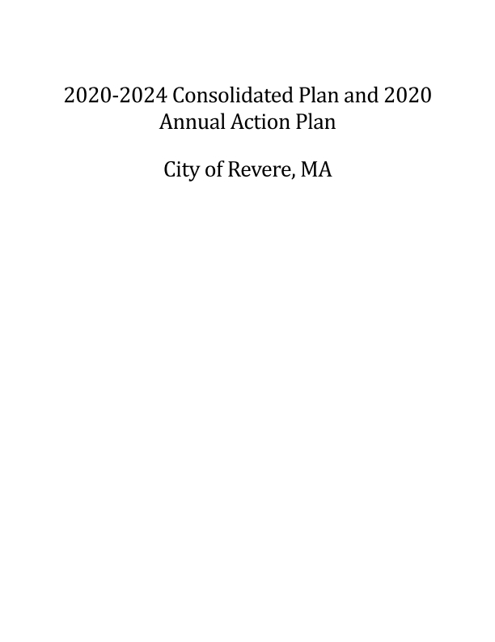
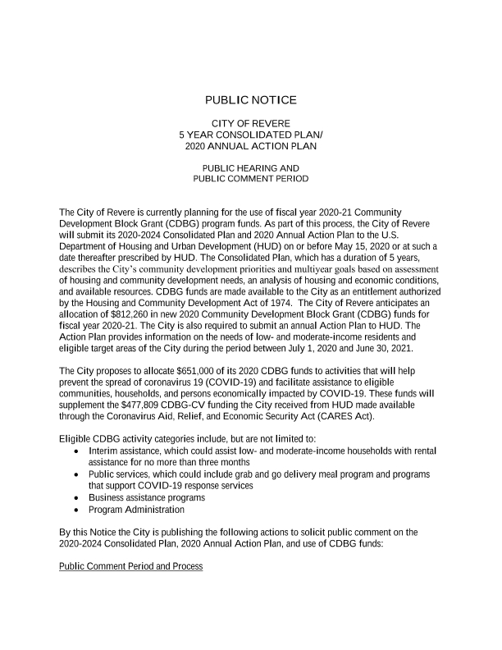
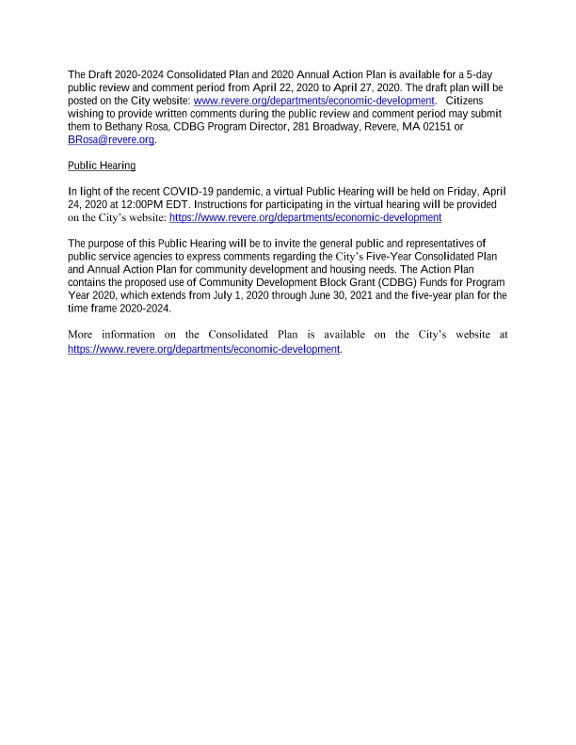
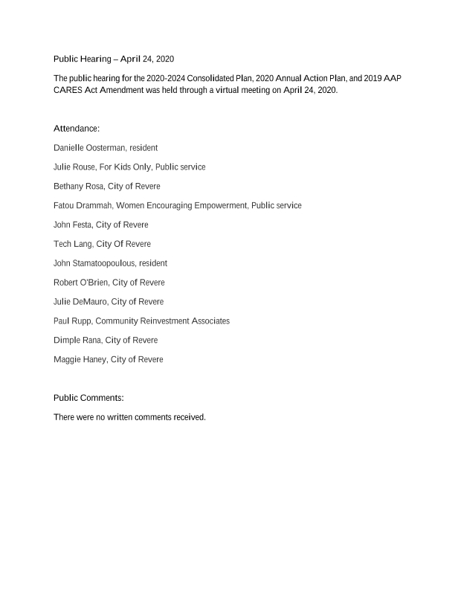
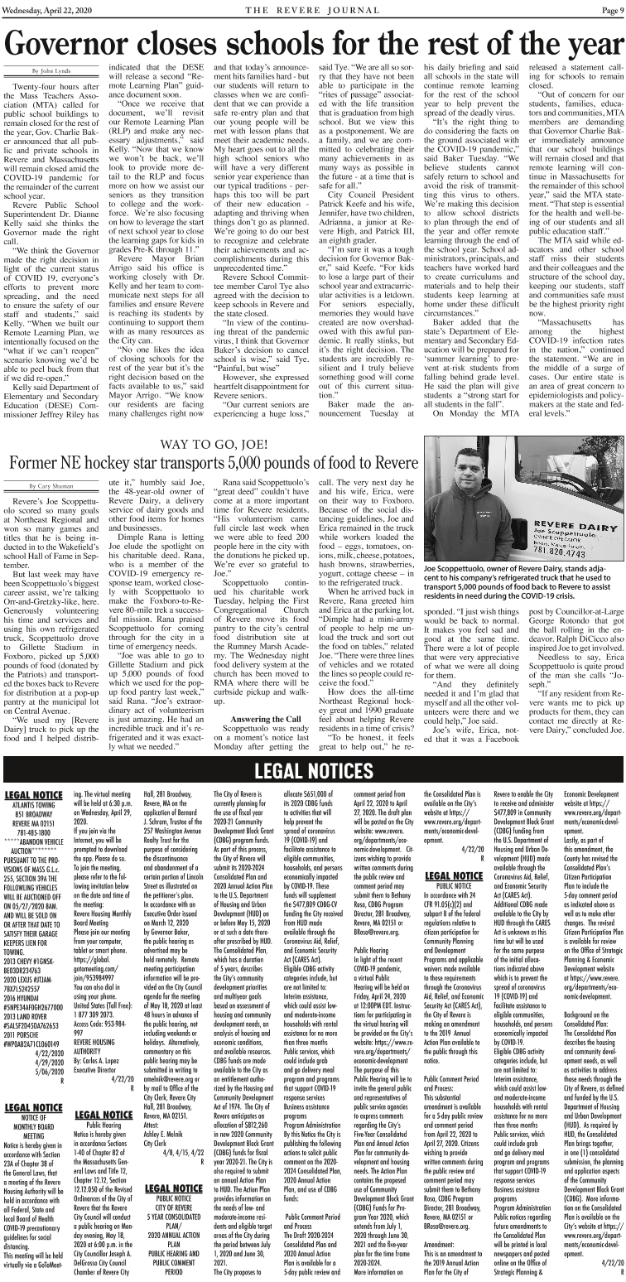
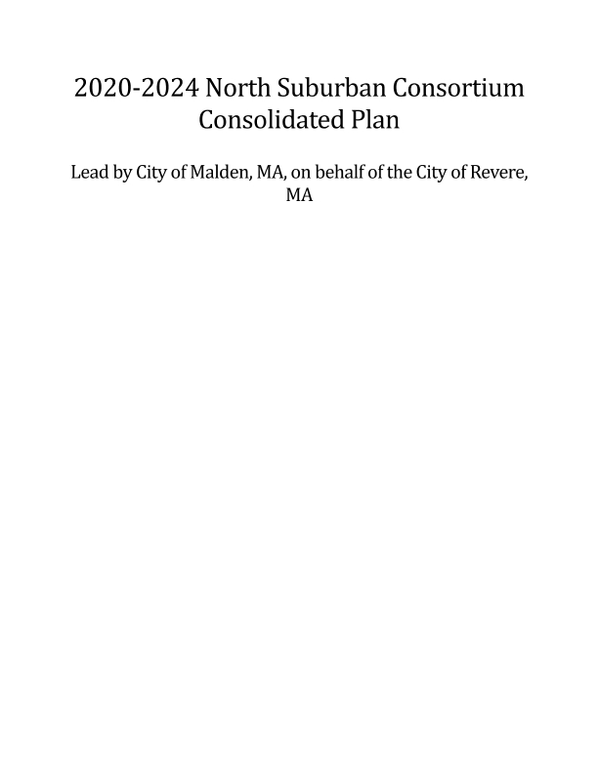
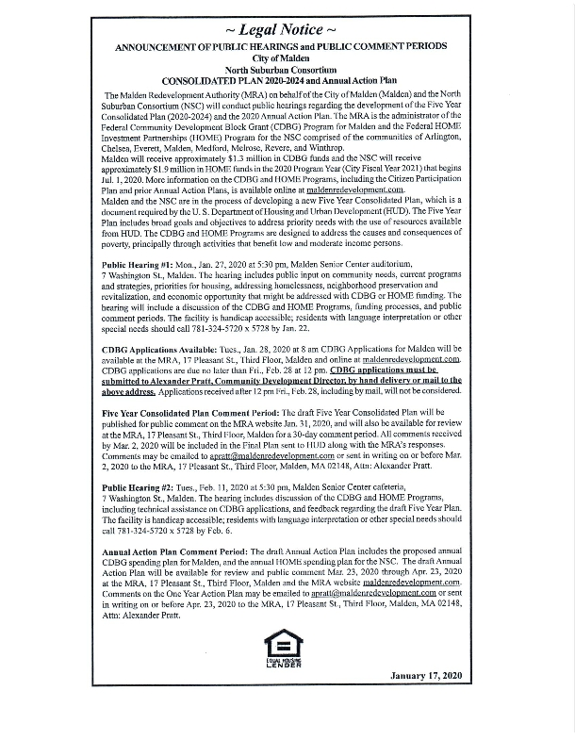
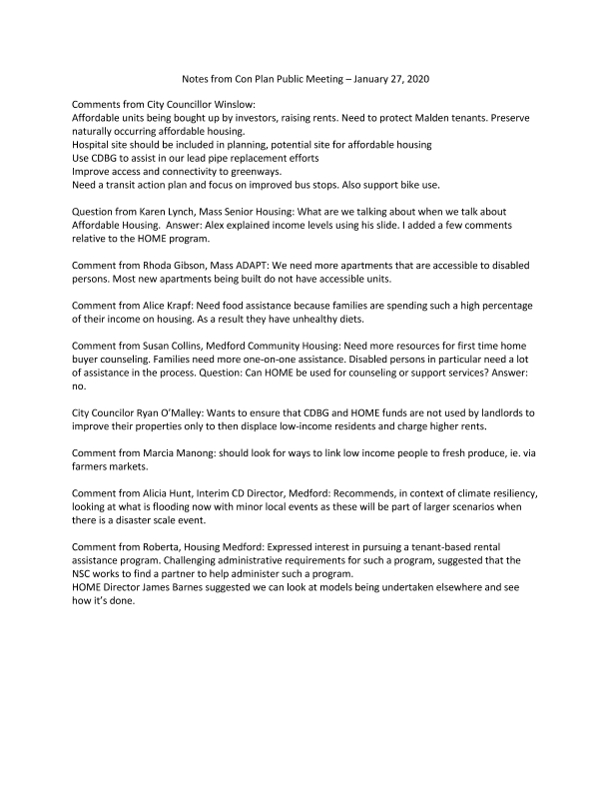
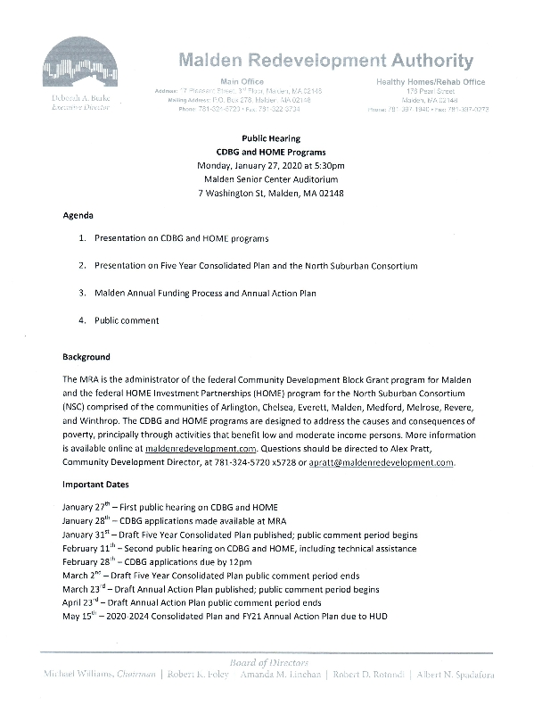
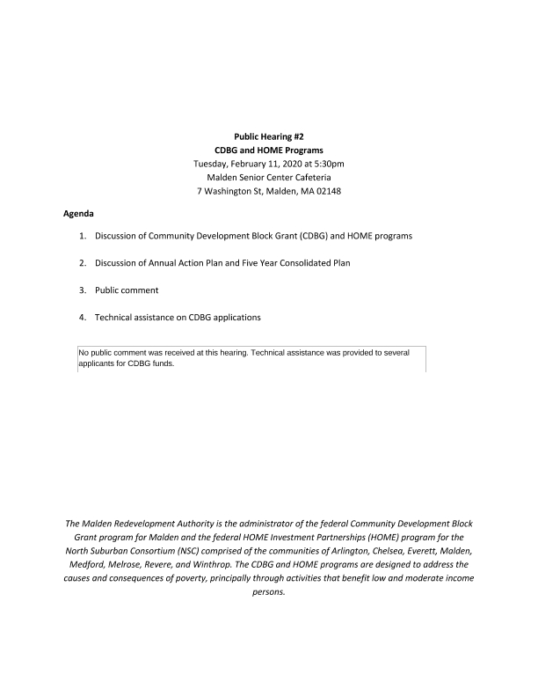
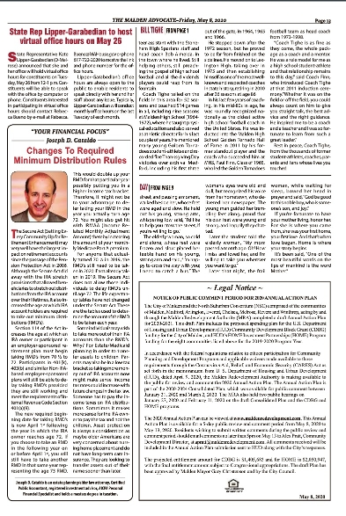

Grantee SF-424's and Certification(s)
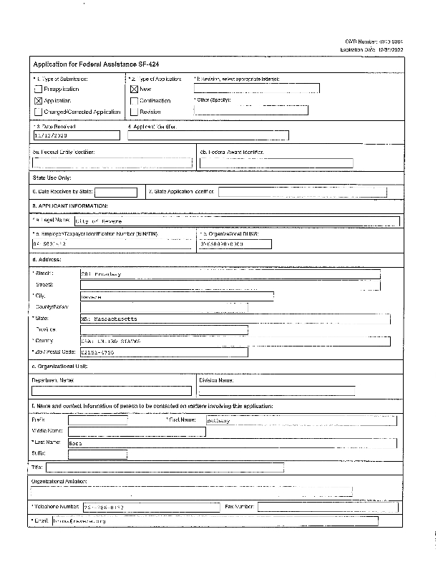
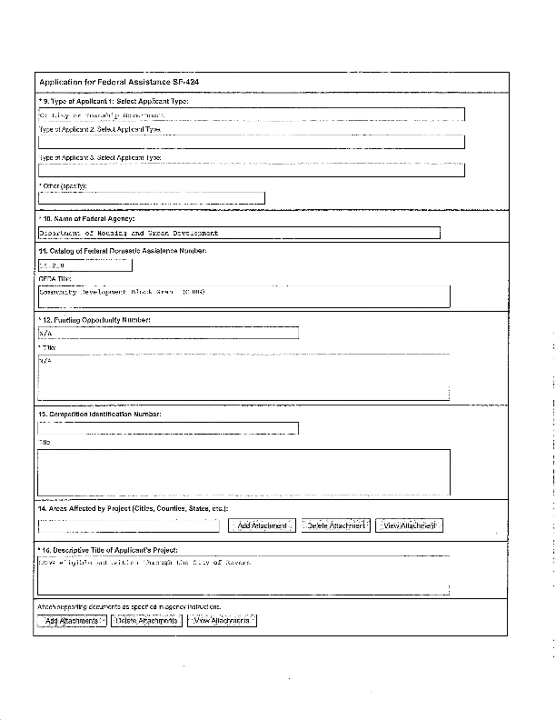
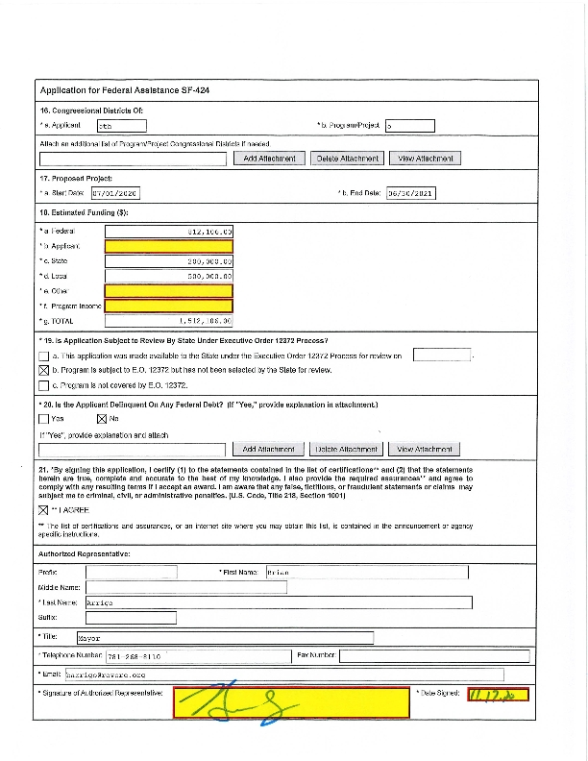
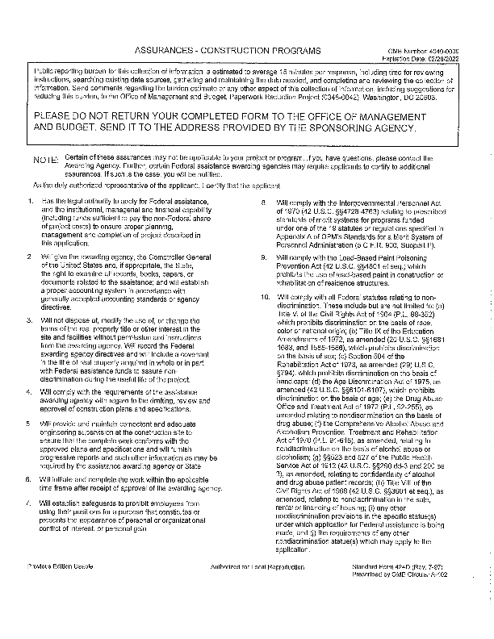
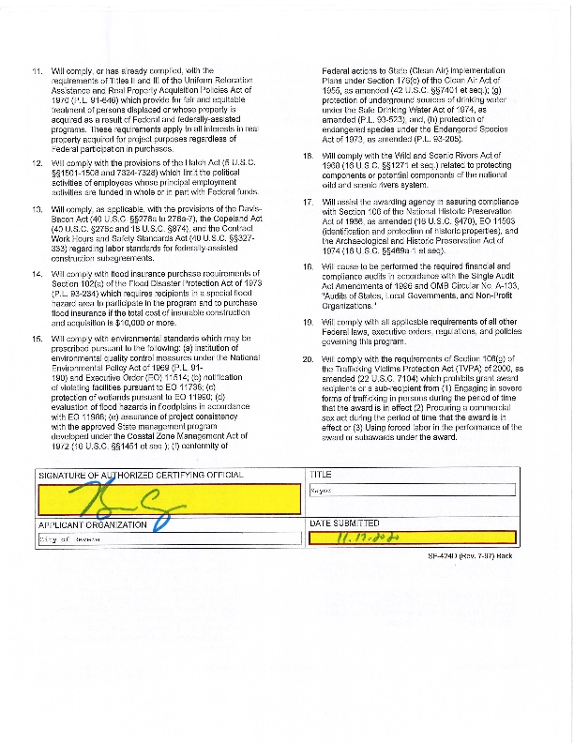
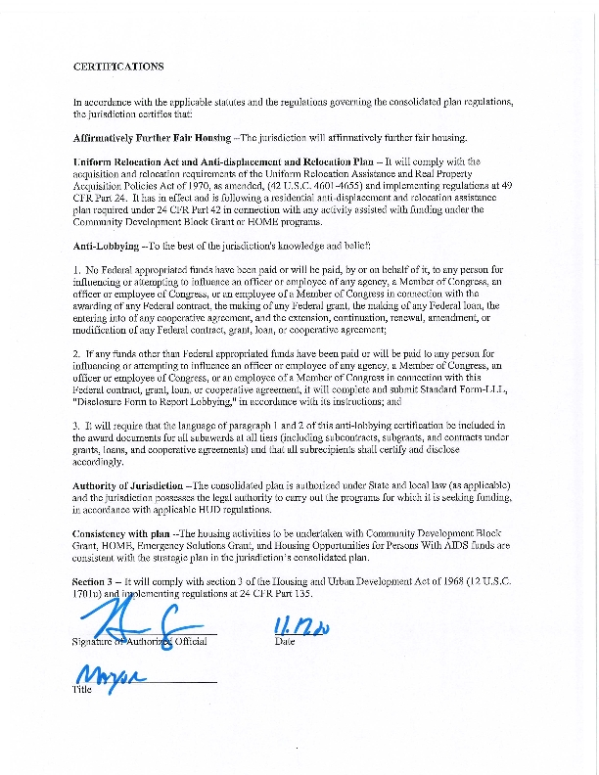
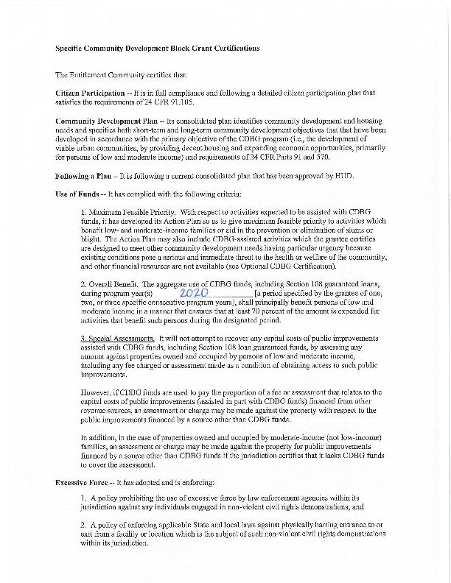
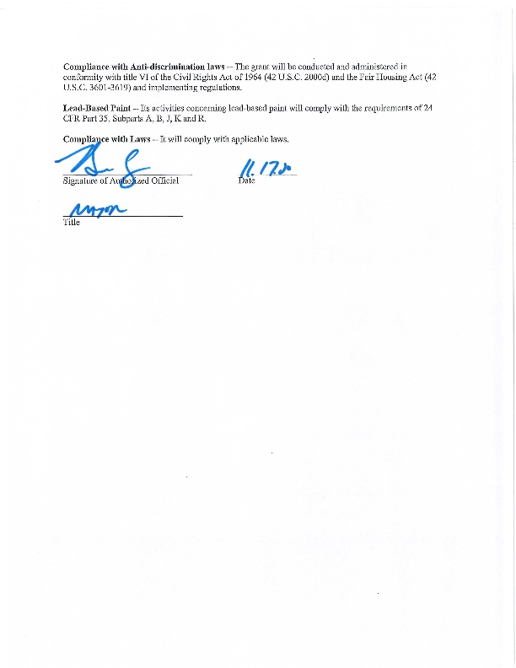
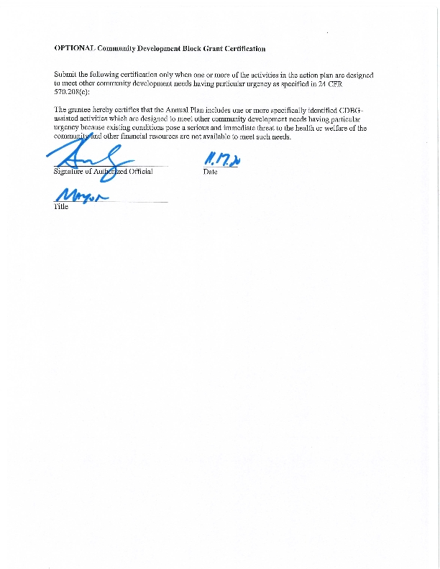

Appendix - Alternate/Local Data Sources

