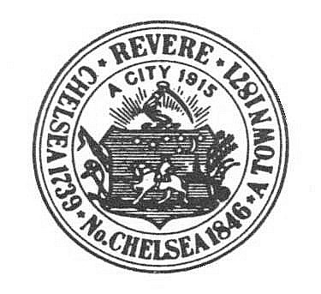
City of Revere
Inspectional Services Department

APPLICATION FOR CERTIFICATE OF INSPECTION

DATE (x ) Fee Required (Amount) $75.00

In accordance with the provisions of the MASSACHUSETTS STATE BUILDING CODE Section 106.5. I hereby apply
for a Certificate of Inspection for the below named premises located at the following address:

STREET AND NUMBER

NAME OF PREMISES

PURPOSE FOR WHICH PREMISES IS USED
License(s) or Permit (s) required for the premises by other Governmental Agencies:
LICENSE OR PERMIT AGENCY

Certificate to be issued to:

Address of Holder:
Owner of Record of the Property:

Address of Owner:

Name of Present Holder of the Certificate (if any):

Address of the Present Holder (if any):

Signature of Person to Whom Certificate is issued Title/Phone Number
Or His Authorized Agent

INSTRUCTIONS: Date
- Make check payable to: The City of Revere
- Return this application with your check to the Building Department, 249R Broadway

PLEASE NOTE:
- APPLICATION FORM WITH ACCOMPANYING FEE MUST BE SUBMITTED FOR EACH BUILDING OR STRUCTURE OF PART THEREOF TO BE CERTIFIED.
- APPLICATION AND FEE MUST BE RECEIVED BEFORE THE CERTIFICATE WILL BE ISSUED.
- THE BUILDING INSPECTOR SHALL BE NOTIFIED WITHIN TEN (10) DAYS OF ANY CHANGE IN THE ABOVE INFORMATION.
___

CERTIFICATE# EXPIRATION DATE:

