BIOGRAPHICAL SKETCH

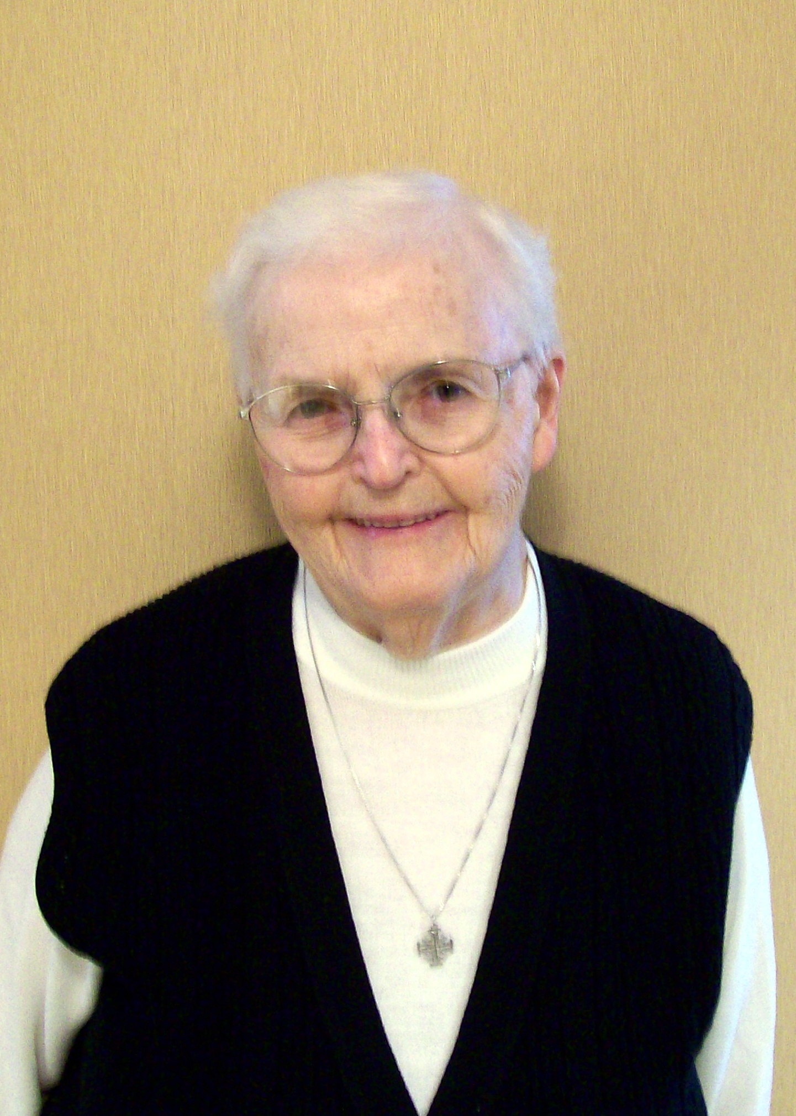

Sister June Rita Fortier
(Sister William-Marie)

August 21, 1930 - September 16, 2020

1783rd death

"The Lord is my shepherd; I shall not want...
He guides me in right paths
I fear no evil; for you are at my side
With your rod and your staff that give me courage."
(Psalm 23)

Sister June Rita was the only child born to William Fortier and Marion Morisson Fortier on the 21st day of August, 1930. She died at St. Joseph Convent on September 16, 2020 at the age of 90 years.

June Rita’s family resided in Somerville, Massachusetts. Her mother was adopted into a strict Episcopalian family, who threatened to disown her if ever she joined the Roman Catholic Church. When her mother was an adult, she married William Fortier, joined the Catholic Church, and became a devout Catholic. They longed to raise a family and waited for six long years for the arrival of little June Rita. Her mother's health declined following her birth and when June Rita was only three years old, her dear mother died. Her father was a very loving and caring parent and was helped in the upbringing of little June Rita by his sisters.

Before dying, June Rita's mother had her husband promise to bring up her little daughter Catholic. She also asked him to promise three things regarding the future of her little daughter. At her birth she had consecrated her baby to the Blessed Virgin Mary. She asked that if June Rita desired to become a religious sister, that her father would encourage her in her vocation. She also asked that June Rita would be with him when he died and that he receive the Sacrament of the Sick while he was still responsive.

All of her mother's wishes were realized. However, Sister learned of them only at her final profession for her father did not want to influence her decision to become a religious. Sister June Rita feels that her mother was responsible for her vocation.

June Rita began kindergarten at a public school. Her father had promised to bring her up Catholic, so one of her Aunts who was very religious agreed to have her move in with her. From the age of six June Rita attended Mass daily. When she was in the fourth grade, she asked her father if she could attend St. Vincent Boarding School in Cambridge, Massachusetts which was run by Sisters. This school was near her home so he agreed and was able to visit her three or four times a week. She attended this school until grade eight. At this time, June Rita became very interested in religious life and asked her father if she could attend Immaculate Conception School in Cambridge, MA, then Archbishop Cushing Central High School in South Boston. Her father did his best to please his daughter and to meet the wishes of his late wife.

After her high school graduation, June Rita worked for nine years for the First National Stores. She also took a Red Cross Nurse's Aide course and visited patients at Carney Catholic Hospital on her free time. She enjoyed life and lived it to the fullest.

June Rita had an aunt, her father’s sister, who was a Good Shepherd Sister of Quebec. Her name was Mabel and when her mother died, she was brought up by a Picard family, cousins of June Rita’s father, who lived in Montmagny. When her Aunt Mabel became a religious she joined the Good Shepherd Sisters and became known as Sister St. Wilbrod. So, when June Rita considered religious life she was attracted to the same Religious Community as her Aunt.

In 1955, Sister June Rita's childhood dream was realized. On September 2, 1955, she entered the Sisters Servant of the Immaculate Heart of Mary, known as the Good Shepherd Sisters of Quebec in Bay View, Saco, Maine. During her formative years, she functioned as a nurse's aide caring for the ailing Sisters in different convents. In 1968, she studied to become a Licensed Practical Nurse at the Lawrence Vocational School and earned her L.P.N. diploma in the fall of 1969. She was greatly appreciated and loved in this profession. Several Sisters wrote their appreciation at the time of her silver jubilee. They commented on her concern about each one of them, even the tying of shoe laces when it was difficult for them to do so. They appreciated her remarkable patience and her work done without "fanfare." They said that everyone saw her silent "Yes, Lord." She never voiced any complaints. With French-speaking Sisters, Sister June always attempted to communicate and was ready to laugh when her French just didn't come out correctly. She struggled with the French language over her lifetime.

Sister devoted herself wholeheartedly to nursing from 1972 to 1987. Then as she prepared to embark on a new ministry, the head of the infirmary of Bay View wrote: Praise the Lord for your many years of self-forgetfulness in Bay View, Sister June Rita. May your future apostolate be a fruitful one, dear Sister. We love you and will miss you.

Sister was transferred to Marie Fitzbach Convent. This move involved another "first" in her life. Each Sister of this convent was expected to do a share in preparing meals for the community. She had never cooked in her life. But she faithfully followed recipes and was soon baking goodies from scratch—blueberry muffins, coffee cakes and angel food cakes for the holidays.

Sister June Rita was employed part-time in St. Joseph Parish to visit the shut-ins and elderly. She did not have a driver's license, so when she was transferred to Marie Fitzbach Convent she walked to the homes that she visited in all kinds of weather. Although this was part-time employment, the Provincial Council allowed her to work full-time to perform works of charity and to witness to our charism of communicating love and goodness. She often spent many hours on the phone after her work day to reach out to someone in need. Not only did Catholics benefit from her service, but those from other churches as well. They saw how faithful she was in her visits and asked if she could visit them also.

Sister also volunteered to visit Truslow Adult Care Center (now renamed Cohen Adult Care Center) in the area and was honored as one of twenty people who distinguished themselves in serving the elderly of the area. The following is an excerpt from the Journal Tribune Newspaper of May 17, 2003.

Sister June Rita Fortier, a member of the Good Shepherd Sisters of Quebec, has touched the lives of thousands of sick and elderly with the warmth and love of her ministry during the last 47 years of dedicated service. As Pastoral Visitor at St. Joseph Parish, Biddeford, she continues to provide emotional support and counseling to sick and dying members of the parish, offers comfort and solace to the bereaved, and serves as a community resource for individuals and families traumatized by life's tragedies and traumas. Her citation reveals that Sister has become a familiar and loved figure within the community and finds that even as she walks the streets (her street ministry, as she calls it) she is often sought after by people in need of a friendly word, a smile, or a touch of comfort.

In June, 2006, Sister June Rita felt forced to retire because of health issues and was transferred to Miriam Residence and later in April, 2008 to Good Shepherd Pavilion. She stated how she loved having extra time for prayer, walking, enjoying nature, doing water exercise, reading and sightseeing.

Sister remained as active as she possibly could. She visited the Biddeford Y.M.C.A. where she joined their Aerobics Class in the pool. She also attended many Active Older Adult Luncheons and was a dedicated member of the Y.M.C.A. for many years. Pat Donahue, the Swim Coach spoke of Sister June Rita's dedication to fitness and health. She shared that she was my student, mentor and a dear friend. I considered her to be "A gift from God of Love and Friendship whom I will always cherish."

Sister June Rita was a loyal friend to many people. She was very kind, and sensitive to the needs of others. She was serious, yet jovial and always willing to go the extra mile. She loved her nursing days and served others with great empathy and kindness. She would often do the "special deeds" to make others happy. She was an excellent listener and never betrayed a confidence shared with her. As long as her health allowed, she enjoyed her walks outside for she loved the beauty of her surroundings. She also enjoyed the Nature Programs which told the lives of the many interesting animals God created.

When Sister's life on earth was drawing to a close, she didn't want any extraordinary care. Her 90th birthday was spent in the hospital. How happy she was to return home to Good Shepherd Pavilion after her hospital stay. When her final hours drew near, Sister June Rita peacefully breathed her last to be with her beloved parents and her long-awaited Good Shepherd. She had shared the “walking staff” of the Shepherd on the Biddeford streets and in the many homes she had visited in His name. She brought His message of prayer, comfort and peace to many home-bound people.

Sister June Rita is survived by one aunt, Gloria Morrison of Swampscott, MA and two cousins, Kay Parisi of Peabody, MA and Martine Bédard of Notre-Dame-de-L'Ile Perrot, Québec.

We were unable to have a Mass of Christian Mass of Burial for her due to the pandemic. Otherwise, our chapel would have been filled to overflowing were it not for this condition. Sister June Rita was well known and loved in the city of Biddeford. Her burial service took place on September 21, 2020 at St. Joseph Cemetery, Biddeford, Maine. Reverend Norman Richard officiated. Deacon Kevin Jacques and Msgr. Marc Caron and several affiliates and friends attended the ceremony. A Mass of Christian Burial will be celebrated at a later date at the conclusion of the pandemic.
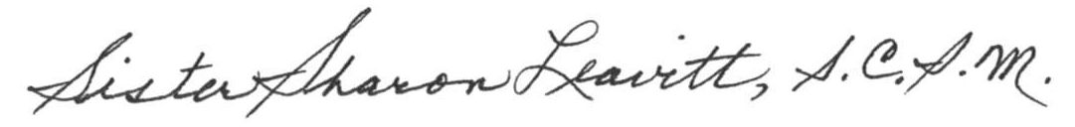

Sister Sharon Leavitt

October 22, 2020

