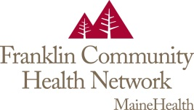
Medical Staff

The Medical Staff of Franklin Community Health Network have established a scholarship fund for local high school seniors. One $500 scholarship will be awarded to each of the following schools; Mt. Abram High School, Mt. Blue High School, Rangeley High School, and Spruce Mountain High School. If a school does not have a scholarship applicant, the scholarship will be awarded to a qualified applicant from one of the other schools.
The applicant should demonstrate strong motivation to pursue a health care career, display academic excellence, and show a dedication to community service.
Requirements:
- Personal essay displaying future career goals
- Current transcript
- 2 letters of recommendation: One letter from a health care professional and one letter from a high school educator

The applications can be mailed to the Medical Staff Office, 111 Franklin Health Commons, Farmington, ME 04938. The application deadline is May 1st.

