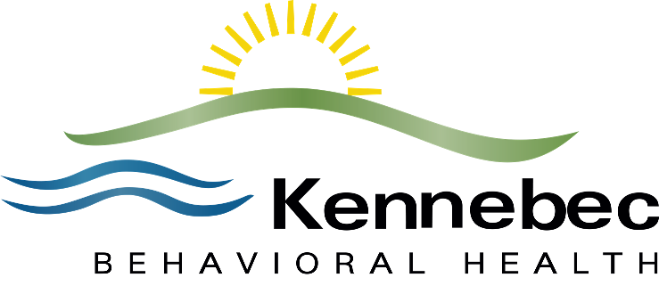

Kennebec Behavioral Health Scholarship Program 2021

Kennebec Behavioral Health believes that investing in the education and training of individuals who will become our future behavioral health professionals is critically important. Workforce development specific to mental health and substance use disorder is key to assuring that KBH will be able to fulfill its mission for many years to come.

To that end, up to ten $1,000 scholarships will be awarded each year to local graduating high school seniors who plan to continue their education in a field related to behavioral health. One student from each of the high schools listed below, and will be selected by the school’s scholarship committee. Scholarship recipients will be notified by school officials during their senior awards ceremony. A copy of the selected student’s scholarship application and his or her contact information will be forwarded to KBH once the student has been notified.

To be eligible, students must:
- be graduating seniors from Cony High School, Erskine Academy, Lawrence High School, Maranacook High School, Winslow High School, Waterville Senior High School, Gardiner High School, Winthrop High School, Mt Blue High School or Skowhegan High School, and

- be accepted at an accredited college, university or technical school including but not limited to Kennebec Valley Community College, University of Maine, UNE (University of New England), and USM (University of Southern Maine)

- plan to major in a behavioral health field, and

- have at least a B average or equivalent in high school

In order to receive the award:
- students must provide evidence of having successfully completed the first semester as a full-time student in good standing (passing grade in all subjects),

- students must provide evidence of enrollment as a full-time student for a second semester, and

- the second semester referred to above must begin within 30 months of the awarding of the scholarship.

For more information contact:
Tina Chapman
Senior Engagement Officer
Kennebec Behavioral Health
67 Eustis Parkway
Waterville, ME 04901
(207) 873-2136 X 1022
Fax: 207-660-4544
tchapman@kbhmaine.org

Kennebec Behavioral Health Scholarship Application 2021

Student Name:
Address:
Phone Number:
Home E-mail:
Name of High School:
Accepting College/University:

In an essay not to exceed 200 words, describe why you are interested in pursuing a career in the behavioral health field.

Please describe your secondary school scholastic activities, including all honors and leadership positions you have held.

Please describe briefly all other activities in which you are involved (sports, community service) whether through the school or other organization, for example church, scouting, 4H, etc., noting again all leadership positions you have held and/or awards or designations you have received.

Please return the completed application to your high school Guidance Office.

